Uncertainty In Cognitive Science

Jesper Fischer Ehmsen,

# Summary

# Acknowledgement

part of the computation done for this project was performed on the UCloud interactive HPC system, which is managed by the eScience Center at the University of Southern Denmark.

All scripts, code, models and simulated data can be found on the following [Github page](https://github.com/JesperFischer/Master-thesis). Here all analyses as well as the entire manuscript is documented.

# Introduction

Most scientific inquiry revolves around measurements of the physical world; may that be the time it takes for a cup to fall to the ground or the time it takes for a person to react to a visual stimulus on a computer screen. These measurements of the physical world will be associated with uncertainty as repeatedly measuring the same thing, will result in different measurements. This means that one of the most fundamental things that scientific inquiry and theories rests on is uncertainty and it is one of the roles of science to quantify such uncertainties. In this thesis I will investigate shortcomings in uncertainty handling in cognitive science, while providing ways to properly account for these uncertainties when analyses are conducted. To do this I will rely on Monte Carlo simulations which provides a robust method for accounting for uncertainties when analyses and models are deployed. In particular the thesis will introduce a partially novel way of testing and validating the parameters of models in cognitive science. The thesis will demonstrate this with a focus on the psychometric function, a commonly used cognitive model in cognitive science. It will be shown that the parameters of the model and their uncertainties can be reduced by several different interventions and assumptions, including optimization of the experimental design, but also by incorporating additional information already available in most experiments like reaction times.

To further reiterate the utility of jointly modeling additional variables the thesis will re-analyze published data using a psychometric function. Here it will be demonstrated how carefully using the known structure of the data can greatly improve session by session correlation between parameters, i.e. minimizing uncertainty. Lastly using this reanalysis, the thesis will highlight opportunities to conduct power analyses utilizing a novel modeling framework that accounts for the uncertainty in model parameters as well as sampling variability of the effect investigated. Comparison will be made to popular tools such as G*power highlighting the need for rigorous methods, when conducting power analyses but also in model validation.

## *Uncertainties in science and examples from physics*

Science is a systematic way to organize knowledge in hierarchies, leading to testable hypotheses. Knowledge can be hard to define, but most often it is something that is achieved though experience. Imaging a cup being dropped, most will have the knowledge that it will fall towards the ground and reach our foot at a particular speed, because of our previous experiences with dropping a cup. This is to say that knowledge is the relationships that we believe to be true with differing amounts of certainty. The reality is that even though we might say that we are completely certain of events, i.e. know, that the cup will fall towards the ground and reach it at a particular speed, this is in an assumption that is true only most of the time. Given that the natural world is bounded on probabilities, complete certainty is unwarranted, both in the assumption of the cup hitting our foot, but especially the speed at which it hits our foot. Most of the time the probabilistic nature of the natural world stems from the uncertainties during measurement or perhaps unseen events. The interest here is not in the unseen events, but instead in the predictability and (un)certainty of the expected. Taking the falling cup as an example, in science we would normally not be interested in the probability that the cup will hit the ground, but instead in the acceleration of the cup and the uncertainty in this estimate. What scientists have shown is that objects dropped on earth will accelerate towards the ground with an acceleration of (Johannes & Smilde, 2009). However, this number does not mean anything without an estimate of the uncertainty, while also accounting for the assumptions that are entailed with these numbers. The first proposition is well studied and the 95% confidence interval of the value is estimated to be (Johannes & Smilde, 2009). The second proposition is also quite well studied as we know that the density of the medium that the cup is dropped in is important, but also the shape and weight of the cup if dropped outside of a vacuum. In order to estimate this constant acceleration, measurements have to be made of the distance a falling cup travels and the time it takes to reach the ground. With these measures of distance and time, uncertainty is introduced and propagated to get the an estimate for the acceleration, but also the uncertainty associated with it. There are 2 main points of the example which this thesis will explore, firstly uncertainties are organized in hierarchies and are just as important as beliefs as without one, the other is meaningless. Secondly, taking these uncertainties seriously and herein estimating and propagating them should not be a choice or something that can be avoided, but a necessity of all scientific endeavors, where they can be quantified or at least approximated. Taking its outset in the published literature, the thesis will establish issues regarding uncertainty handling and propagation and use simulations to highlight the problems with neglecting a proper account of uncertainty in statistical models particularly in cognitive science. After highlighting these potential issues, the thesis will provide possible ways of dealing with the shortcomings by means of simulations. The goal of this thesis is to illuminate the often-overlooked uncertainties in the data collected on human behavior and cognition while providing ways of accounting for it. This would therefore entail that the uncertainty reported in the published literature more accurately reflects the (un)certainty in the results.

The thesis will argue that accounting for uncertainties is more important than ever, especially in research of complex systems such as humans, as computational resources have made it possible to easily develop more sophisticated analyses and models that have dependencies on lower-level analyses. The dependent structure makes the need for proper uncertainty handling even more imperative, as without propagating uncertainties the resulting estimate will be overly confident. Furthermore, these computational resources do allow for uncertainty propagation without a deep understanding of the underlying mathematics, making it accessible to most researchers with some coding experience. To effectively communicate both the statistical models as well as the underlying uncertainties associated with doing computations on data, the thesis will start by exploring different types of uncertainty in cognitive science. Next the thesis will be investigating a particular cognitive model, the psychometric function, used in many sub fields of cognitive science. This model will be examined and used to show how a novel way of validating cognitive models can be used to gain more information about the structure of the uncertainty in the parameters of the model.

## *Levels of uncertainty and uncertainty propagation*

I will here broadly define 3 different types of uncertainty which are going to be used throughout the thesis, measurement, estimation, and test-retest reliability uncertainty see figure 1 and 2 for a visualization. These definitions are not exhaustive and will be centered around how experimental studies in cognitive science are conducted, from data collection to data analysis. However, before examining these three types of uncertainty it is to acknowledge that uncertainties can be defined in hierarchies and that uncertainty propagates through these hierarchies. This uncertainty propagation means that as calculations are done based on measures with uncertainty, the uncertainty propagates to the results of the calculations. In this thesis I will be using simulations to show how uncertainty propagation can be understood and handled without a need for rigorous mathematical proofs. For a more mathematical treatment see (Saccenti et al., 2020).

The lowest level of uncertainty is in the measurements themselves i.e. measurement uncertainty. Measurement uncertainty reflects the uncertainty in how well one can for instance measure the reaction time on a computer or the time it took a falling cup to reach the ground. This level of uncertainty is often neglected in cognitive science when applying statistical models, because they are thought to be minuscule as in the case of reaction time tasks, which may or may not be true given the experiment setup (Crocetta & Andrade, 2015; Holden et al., 2019; Ohyanagi & Sengoku, 2010). This is not to say that cognitive scientists do not care about them, as moving towards more sophisticated measurement methods is an ongoing endeavor. For instance, using better and more sophisticated computers to measure reaction times commonly found in cognitive science experiments (Crocetta & Andrade, 2015). Minimizing this kind of uncertainty most often revolves around getting better tools to measure the variable(s) of interest. Interestingly some variables of interest in cognitive science do not have a explicit quantification of measurement uncertainty. One of the main instances coming to mind is the use of questionnaires. Many of these questionnaires try to quantify a latent construct such as mental health conditions i.e. depression or anxiety. Many of the main questionnaires used to assess these latent constructs use several questions that are then added together to give a score of said mental health condition without a quantification of the uncertainty on the latent construct because no uncertainty is quantified on each question (Cohen, 1994; Johnson et al., 2019; Kroenke et al., 2001; Xiao et al., 2023).

In order to contextualize these forms of uncertainty i will consider an idealized example of a fictional researcher wanting to understand the relationship between reaction times and stress. To do this the researcher conducts an experiment where participants are measured several times under different conditions to introduce stress. A questionnaire is used to access the stress of the participant and a computer based experiment is used to determine their reaction time. In this example both of these measures have associated uncertainty, measurement uncertainty, see the individual data points in figure 1. The relationship between reaction times and stress is determined by the slope of the regression line depicted in Figure 1.

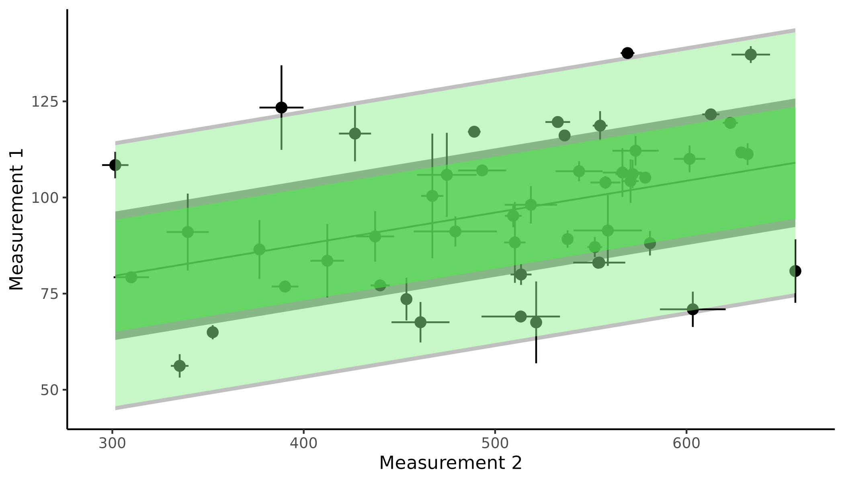

**Figure 1 Measurement and Estimation uncertainty;** the figure displays a linear regression between two measurements for instance reaction time and stress with measurement uncertainty depicted as vertical and horizontal error bars on individual points. The mean of the regression line with and without propagated uncertainty is highlighted in grey and dark green respectively. Lastly a prediction interval is depicted as the shaded area around the mean of the regression line with and without propagated uncertainty again in grey and green respectively.

The next level of uncertainty is when a particular model is fit to some data, or more broadly when calculations are done on data with uncertainty. In cognitive science we achieve parameter estimates from our collected data and these parameter estimates have uncertainty associated with them, this uncertainty will be referred to as estimation uncertainty. Estimation uncertainty is most often quantified by the statistical model be that the standard error of a regression coefficient or the width of a posterior distribution of a parameter in a Bayesian framework. Taking the example of the researcher investigating reaction times and stress this is the uncertainty in the parameter estimates achieved by fitting a linear model to the data see the linear model in figure 1. Minimizing estimation uncertainty is partly what scientists care about, as inevitably most cognitive science experiments revolve around null hypothesis testing, which in most cases will involve testing whether the parameter estimate includes a particular value, mostly, 0. Therefore if there is an underlying effect i.e. the parameter is not zero, then minimizing estimation uncertainty will reveal this effect as being statistically significant. To minimize this type of uncertainty the standard approach is to get more data, given that it comes from the same population and produces similar results. In cognitive science this might include increasing the number of trials or subjects to get a more precise estimate of interest i.e. minimizing estimation uncertainty. This way of minimizing estimation uncertainty is however not free or free of uncertainty itself. Firstly, increasing the number of trials in a cognitive task might even increase the estimation uncertainty itself. This can happen for several reasons, but boredom, habituation, fatigue and lack of engagement can become big contributors when experimental tasks become very long (Jeong et al., 2023; Meier et al., 2024). Secondly for some cognitive science experiments massively increasing the number of trials could make subjects more prone to switching between cognitive strategies and if not properly accounted for in the analysis might be interpreted as additional noise by the model and its parameters. Next increasing the number of subjects included in a study will many times decrease estimation uncertainty on the population level estimates, if the sample population is homogeneous. The trade off between subjects and trials in an experiment is therefore quite important to minimize estimation uncertainty, but also minimize the overuse of resources. Beyond these traditional approaches to minimizing estimation uncertainty there are other ways, for instance changing the task design such that responses will give more information on parameter values of interest (Baldi Antognini et al., 2023; Stone, 2014). This optimization strategy involves individualizing the task design such that each presented stimulus is the most informative it can be. This task design optimization is frequently used in psycho-physical experiments where adaptive algorithms are used to select the upcoming stimuli such that it minimizes the uncertainty in the estimated parameter values. See for example algorithms like PSI, QUEST and ADOPY (Prins, 2013; Watson, 2017; Yang et al., 2021). From the example of the researcher investigating reaction time and stress this might involve selecting interventions that will produce varying levels of stress to increase the precision of the parameters of the model, again minimizing estimation uncertainty. A practical example of how these algorithms work to minimize uncertainty in the parameter estimates, see the section about Adaptive design optimization. The next level, and last level presented here, of uncertainty stems from the fact that these parameter estimates will vary over time, as humans vary over time. This variation stems from both behavioral factors like learning, but also psychological factors such as mood and arousal (Schurr et al., 2024). This type of uncertainty will be referred to as test-retest uncertainty. Again with offset in the example, participants in the researchers study on reaction times and stress might be tested twice on different days to understand how stable the relationship is over time. As the relationship is measured by the parameters of the model the stability of the relationship is measured by the stability of the parameters. One might imagine that the amount of sleep acquired before the experimental day could influence both measures of the task i.e. reaction time and susceptibility to stress and perhaps even their relationship. Figure 2 displays how the parameter estimates of the same model as presented in Figure 1 with and without accounting for uncertainty propagation change based on the propergation of uncertainty. As can be seen from Figure 1 accounting for the measurement uncertainty does not change much the prediction made by the model, however when propagating these extra uncertainties into the next analysis of the parameters i.e. from session to session in Figure 2 the change in results become more pronounced. The main effect for the current linear model is that the residual variance is underestimated without error propagation and the slope parameter is overestimated.

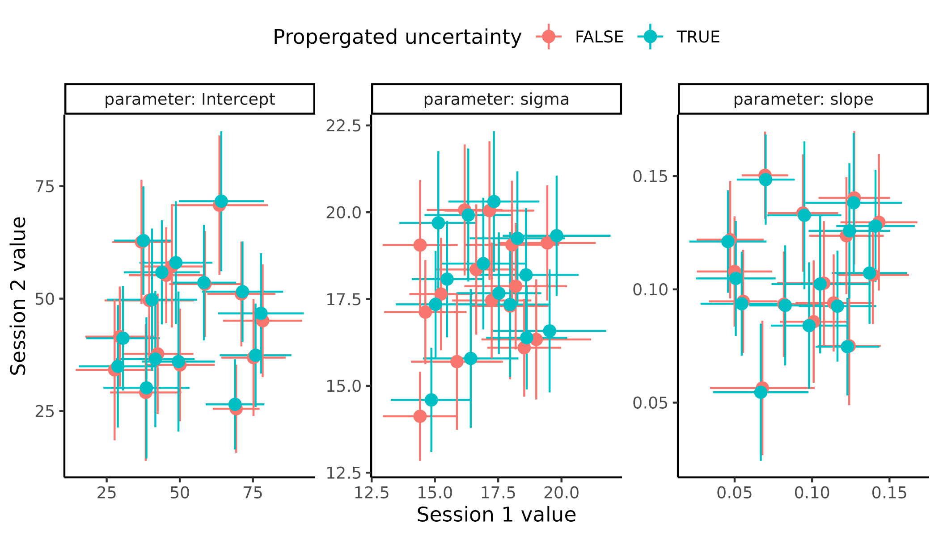

**Figure 2 Test retest uncertainty;** displays the results of fitting the linear regression in Figure 1 twice with and without accounting for measurement uncertainty. Each facet represents one of the three parameters of the linear model, the intercept the residual uncertainty and the slope respectively from left to right. Colors represented weather the measurement uncertainty was proporgated or not.

The main message here is that to get reliable estimates and, in the end, to make reliable inference one needs to account for all these sorts of uncertainties and the lower in the hierarchy you move the more fundamental and important they become, when doing higher level calculations with them. Having a parameter estimate that is stable over time won’t matter if you cannot estimate it, or measure it, reliably in the first place.

# Measurement uncertainty

To keep a consistent theme, I will throughout the thesis be demonstrating how computational resources have made the need for analytic solutions involving tedious assumptions sometimes irrelevant. This is highly relevant as closed-form-problems where an analytic solution is known or even attainable are becoming less and less frequent with the surge in popularity of more and more complex models, see section about modeling definitions for further elaboration. In order to explore measurement uncertainty in examples related to cognitive science the thesis will here investigate the relationship between correlation coefficients and measurement uncertainty. This will be done, as a non trivial part of the published litterature in cognitive science revolves around conducting correlational analyses on measures that have quantifiable uncertainties. These measure involve estimated parameters or even structural properties of the brain like the myelination or grey matter volume in a region of interest (Berker et al., 2016; Luijcks et al., 2015; J. Wu et al., 2021). Another reason for this extra section of how propagating uncertainty when conducting correlational analyses is that through the thesis correlations are going to be used extensively and it serves as a primer for the upcoming sections.

In this section I will demonstrate how using simulations to both understand and explore how adding uncertainty will change the strength of interpretation of correlational analyses this will serve as an abstract representation of how correlation coefficient estimate change under different sizes of measurement uncertainty. In order to use simulations to include uncertainty firstly an understanding of the uncertainty of the correlation coefficient itself is needed. Analytical solutions exist to calculate the uncertainty of such statistics, which is incorporated in most statistical softwares (Makowski et al., 2023), however another way to find and understand this uncertainty comes from re-sampling. Below is an explanation of using re-sampling to evaluate uncertainty in a general case and thereafter its implementation for adding measurement uncertainty. The way to estimate the uncertainty in the correlation coefficient is to re-sample the collected data with replacement i.e. bootstrapping and then recalculate the test statistic of interest (Efron, 1983). Iterating this process gives a distribution of test statistics which with enough iterations will converge towards the analytic solution with recommendations of having at least 30 data points to begin with (Efron, 1983; Efron & Tibshirani, 1994; C. F. J. Wu, 1986). For the simplest case of recalculating the correlation coefficient and its uncertainty it is somewhat tedious compared to taking the direct analytic solution, as this is already implemented in most statistical softwares and packages (Makowski et al., 2022). However, once implemented and understood this approach allows for adding not only measurement uncertainty, but a more general way of thinking about the uncertainty of statistical metrics. One of the advantages of having an analytic solution to this simple case of recalculating the uncertainty of the correlation coefficient is to ensure that the code and scripts are properly set up. This therefore serves as a validation step before exploring territories where analytic solutions are scarce or nonexistent.

The first step is therefore to show that the two approaches of simulating and analytically estimating the uncertainty of the correlation coefficient is identical across different ranges of correlations and sample sizes. To do this, simulated data from a multivariate normal distribution with the following parameters are produced.

$$\left(\begin{matrix}x_{i} \\ y_{i}\end{matrix}\right)∼N\left(\left(\begin{matrix}μ_{x} \\ μ_{y}\end{matrix}\right),\left[\begin{matrix}σ_{x}^{2} & σ_{x}⋅σ_{y}⋅ρ_{xx} \\ σ_{x}⋅σ_{y}⋅ρ_{xx} & σ_{y}^{2}\end{matrix}\right]\right)$$

Where

$$μ_{x}=50, μ_{y}=100, Σ=\left[\begin{matrix}{10}^{2} & 10⋅10⋅ρ_{xy} \\ 10⋅10⋅ρ_{xy} & {10}^{2}\end{matrix}\right]$$

The multinormal distribution produces random variables with a means $μ_{x}$ a standard deviation $σ_{x}$ and crucially with a correlation coefficient between all random variables $ρ_{xy}$. This distribution is perfect for understanding how the correlation coefficient changes as it is a parameter of the distribution. Now demonstrating that bootstrapping and the analytic solution implemented in R are identical, is a matter of simulating correlation coefficients ranging from -0.9 to 0.9 in increments of 0.1 with the total number of samples per random variable being between 50 and 500 in increments of 50 (Makowski et al., 2022; R Core Team, 2024). See supplementary Figure 1 for demonstration of the similarity of these two approaches.

Having shown that the two approaches are identical (or close to) we can add measurement uncertainty to each observation. This has been analytically solved and solutions exist to calculate the correlation coefficient under particular circumstances of normally distributed noise (Saccenti et al., 2020). To add measurement uncertainty to the measurements we can instead of randomly re-sampling pairs of data points from the original data, as done for the case without measurement uncertainty, instead one re samples these pairs as means of an error distribution where the uncertainty (standard deviation) of this distribution is the measurement uncertainty. A mindless choice of error distribution would be the normal distribution which would reflect the fact that the directionality of the uncertainty is assumed to be bidirectional i.e. with no preferred direction. Of note here is that one might re sample the original data from other error distributions. For instance if values are strictly positive or bounded in other ways then simulating from a truncated normal or strictly positive distributions like a lognormal, would be preferred to avoid sampling values that cannot be obtained i.e. negative reaction time values. For this demonstration of adding measurement uncertainties to observed data, normally distributed noise is simulated, which means simulating new “observed values” from a normal distribution with a mean of the observed observation and a standard deviation $σ$ equal to the measurement uncertainty. This can be seen in Figure 3, here uncertainty is added to just the x values in increasing amounts (A), with the resulting correlation coefficient distribution obtained by bootstrapping displayed in (B). It should be noted that the correlation coefficient simulated in this case was 0.8, as indicated by the vertical line in figure 3 (B). it is clear the estimated correlation coefficient using bootstrapping is being attenuated in size but also that the width of the correlation coefficient distribution is increasing with increasing measurement uncertainty, mimicking what can be shown using the analytical solutions (Saccenti et al., 2020). This demonstration serves as a primer for the rest of the thesis, in how uncertainty on the data going into a correlational analysis can shape the correlation coefficient. Here it was shown with normally distributed noise that decreased the size and width of the correlation coefficient, later non trivial types of noise is added where the simulation approach used here is nessecary to properly propergate the uncertainty.

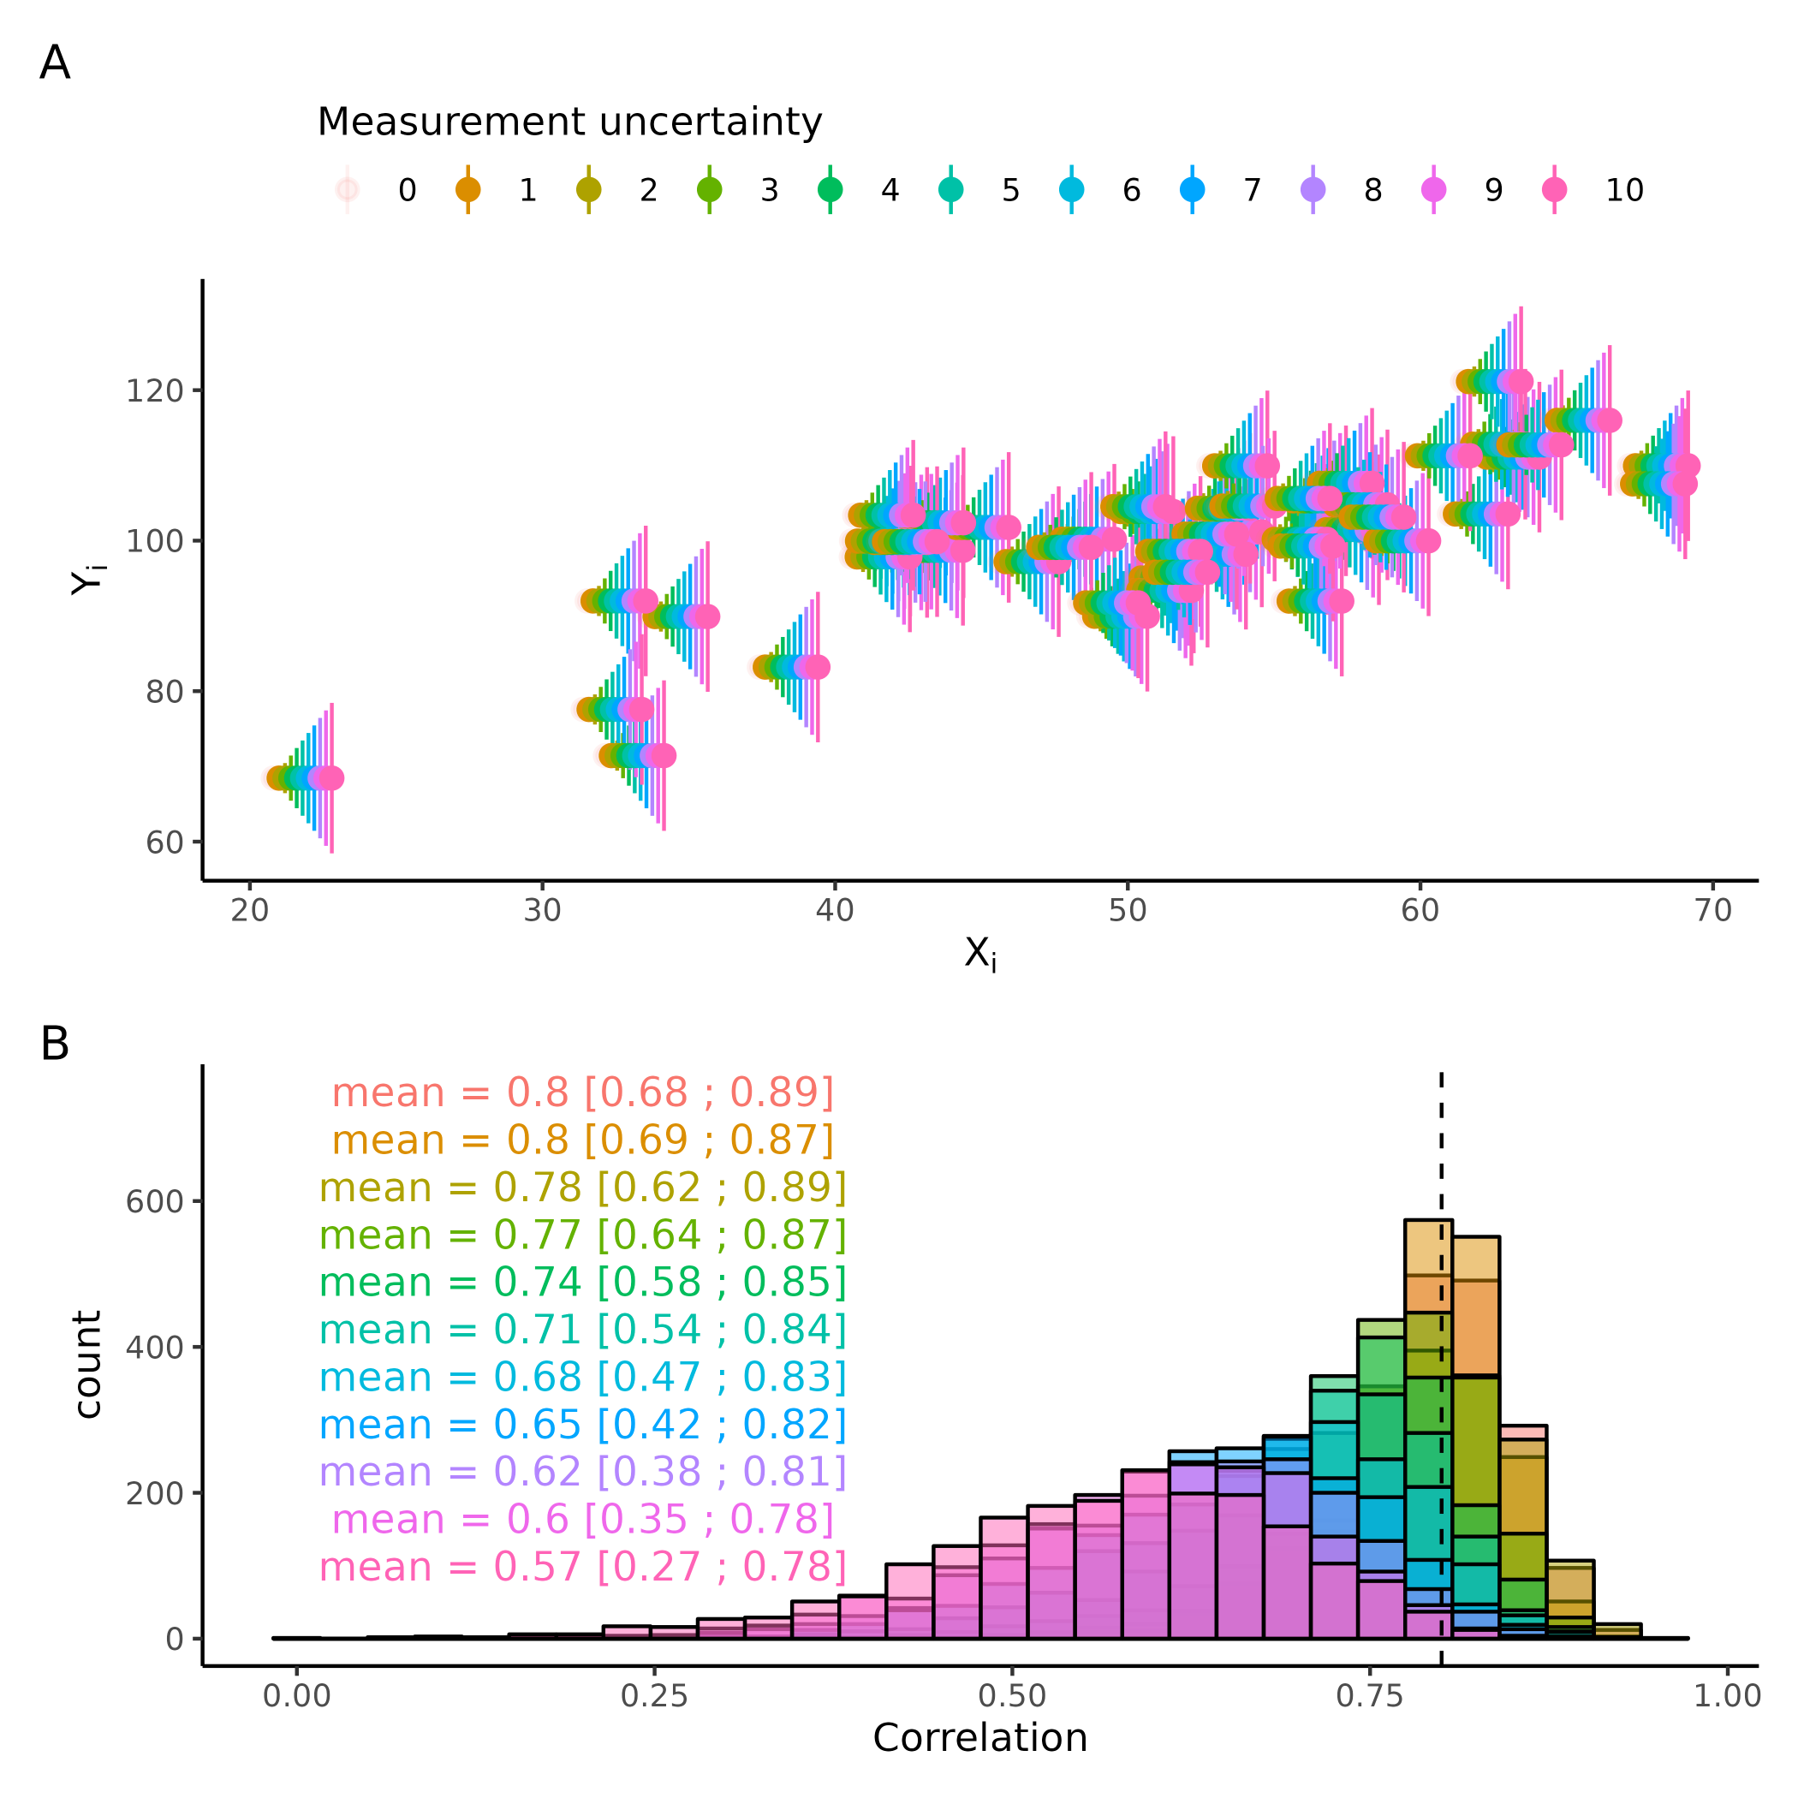

**Figure 3 Measurement uncertainty on correlation coefficient** (A) Displays a scatterplot with varying amounts of measurement uncertainty. (B) displays how the correlation coefficient distribution, obtained through bootstrapping changes with increasing measurement uncertainty. Vertical line is the simulated correlation coeficient without uncertainty.

# Modeling definitions and validation.

The rest of the thesis will revolve around refining, testing, and designing models of cognition. To do this cognitive modelling will be deployed. Here cognitive modelling is meant as an intermediate level in a hierarchy of computational models on top, and statistical models in the bottom. The distinction between these concepts can be found in their flexibility, assumptions, and scope of investigation. It should be noted that all these types of models have many things in common such as being mathematical representations of a data generating process and that these are working definitions with fuzzy boundaries (Durstewitz et al., 2016).

*Statistical models* are the models primarily used in medical, social, and educational sciences, these models mostly consist of linear and generalized linear (mixed) models. What these models have in common is that they are linear combinations of independent variables which are sometimes transformed (making them generalized) to a particular domain such that this linear combination maps to a dependent variable. The mathematical representation of such models are as follows:

$$F\left(y\right)=β·X+ϵ$$

Where y is a vector of dependent variables of N elements, F is a link function that maps the conditional mean unto a particular space, common link function are the logit and log transformations which maps unto domains of [0 ; 1] and [0 ; ∞] respectively, which makes predictions on probabilities and strictly positive values like reaction times possible. $β$ is a vector of regression coefficients of P predictors which gets estimated, X Is a matrix of independent variables of size [N, P]. Lastly $ϵ$ is a vector of N elements containing the errors of the model predictions on the dependent variables. The benefit of these statistical or regression models is that maximum likelihood estimators are available meaning that parameters estimates can be calculated using a frequentists statistical framework, making the estimation process fast and efficient. The downfall however is that they put quite big constraints on the types of models that can be fit, i.e. there must be a linear mapping between all independent variable and the dependent variable in a domain that can be mapped with a link function. This constraint will in many instances make theories hard or impossible to test as human behavior and cognition is nonlinear in different ways (Ivanova et al., 2022). It should be noted that the correlation coefficient examined in the previous section, can be thought of as a special case of this linear model where $β$ is a single value and y and x are z-transformed vectors, see supplementary figure 2.

*Cognitive models* are models that are meant to resemble the generative processes of human behavior more closely. These models are generally more theoretically driven as the constraint of linear combinations is avoided, by employing different optimization schemes that sometimes use sampling algorithms to obtain the results. In many cases cognitive models are estimated in a Bayesian framework due to the flexibility with which models can be specified. The main advantage of these models, in this context, is the added freedom in model specification, but see discussion for other advantages.

*Computational models* are the upper most level of the hierarchy which here will be used to refer to the generalization of cognitive models to other scientific domains, such as physics, biology chemistry etc. These models are outside the scope of this thesis.

These three categories are arbitrary, and many methods and models will fall between them, with this vague definition. However many times these arbitrary definitions do add value in communicating what general framework we are working in and thereby what methods are used. The next section will describe a particular cognitive model which will be the focal point for the rest of the thesis.

## *The Psychometric function.*

The thesis will explore the psychometric function (PF), as this type of function has been a stable corner stone in the cognitive science literature across many different sub fields (Bahrami et al., 2012; Coates & Chung, 2014; Courtin et al., 2023; Ma et al., 2024). The psychometric function is a continuous function that maps real inputs (here called intensity values) onto probabilities, i.e. the domain $\left[−∞;∞\right]$ with the range of $\left[0;1\right]$. In most cases the PF used is like a logistic regression in statistical modeling and is commonly used in perceptual research where the inputs are stimulus intensities, and the probabilities are then converted into binary forced choices through a Bernoulli or binomial distribution. The mapping of inputs to probabilities is usually done through a cumulative density function such as the cumulative logistic or normal distribution, which amounts to conducting a logistic or probit regression in the statistical framework. The main difference between the statistical and cognitive framework of the PF is the number of parameters. The least number of parameters used to describe the PF is 2, the threshold ($α$) and the slope ($β$).

These two parameters describe the center of the curve, with $α$ being the intensity of the stimulus at probability 0.5 (i.e. the x-value at y = 0.5) and $β$ being the steepness of the function around the threshold. In the cognitive modeling framework one or two more parameters are typically introduced the lapse ($λ$) and guess rates ($γ$). These two parameters together handle the tails (i.e. the far ends) of the psychometric function and essentially makes the probability in the two ends of the psychometric no deterministic i.e. the upper and lower bounds become ($λ$) and ($γ$) instead of 0 and 1, see figure 4. These parameters help with fitting the PF to data where attentional slips or wrong button presses happen and it can be shown that including these parameters will greatly improve the estimation of the slope of the PF if lapses and or guesses are present in the data (Wichmann & Hill, 2001). Figure 4 depicts how all these parameters change the shape of the PF. For the sake of this thesis, the cumulative normal distribution is used to map stimulus values to probabilities only with a single lapse rate. This single lapse rate will govern the distance between the upper and lower bound, essentially making it equally likely to have an erroneous response for high and low stimulus values. This mathematical formulation of the function is as follows:

$$p\left(x|α,β,λ\right)=λ+\left(1−2*λ\right)*\left(0.5+0.5*erf\left(\frac{x−α}{β*\sqrt{2}}\right)\right)$$

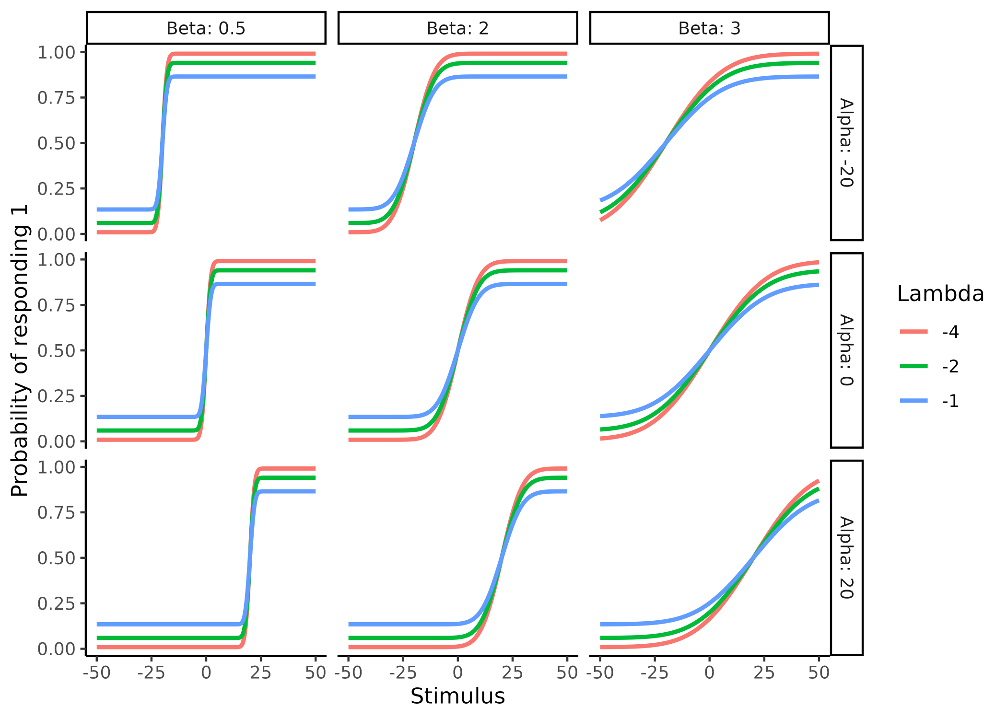

**Figure 4 Psychometric parameters.** Displays how the parameters alpha ($α$), beta ($β$) and lambda ($λ$) of the psychometric fucntion changes its shape. Columns display how the beta parameters changes the slope of the function. Rows show how alpha changes the location of the center of the function changes. Lastly, colors in the plot depict how lambda changes the asympotes in extreme stimulus (x) values.

## *Model validation.*

In the same vein of validating the bootstrapping approach with the analytical solution in the previous section about measurement uncertainty, cognitive models themselves are many times validated to ensure that at least in principle the parameters of the model can be estimated with increasing accuracy with increasing number of trials. This section will highlight some of the emerging ways in which computational models in the cognitive science literature are being tested and validated and takes offset in the seminal paper from Wilson and Collins (Wilson & Collins, 2019) describing 10 simple rules of computational modeling, which is commonly cited when validation of computational models are described (Hess et al., 2024).

There are at least three main challenges when building and validation cognitive models, which are particularly relevant when writing novel models. How do we know that our models do what we think they do (identifiability). How do we know that they accurately estimate the parameters of interest (Internal validity)? And lastly how do we know that we can distinguish between competing models (external validity). The last challenge is beyond the scope of the current thesis and is well covered elsewhere (Wilson & Collins, 2019). The answer to the first two challenges must be found in simulations, especially when our models become more and more complex and analytical solutions are sparse or non existent.

This simulation practice revolves around selecting an appropriate range of parameter values and using these to simulate data from our models and then refitting the data to then see how well the model approximates the simulated parameter values. It should therefore come as no surprise that ensuring that in these simulations, we would like our models to perform well, such that we can have faith in them when the real underlying process is unknown, i.e. analyzing real experimental data. An appropriate range of parameter values for a particular model can be difficult to select as this is exactly the problem of identifiability. However, several lines of information can help gauge this. Firstly, looking at mathematical constraints of the model formulations can reduce the possible ranges of parameter values. For the case of the PF this amounts to ensuring that the slope is strictly positive as this ensures that increasing levels of stimuli will produce greater probabilities of responding 1, but also ensure that the standard deviation of the underlying probability density function is strictly positive. The lapse rate of the PF will be constrained between 0 and 0.5 again to ensure a particular the shape of the PF. lapse rates below 0 and above 1 will produce probability values outside the [0; 1] range and values above 0.5 will flip the shape of the PF, as negative slope values will. Not constraining the PF in this way could lead to two distinct solutions to a given problem as negative slope values and lapse rates above 0.5 would be able to produce the same mathematical transformation of stimulus values to probabilities making the solution non unique. From a more theoretical level an appropriate range of parameter values can be narrowed down by looking at the function of interest and investigating whether the observed behavior (given the simulated parameter values) is physically or biologically plausible. For the PF we might expect a few of our participants to not be particularly interested in the task and therefore just respond at random, which would amount to having a high lapse rate i.e. above 0.2 (amounting to 20% lapse responses) or really shallow slopes, however this behavior is quite unlikely and expecting only few lapses in the experiment, given that it is conducted in a quiet environment is likely. Lastly using empirical knowledge from the literature at large helps narrow the parameter space further. For the sake of argument, one might investigate the detection threshold for cold stimulation on the skin. Just given this information alone we can narrow down the threshold for cold detection to being below the skin temperature of around 30-34 degrees (Courtin et al., 2023) and above the absolute zero of -273 degrees. However knowledge from the scientific literature would suggest that thresholds between 28 and 33 $​^{∘}$ would capture most of the population (Lithfous et al., 2020). These same arguments would apply for the slope. This practice of investigating the assumptions of the simulated parameter values is closely related to those of prior predictive checks when doing Bayesian inference. Prior predictive checks serve as a check of the model, without having seen any data. This check also revolves around simulating data from just the priors of the model and then investigating whether these conform with both what is physically and theoretically plausible, but also serves as a tool to investigate that the model can capture the behavior that is expected from the given experiment (Kruschke, 2021).

The next challenge is about internal validity i.e. can our model estimate the parameter values that was used to simulate the data that the model estimates the parameter values on. To test and validate our models in this regard, we simulate data from pre-specified parameter values which have been deemed to be appropriate using the first step described above. We then feed our models with this simulated data and investigate how well the model can estimate the latent simulated parameters (i.e. those that produced the data). This exercise of simulating behavior and then re-estimating the parameter values from the simulated behavior is commonly known as parameter recovery in the cognitive modeling framework. Generally if this procedure succeeds, then the parameters are said to be recovered and the satisfactory criterion often refers to some correlation coefficient between the estimated and simulated parameter values (Wilson & Collins, 2019). Parameter recovery can thus be thought of as an internal validation of a model, which if done properly should increase the faith in the parameter estimates when the model is fit to real experimental data. This is because if we had known the parameters values beforehand (i.e. simulated them) then we know that they are somewhat close to the estimated parameter values we got from fitting our model to the data. The assumption is thus; if our model recovers the parameter values well in a simulated setting then it must also do so when fitted to real experimental data where the underlying parameters are unknown. This assumption is of cause not necessarily true and rests on auxiliary assumptions such as; that the underlying generative cognitive model is the same or at least close to the same as the one used to model the data. Because the process of doing parameter recovery assumes that we know the underlying generative model, which is not the case when fitting real experimental data. To further elucidate this point, imagine using the 3 parameter PF described above; we find that it recovers its parameters well using simulated parameters from the same model. However, if we instead of simulating data from the same underlying PF, instead simulated data where the underlying cumulative distribution was the logistic, one might find that the model cannot well recover the parameters. This is of course nonsensical from the beginning, as how might our model recover parameters of another model, but many times the differences in our model space (i.e. the models that we think underlie the generative process) are similar and the parameters have similar meanings as they come from the same or similar underlying theories, meaning they can be compared as would be the case in this example. This last point of ensuring that we are selecting the right generative model is the challenge of external validity. The challenge is that infinitely many generative models exist that are also compatible with the observed behavior. This challenge cannot easily be solved as ensuring that we are using the right generative model would entail testing all generative models and being able to compare them, while ensuring that all these models are distinguishable. What is therefore commonly done in the cognitive science litterature, is to use the theoretical framework(s) to build competing models which contain different assumptions of the underlying generative process and then compare this subset of the entire model space, as these are the models that our theories deem relevant. This highlights two important aspects, firstly our models reflect our theories and are therefore at best as good as our theories and secondly, we are surely missing the real generative model in most cases. In practice what is commonly done is that models are fit to real experimental data and then compared on how well they can describe the data using statistical metrics such as information criteria or leave one out cross validation. The problem with this approach is whether we can accurately distinguish the the particular models that we are testing in principle.

This challenge has been addressed using model recovery, which is the act of simulating data from all tested models and then refitting all models to the data simulated by all individual models. Going back to the example of the PF we might have two competing theories of how stimulus values are translated into binary choices, one involving the lapse rate and one without, further we want to ensure that we can distinguish between the normal and logistic cumulative distributions which transform stimulus values into probabilities in different fashions. In this practical example the model space consists of 4 models i.e. two or three parameters for each of the two types of PFs. One would therefore simulate data from these 4 distinct models and fit them all individually to each of the 4 simulated data-sets and lastly determine which of the 4 models describe the data the best in each case. The result of such model recovery is a N times N matrix with N being the number of models, the rows being which model was used for the simulation and columns being which model was used to fit the data. The entries of the matrix are commonly depicted as the probability of choosing a particular model given the data simulating model. An identity matrix therefore represents that the models are completely distinguishable and anything else would indicate that in some of the simulations the best fitting model was not the model that simulated the data (Wilson & Collins, 2019).

## *Limitations of current internal model validation steps*

The model validation steps above should ideally serve to increase our faith in our models, their parameters, and the comparison between them. However, some of the metrics used to access these different types of validations are flawed. Firstly, the metrics used can be easily manipulated (faithfully or not) to show good model validation when masking the actual poor or terrible validation. This problem can thus introduce false faith in the model and overconfidence in the inference made based on it. Next and perhaps more importantly the metrics used are not sensitive or specific enough to give the person building the model, information about how and were in the model space the models perform well, thereby leaving valuable insights hidden. In this section I will highlight the metrics commonly used in the literature for model validation which are described in Wilson & Collins (2019), focusing one of the challenges described above; internal validity or parameter recovery. As mentioned above internal recoverability or validity of computational models are accessed by simulating data from a model given a set of parameters. This behavioral data is then fitted to the model which then optimizes for the parameters, given the data. What is commonly done is then estimating the correlation coefficient between the estimated and simulated parameters. In their seminal paper Wilson & Collins (2019) describes that in a perfect world the estimated and simulated parameters should be tightly correlated without any bias, and that a weak correlation could mean bugs in the code or an under powered study i.e. few trials. They also reiterate that plotting simulated vs estimated parameters in a scatter plot should be done to access if ranges of parameter values are problematic and whether there might be biases. I will here argue that the correlation coefficient is an inappropriate metric and that a version of an intra class correlation (ICC) is better suited for the task. Acknowledging two important things; neither metric is perfect, and visually inspecting the simulated vs estimated parameter scatterplot is crucial. The importance in using the right metric is therefore as a precautionary step given that some literatures are starting to just report correlation coefficients without this crucial scatter plot, which arguably in some cases would make the correlation coefficient meaningless, see problems with the correlation coefficient below. These precautionary steps are crucial to enforce, in the development stages of new statistical, cognitive or computational models as they will serve as the basis of model validation and if not sensitive or specific enough many resources might be used in using a model that in reality cannot be properly identified. This would therefore serve as a roadblock for scientific progress as years might pass before it is realized that the model used in the field is cannot behave properly even in simulated settings.

## *Current problems with internal recoverability of models (parameter recovery)*

The first and perhaps biggest problem of internal validation of computational models, is that it is not universally done, which makes it hard or even impossible to know if the generative model in question can be trusted. The second, almost ubiquitous problem in the literature using parameter recovery is that interactions between parameters are either neglected or disregarded. This is less of a concern for individuals using an established cognitive models wanting to ensure that given their experimental design and ranges of parameters are sensible, but a big concern in highly cited method papers describing and formalizing the models themselves. A prime example of this is the Hierarchical Gaussian filter paper (C. Mathys et al., 2011 ; C. D. Mathys et al., 2014). Where after having laid out the equations of the model, two of the most crucial parameters of the model are held constant when performing parameter recovery. Even in much more simple models such as with the PF described above, I will show that there are tradeoffs and interchangeability between parameters. The last problem with parameter recovery is the metric used to access it. As has been suggested elsewhere, the correlational approach is at best insufficient and at worst misleading (Schurr et al., 2024). The three most obvious problems with using correlation coefficients to examine internal validity is as follows;

Correlation coefficients are invariant to linear transformations, making two sets of variables i.e. [1,2,3] and [1,2,3] have the same correlation after transforming one of the sets with linear transformation. Say the we use the transformation, $f\left(x\right)=2⋅x+3$, resulting in the sets [1,2,3] and [5,7,9] this set will have the same correlation coefficient, but in terms of model validation would be very different. This in variance to linear transformations does not make sense for parameter recovery as we want a metric that penalizes this behavior.

The domain of correlations is [-1; 1]. This directionality also does not make sense given that a correlation coefficient of -1 would mean perfect parameter recovery, with a negative sign, meaning that you do recover the value (or the linear transformed value) just not the sign. Ideally, we would want a metric that goes from no recovery to perfect recovery, and not from perfect recovery without the sign to perfect recovery with the sign.

Lastly, the interpretation of the correlation coefficient in terms of parameter recovery is difficult. What is a sufficiently large correlation coefficient for the parameter such that it can be said to be recovered and what types of uncertainty is causing the correlation to be less than ideal? Authors have tried to make such distinction without much traction (White et al., 2018). All these issues are similar to what researchers have faced when wanting to estimate the stability and or test -retest reliability of different metrics over time, where the solution has been to use the ICC as the metric instead of simple correlation coefficients (Schurr et al., 2024).

## *ICC Parameter recovery*

Given that the idea of using the ICC as a metric for parameter recovery is relatively new and has only been suggested and not implemented anywhere in the literature (Schurr et al., 2024) I will here outline what the ICC is and how it can overcome some of the shortcomings of the correlation coefficient in model validity. The ICC is in its simplest form a ratio of irreducible variances (uncertainties) to the total variance in the data. In practical terms revolving around a cognitive science experiment the irreducible uncertainty is the uncertainty between subjects, whereas the total uncertainty can have several parts. In order to calculate the ICC, these variances needs to be estimated such that their ratio can be computed. The estimation of the variances can be done using a model that can properly account for these different types of variance and the typical approach are hierarchical models, where known structure of the data is added to the model. Taking the introductory example, of a researcher doing a test-retest reliability study on the parameters of now a generalized linear model investigating anxiety and binary responses. His subjects are coming in for x sessions and doing the same task each time. We will now assume that all subjects come from the same underlying distribution of say humans (i.e. the population), this is the highest level in the hierarchy and is governed by a population mean and a population variance, i.e. the between subject variance. The next level in the hierarchy is the subject level, here each subject has their own means and variances (within subject variances), their means are drawn from the population level distribution. Now for each session that the subject is in, a parameter value is drawn from this subject level distribution which then governs the participants’ behavioral responses. This nested hierarchical structure is demonstrated in figure 5, where each of the levels are governed by the levels above and each of the levels has a variance associated with it. Where the between subject variance is the variance of the population level distribution and the within subject variance is the variance of each of the participant level distributions. The ICC as mentioned above is the ratio between this within and between subject variances, see equation below:

$$ICC=\frac{σ_{between}^{2}}{σ_{between}^{2}+σ_{within}^{2}}$$

Where $σ_{between}^{2}$ is the variance between the subjects’ parameter estimates and $σ_{within}^{2}$ is the within subject variance. Given that we are interested in the performance of the model we can simulate agents that have no within subject variance i.e. the same true parameter values for each session and then see how the number of subjects and or trials of the cognitive task will influence the model’s ability to pick up on this association. This approach has one clear problem it does not necessarily tell us something about how well the model estimates the true parameter values for each participant at each session, as it just looks at how close each parameter is to itself between sessions. To capture this, one might use the mean squared errors (MSE) between the simulated and estimated parameter values, which serves as a residual error of the model. Including this into the ICC formulation is easy, as this is just another source of variance which can be added into the denominator, highlighting the fact that the ICC is a partitioning of variance in the model. This partitioning of variance is exactly what we are interested in when building and validating models, as this tells us where the model fails and where it might excel. In figure 5 this amounts to taking the difference between the estimated parameter value (distribution) of a particular subject at a particular session and the simulated value. Formally we add the MSE into the equation and get:

$$ICC=\frac{σ_{between}^{2}}{σ_{between}^{2}+σ_{within}^{2}+σ_{ϵ}^{2}}$$

Where $σ_{ϵ}^{2}$ is the MSE. This conceptualization allows us to put parameter recovery for a model into a single value for each parameter that ranges from 0 to 1 which is going to be trial and subject level dependent, but also dependent on the simulated ranges of parameter values like the correlation coefficient.

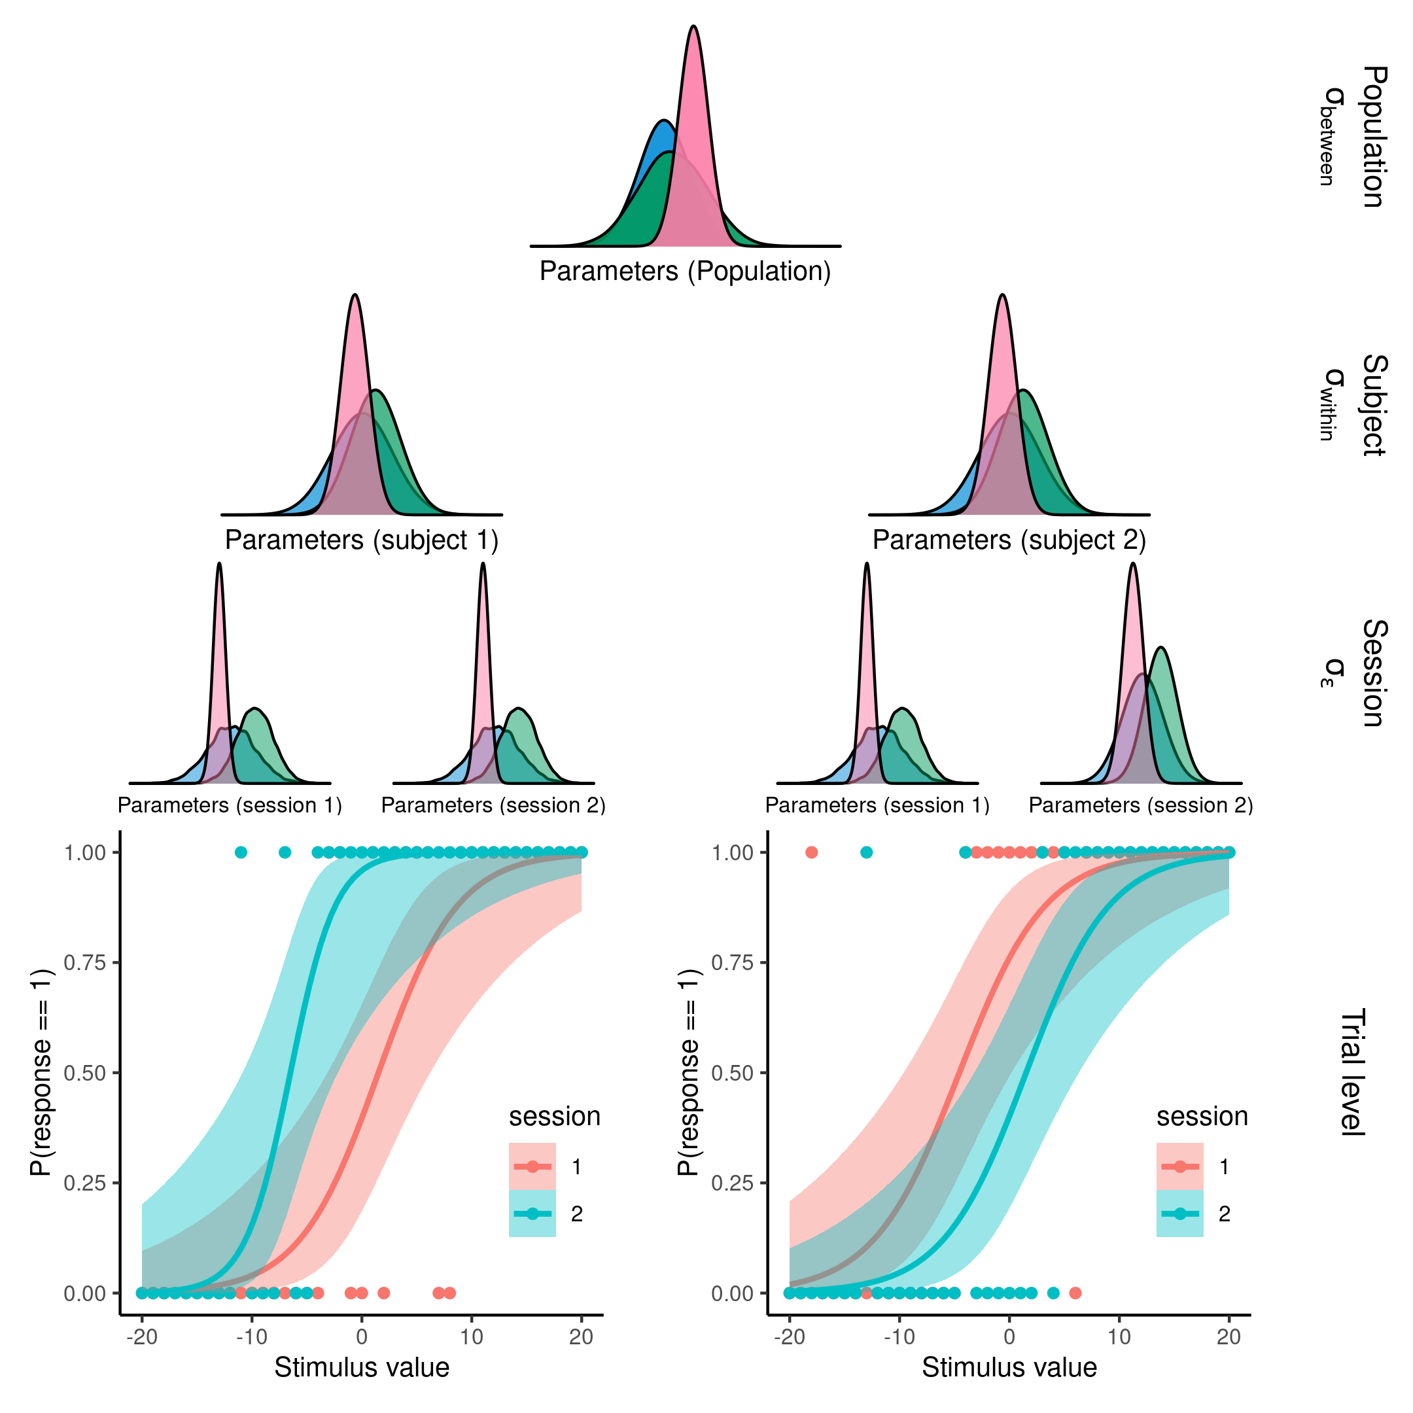

**Figure 5. Visualization of a nested hierarchical model with sessions nested in subjects in a population.** Displaying from the top down how the nested hierarchical model assumes structure of the underlying data. From the model’s perspective data (points in the bottom plot) is entered at the lowest level where the cognitive or statistical model is fitted. The parameters of this model is drawn from a session distribution which is nested within a subject distribution which again is nested in a population distribution. This nesting of the parameters of the model allows for seamless estimation of the partitioning of variance within the model. For the sake of parameter recovery within subject variance is simulated to be 0, and the mean squared difference between the session level distribution and the simulated parameter value is calculated and put into the denominator of the ICC metric.

Figure 5 displays the conceptualization of the ICC with the added MSE. Parameters flow from the population level distribution to the subject level distribtuion and into the session level distributions which then forms the cognitive model on the data at the trial level. Figure 5 displays this as a psychometric function for two sessions. The idea of parameter recovery using this framework, is therefore to access the degree to which the whole model can distinguish between the types of variation (uncertainty). What will be shown below is that within subject variance can be simulated to be 0 and the MSE can be calculated as the difference between the session level parameter estimates and the simulated parameter values. This therefore means that in the simulated setting the ICC displayed in the above equation is 1, i.e. the only source of variation is between subjects, but that the model itself might ascribe some of this variation to either within subjects or session variation in the parameter estimates.

## *Standard parameter recovery.*

The model and task used to demonstrate and investigate parameter recovery in this thesis is the 3 parameter PF described in the section “The Psychometric function”, which is widely used in the cognitive science literature from perception to decision making (Courtin et al., 2023; Gold & Ding, 2013). After having specified the model, we can simulate data from different ranges of parameters to select an appropriate range of parameter values. Parameter ranges are selected and simulated in accordance to table 1 and figure 6. Using the probabilistic programming language Stan and its interface with R, Rstan (Gabry et al., 2024), it is possible to invert the model from the data to obtain estimates of the latent parameters which were used to simulate the data in the first place. Note that for all models displayed and estimated their convergence was accessed by ensuring rhat values were below 1.03 and that no divergent transitions were present. Ideally all chains would have been inspected, but given the vast simulation approach presented throughout the thesis, visual inspection of each model was infeasiable and summary diagnotistic were used. Furthermore all priors for all models presented were weakly informed, meaning that most of the prior distributions were set as normal distributions with means of 0 and standard deviations of 3-5 in the unconstrained space. Readers are referred to to the supplementary material or the github for a list of all the priors used.

Table 1: parameter distributions. Parameter distributions for the simulated agents and the transformations for each of the parameters.

| Parameter | Mean | Sd | Transformation |
| --- | --- | --- | --- |
| Alpha | 0 | 10.0 | x |
| Beta | 2 | 0.6 | Log(x) |
| Lapse | -4 | 2.0 | Logit^-1(x) / 2 |

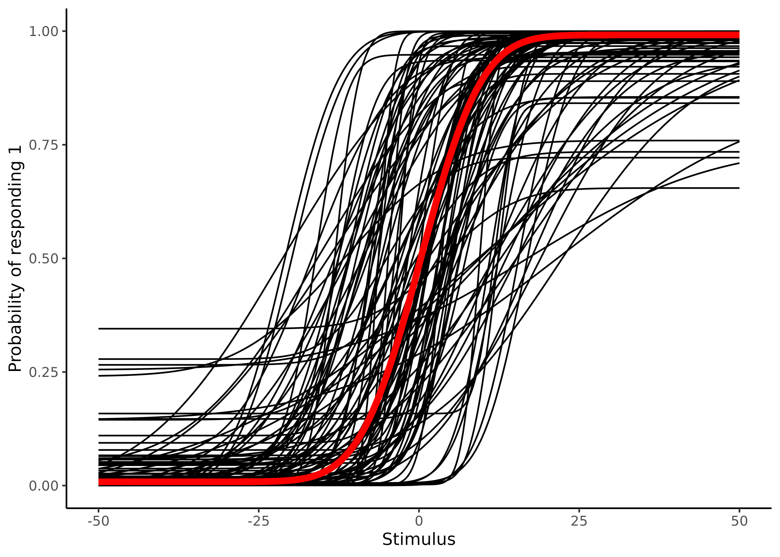

**Figure 6. Displaying 100 samples of the parameters of the psychometric function from table 1.** Visualization of the implications of the simulated parameters of table 1. Black lines depicting individual subjects, while the red line depicts the group mean.

For the sake of argument, the pairwise scatter plot of estimated vs simulated parameter values are depicted in figure 7 with the added estimation uncertainty. This particular simulation is done for 100 subjects over 100 trials where each of the stimulus values were selected as a sequence from -50 to 50 in increments of 1. Figure 7 also displays how adding the estimation uncertainty (of the parameters) to the correlation coefficient changes the resulting size and uncertainty estimate of the correlation coefficient (i.e. its estimation uncertainty). This addition of the estimation uncertainty again highlights how deceptive these estimates can be if uncertainty is not properly propagated as they are all inflated. This inflation is however not necessarily always the case, as if a couple of points fall way off the identity line with high uncertainties, they will have less weight when accessed with uncertainty compared to without, meaning that adding estimation uncertainty could in principle also increase the correlation coefficient and decrease its estimation uncertainty, highlighting the non trivial and non linear link when uncertainties from fitted models are added.

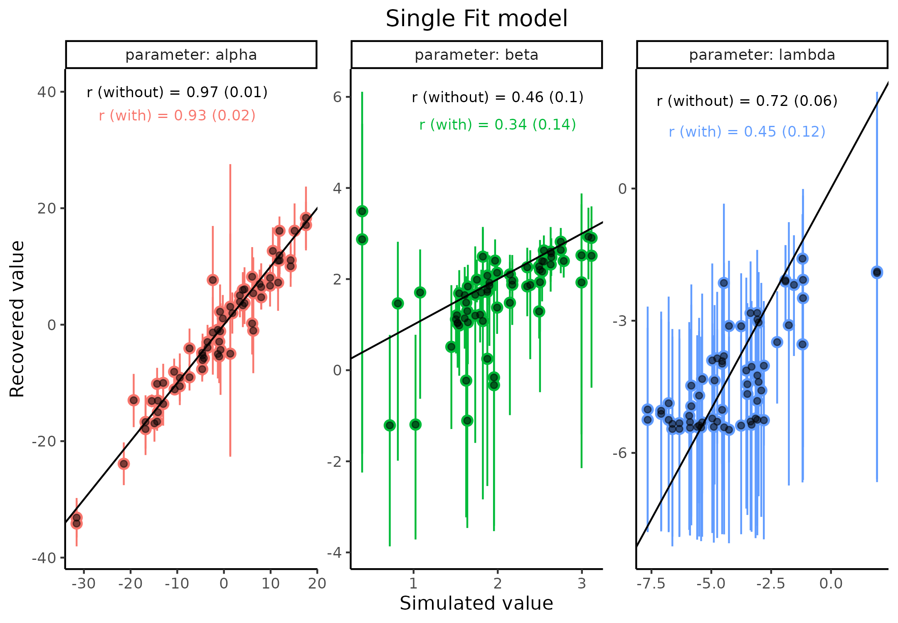

**Figure 7. Parameter recovery for the three parameters of the psychometric function in the unconstrained space.** Scatter plot of Simulated vs recovered parameter values, with error bars displaying the 95 % highest density interval for that parameter on that simulation. Text on each facet shows the estimated correlation coefficient with its standard error (estimation uncertainty) with and without accounting for estimation uncertainty in the individual estimates.

Next the purposed ICC metric is tested on the same data set as above, crucially the data set above was simulated using only 50 simulations that were duplicated, making it eligible to compare the above standard parameter recovery with the ICC. This simulation therefore implies that there is no within subject variation, as the first 50 data-sets were duplicated. One particular difference between the above single fit models presented and the proposed model depicted in figure 5 is the hierarchical structure embedded in the model. The hierarchical structure of the model serves to shrink parameter estimates in relation to their distance and uncertainty from the mean of the higher level dsitribution which they are drawn from, which in the end has been shown to improve predictive capacity. Hierarchical models are becoming corner stones in most cognitive science experiments (Bates et al., 2015; Boekel, 2021; Gomes, 2022).

Therefore to fairly test and compare the two internal validity metrics, the correlation coefficient and the ICC, each of the metrics were calculated from this hierarchical model. the Two ICC values were calculated as above now referred to as $ICC_{1}$ and $ICC_{2}$, referring to not including MSE and including it.

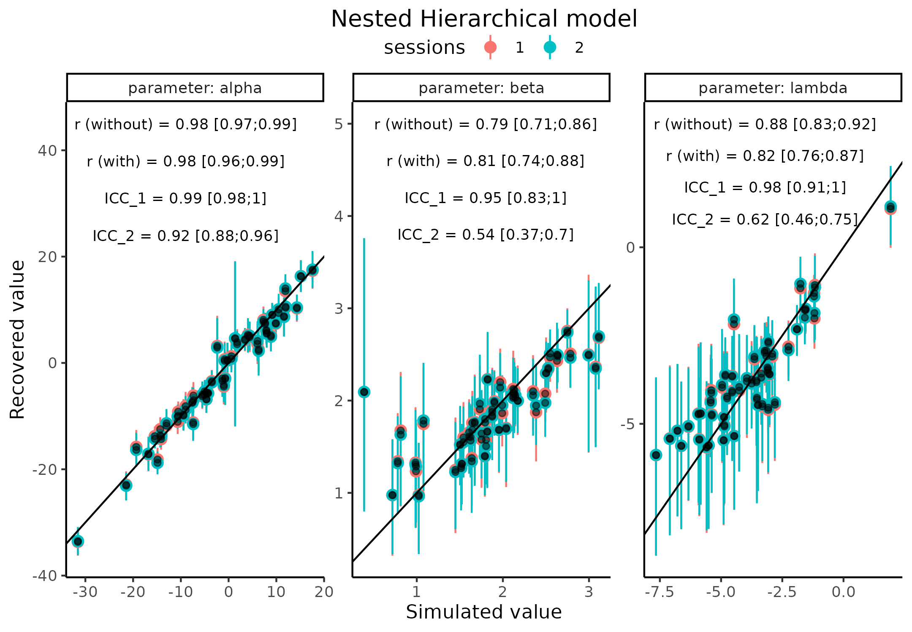

**Figure 8. Parameter recovery for the three parameters of the psychometric function in the unconstrained space, using the hierarchical model.** Scatter plot of Simulated vs recovered parameter values, with error bars displaying the 95 % highest density interval for that parameter on that simulation. Text on each facet shows four metrics of internal model validity, correlation coefficient without and with accounting for estimation uncertainty, and the purposed ICC metric without and with including the mean sqaured error.

As can be seen in figure 8, the hierarchical fit does improve the parameter recovery, both from a visual inspection (points falling closer to the identity line with less estimation uncertainty) and by comparing the correlation estimates between figure 7 and 8. This finding helps to explain why hierarchical models in general are preferred to single fit models as the partial pooling improves estimation of the parameters (Bates et al., 2015; Boekel, 2021; Gomes, 2022). This is highlighted in figure 9 where estimation uncertainty, here the 95% credibility interval, of each parameter at each session is plotted as histograms for each parameter (facet) and colored by the type of fit, generally showing higher uncertainties in the single fit model compared to the hierarchical model. It should here be noted that a single simulation like this would not be enough to ensure that the parameters are nicely recovered as a good example of this is the lambda parameter. The pairwise scatter plot of the nested hierarchical model seems to suggest that this parameter is quite well recovered. However, if we back calculate a lambda value of -5 (on the unconstrained scale as depicted in figure 7 and 8) that would corresponds to a lapse rate of around 1.3%, which should be difficult if not impossible to accurately estimate when there are 100 trials for each subject, as most subjects would have very few, if any lapses. See supplementary note 2 for a deeper explanation on this. Turning the attention to the ICC values, it is observed that $ICC_{1}$ on each of the 3 parameters has an upper bound at the maximum value of one, which is confirmed looked at the scatter plot. This can be seen as all the session one estimates are hidden behind the session two estimates with only a few estimates deviating slightly. The $ICC_{2}$ estimate is crucially the lowest for all three parameters. Visual inspection of the pairwise scatter plot makes this clear as this metric is penalized for both the degree to which the points fall away from the identity line but also by the estimation uncertainty associated with these points. This therefore also explains why the alpha parameter is close to being asymptotic at 1, but with a little to be desired for simulated values between 0 and 10.

In the next section it will be shown how these metrics, especially the $ICC_{2}$, is influenced by different factors and that by reducing estimation uncertainty it is possible to increase these. Four different different strategies will be introduced, adaptive optimization design, increasing the number of trials, assuming different mean group level slope values and lastly jointly modeling the binary responses with response times.

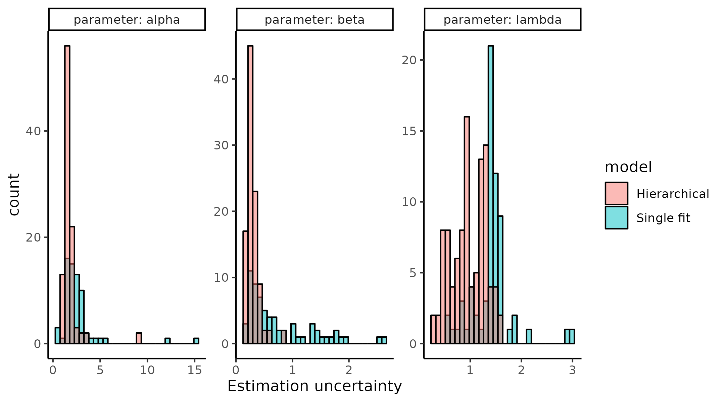

**Figure 9 Estimation uncertainty for each parameter for both single and hierarchical fit models** Each panel represents one of the three parameters of the psychometric function with the estimated uncertainty (95% credibility interval) depicted as histograms. The color of the histogram shows whether the model was fit using the single fit or hierarchical model.

# Uncertainty minimization

## *Adaptive design optimization*

An import consideration of the parameter recovery described above, is what the design of the experiment that the agent goes through. Looking back at figure 6 providing stimulus values in the far ends of the psychometric functions i.e. in the ranges of [-50 ; -25] and [25 ; 50] will in most cases, for most agents, give next to no information on the shape of the psychometric and therefore the parameters we mostly care about i.e. the threshold and slope, see supplementary note 2 for the lapse rate. On average the agents’ psychometric functions are monotonically increasing in the interval of [-25 ; 25]. Therefore, selecting stimuli (inputs) in this interval must be better for decreasing the estimation uncertainty in the two parameters that are most often interpreted, compared to randomly or uniformly exploring the input space. one might even go a step further and instead of selecting inputs that are more appropriate for the mean of the population, one could individualize each experiment to the participant. This practice of individualizing the experiment of interest is called adaptive design optimization (ADO) and revolves around selecting inputs that are optimal given a specific criterion (Prins, 2013; Watson, 2017). Many of these criterion exists such as minimizing entropy, minimizing the posterior variance or mutual information, but what they all have in common is that they decrease estimation uncertainty of either all or certain parameters to a meaningful degree. One of the main challenges of utilizing ADO is that because the experiment is updated and individualized on a trial by trial basis the algorithm determining the stimuli must run in tandem with the experiment. This puts high constraints on computation time of the algorithm. This particular issue has partly been solved in the existing packages by calculating a grid of a particular resolution of parameter values at at a trial and then using the optimization stategy to find the next optimal stimulus value. This clever solution puts the heavy computation time before the experiment and ensures that when the experiment is run only a single look up is needed to provide the next stimulus value on each trial. This approach works great for psychophysical experiments or other experiments where each trial is independent of the next. This is because only a single optimization step is required for each trial, whereas if trials were mutually dependent as in a learning experiment, then the algorithm would need to calculate all possible lines of stimuli and responses until a certain point which given the combinatorics can become a daunting task.

In order to keep coherence with the rest of the thesis, I will demonstrate how leveraging the single-fit model designed for conducting the single-subject parameter recovery can used together with the understanding of informative stimulus values described above to make a custom ADO algorithm. The advantages of being able to write such a custom algorithm is two-fold. Firstly, as long as the model can be written to invert observed data to parameter values (i.e. fit a model to data), then it can also be used to simulate stimulus values, this therefore increases the flexibility in model selection. Secondly, as this approach is not optimial for stimulus selection the method can even be extended to mutually dependent experiments. Illustrating this approach can be done by using variational inference algorithms that can quickly estimate an approximate posterior distribution of the parameters of interest, in this particular thesis the pathfinder algorithms implemented in Rstan is used (Zhang et al., 2022). The rationale behind this approach to ADO is to iteratively fit the model as responses from the participant is collected, the parameter estimates of the model is then updated and a new stimulus value is then selected based on these estimates and the knowledge of which stimulus values are the most informative for particular parameter values. For a full description of how the pathfinder algorithm was implemented, see supplementary note 3.

Figure 10 shows how the posterior distribution of the 3 parameters of the PF varies as a function of trials in both the previously used uniform selection of stimulus values and the implemented pathfinder approach. As can be seen both approaches makes the parameters converge towards the real simulated values (black line), however the speed at which this happens is different, especially for the two parameters that the pathfinder algorithm is optimizing for i.e. $α$  and $β$. For these two parameters after just 20 trials using the pathfinder optimization has found the simulated parameter value and decreased the estimation uncertainty (95% credbility interval), whereas even after 50 trials the uniform approach still has a bit of a bias in the estimation, the individual points are not on the black line, but also a substantial estimation uncertainty associated with it. For completeness a PSI-algorithm was also used, in order to compare the feasibility of this new approach due to the high constraint on computation time of the algorithm (Kontsevich & Tyler, 1999). Interestingly the pathfinder algorithm ran in 14 seconds for the 50 trials whereas the PSI algorithm ran in 30 seconds. This highlights the feasibility of this approach as experimental designs have to be able to run relatively quickly, in order to keep the attention of the subject (Kwon et al., 2023).

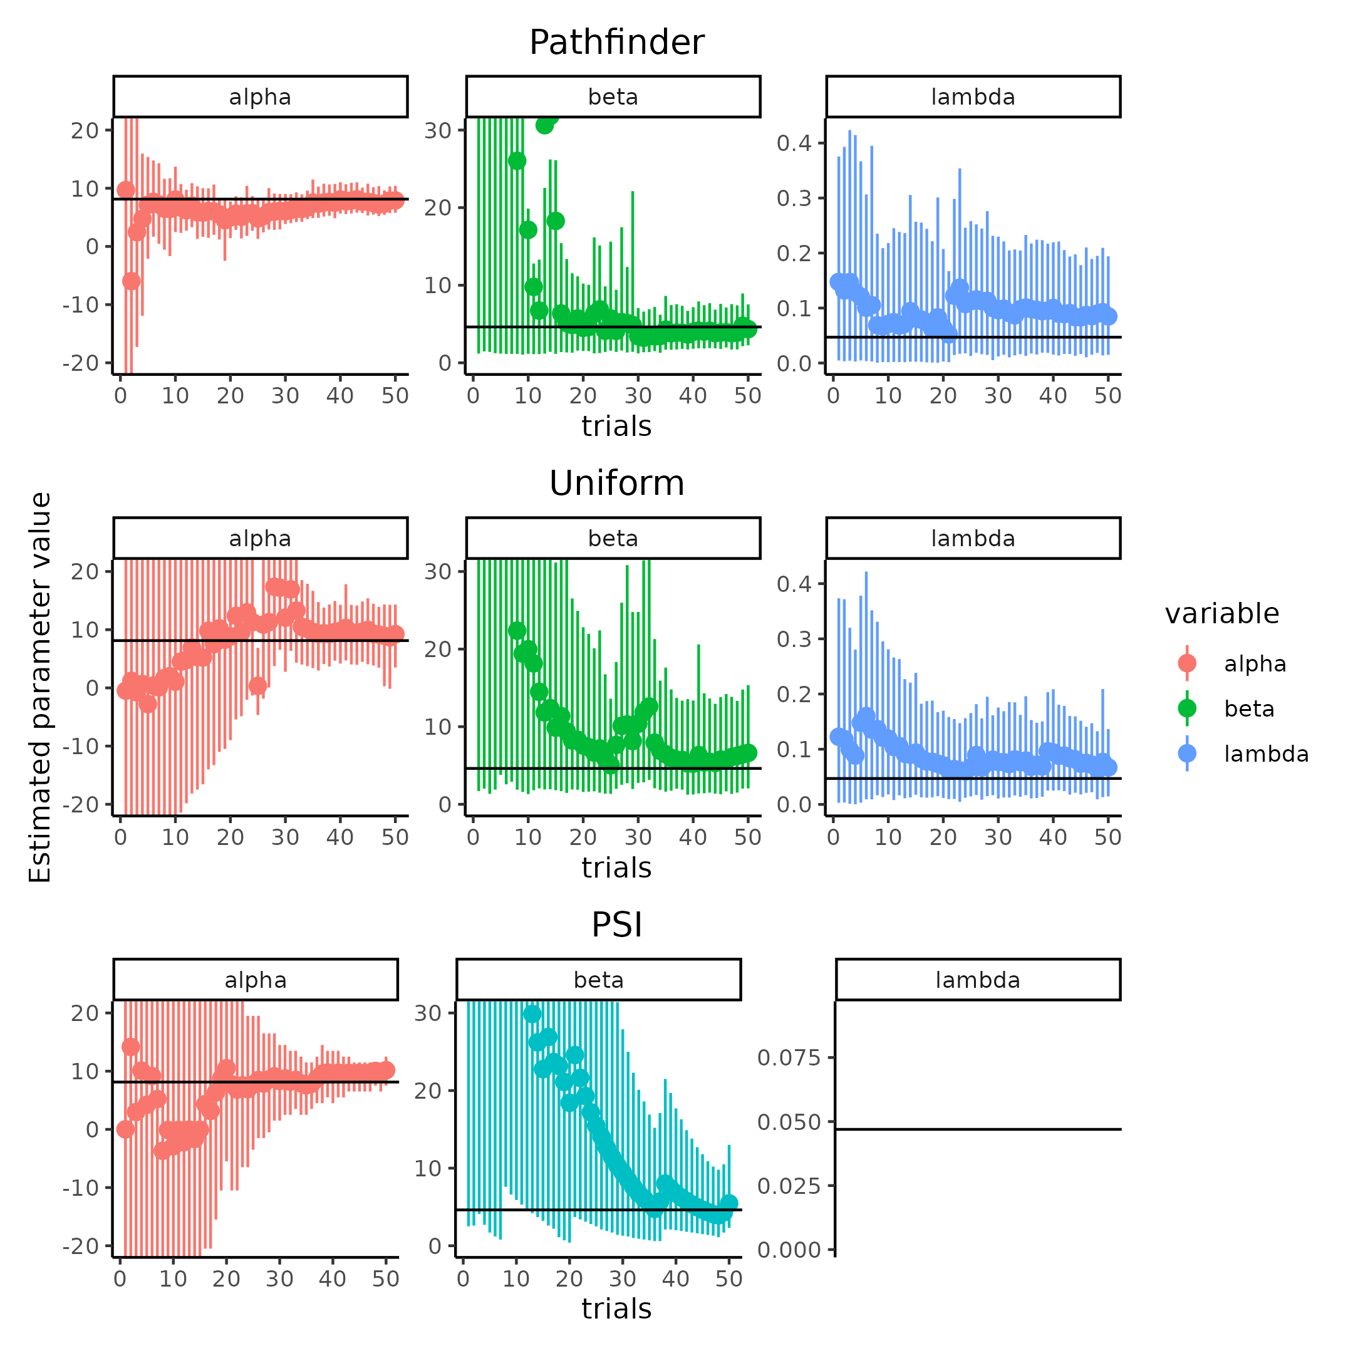

**Figure 10 comparison of algorithms to obtain stimulus values of the psychometric function**

To more formally show the differences in these ways of selecting stimulus values across a range of trial numbers, the Pathfinder, Uniform and PSI algorithms were run 100 times for trials ranging from 20 to 100 in a sequence of 10 trials (using the same range of parameter values as depicted in table 1). In order to make the comparison as fair as possible each of the algorithms were only used to generate the stimulus sequence, meaning that all data-sets were refitted using the same single fit Bayesian model for the final estimate that was compared to the simulated value, the same model used for conducting the single subject parameter recovery. For complete details on the fitting and optimization strategy see supplementary material note 3 and 4, as well as prior initialization for PSI and Pathfinder. Figure 11 shows the results of this simulation with the top panel showing the bias, i.e. the difference between the estimated and simulated parameter values and the bottom panel the uncertainty in the estimated parameter value. Interestingly, overall the PSI-ADO performs the worst both in terms of bias in the slope (Beta) and lapse rate (Lambda) parameter but especially in the estimation uncertainty for all parameters. The main difference between the uniform and Pathfinder approach seem to be in the estimation uncertainty and especially in the threshold (alpha).

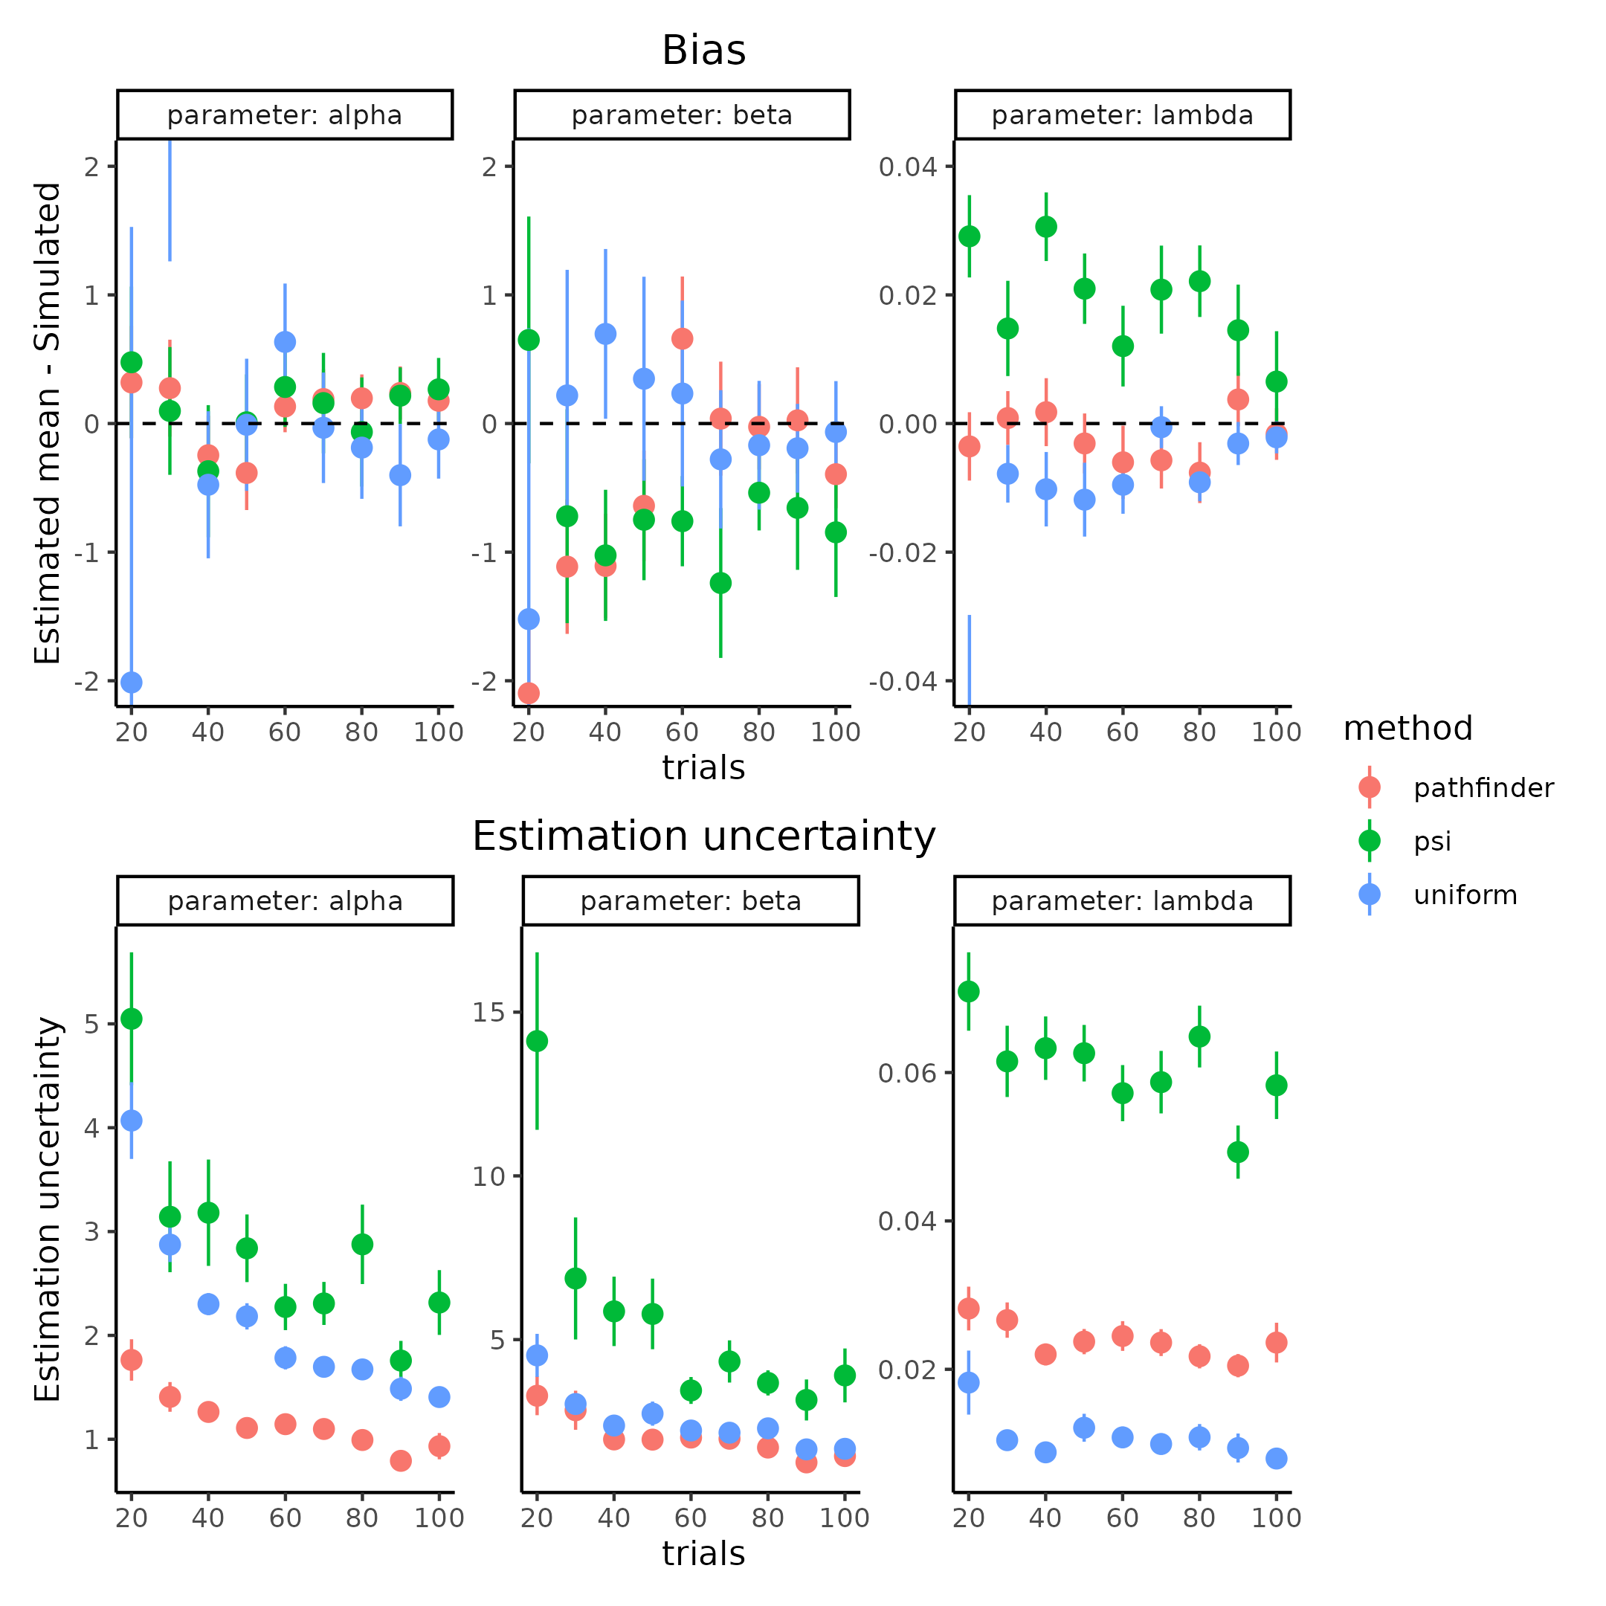

**Figure 11.** shows how the estimation uncertainty and bias changes according to the number of trials and parameter value estimated with the different methods.

Having tested and compared the pathfinder algorithm, it is now possible to examine three other focal points of minimizing estimation uncertainty in the parameter values, i.e. subjects, trials and the influence on the mean simulated slope value. The last point is less obvious than the two others but stems from the fact that increasing the slope (decreasing the steepness) of the PF will make it harder to estimate all the parameters of the function i.e. the estimation uncertainty is increased if other factors are held constant, the reason for this will become clear below. The number of subjects might also influence estimation uncertainty as the partial pooling effect of the hierarchical model will be stronger with more subjects. For this purpose of investigating these three focal points, trials ranging from 20 to 200 in increments of 20, subjects being between 10, 30 and 50 and lastly mean slope values of 1,2 and 3 in the unconstrained space are simulated, with all other parameter values being identical to table 1. To guard against simulations that are not representative due to either bad convergences in the ADO or in the fitting procedure, each combination was run 5 times. Figure 12 displays the result of this parameter recovery across trials and group mean slope levels (i.e. simulated beta values). Figure 12 only displays the correlation approach with inclusion of estimation uncertainty in the upper panel and the developed $ICC_{2}$ in the lower panel, for the two other metrics i.e. the correlation approach without estimation uncertainty and the $ICC_{1}$ see supplementary figure 3. Due to the limited influence of subjects these have been aggregated, Supplementary figure 4 and 5 displays the individual subject simulations separately.

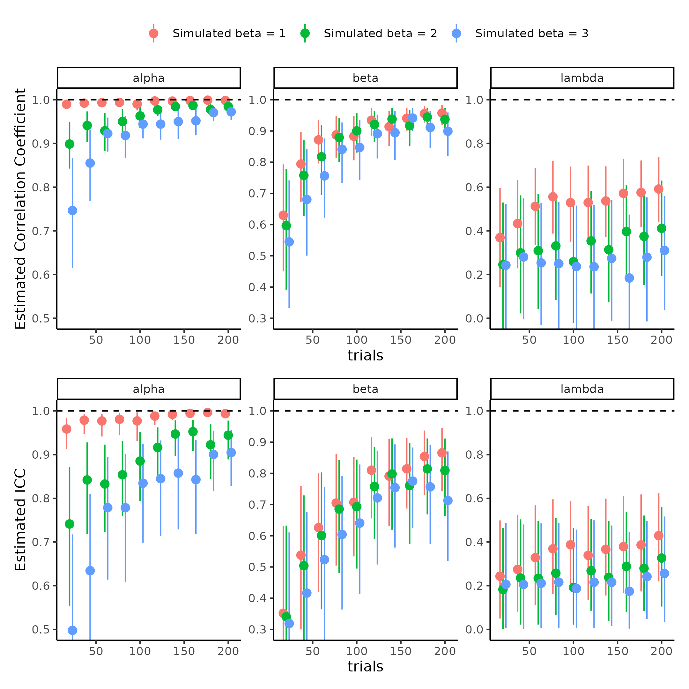

**Figure 12 comparison of parameter recovery metrics.** First row depicts how the estimate of the correlation coefficent between simulated and estimated means change as a function of trials (x-axis) and the simulated mean slope (color) for each parameter of the psychometric function (columns). The bottom row shows how the estimate of $ICC_{2}$ changes based on the same metrics as the correlation coefficient. Note that the correlation coeffecient has been uncertainty propergated using bootstrapping.

From Figure 12, the main differences between the two approaches is that the ICC metric is generally lower than the correlation approach, but both asymptotically move towards one with increasing trials and or simulated mean slopes of the psychometric function. One way to highlight the difference and the meaning of these difference is to plot the pairwise scatter plot of simulated vs recovered parameter estimates. These pairwise scatter plots are what both metrics in Figure 12 attempt to describe. Picking the instances where the difference between the correlation and ICC approach is the greatest will give insight to which metric might be more suitable. Figure 13 therefore shows the pairwise scatter plot of the threshold in three selected trials (40, 120 and 200) for both steep and shallow slopes (means of 1 and 3 respectively for beta). These instances were chosen because the estimate of the correlation and ICC were similar for the steep slopes but remarkably different with shallower slopes of the psychometric function. Figure 13 clearly shows why there is such a difference between the two approaches, the ICC metric is penalized much more by the increased estimation uncertainty in the threshold of shallower slopes than the correlation coefficient together with the deviation from the identity line. These observation indicates that the ICC metric is much more sensitive to the uncertainty of which it is calculated compared to the correlation approach. The same reasons apply for the difference in the slope estimate itself and pairwise scatter plots can be found in supplementary figure 6. Lastly both approaches suggest that the lapse rate is below the two other metrics without much improvement with increasing trials, but still with the ICC being more conservative.

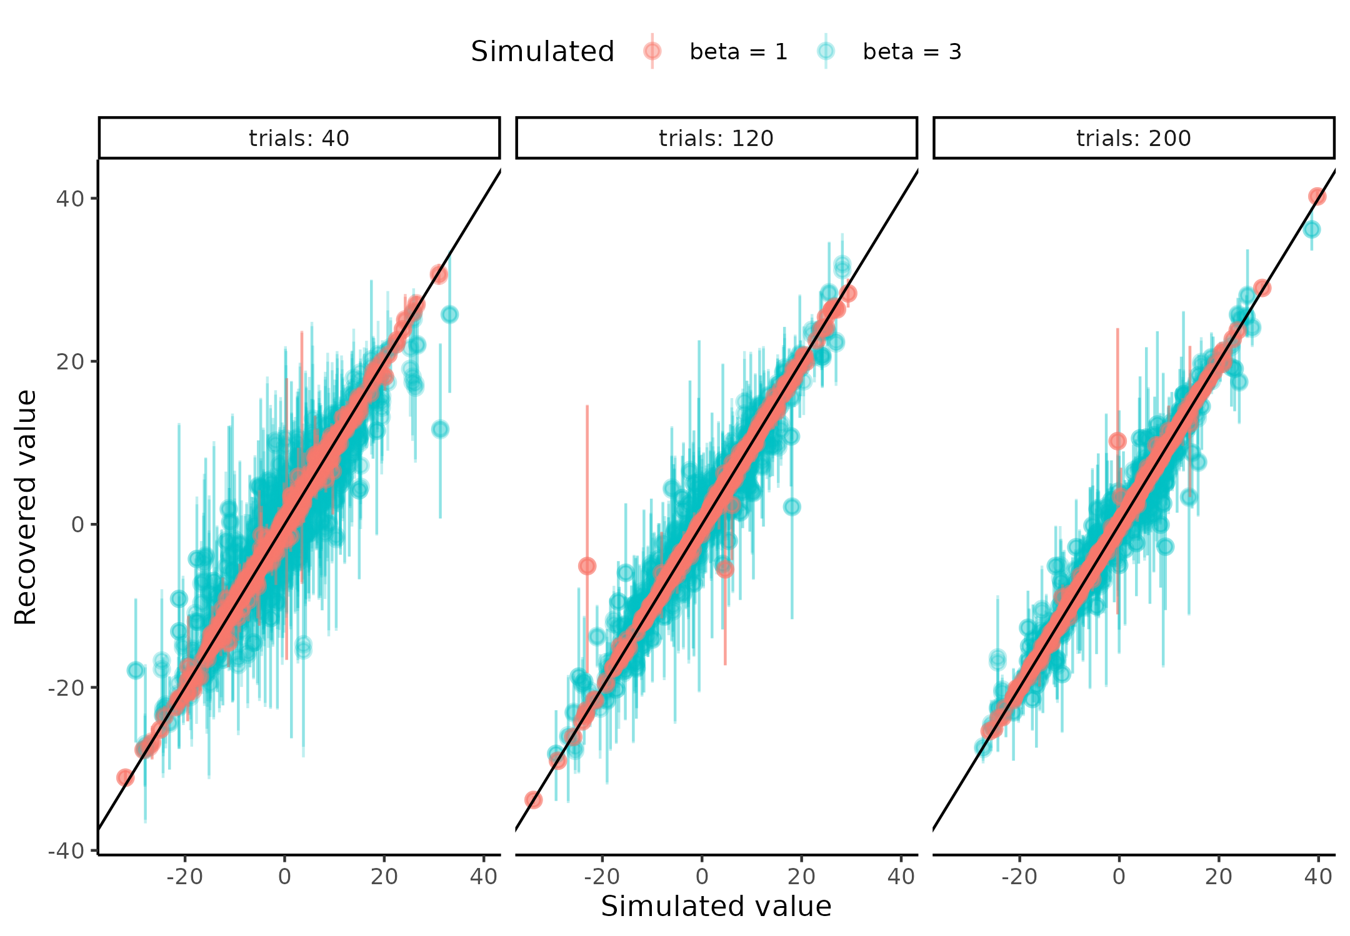

**Figure 13.** Showing the pairwise scatter plots of simulated vs recovered threshold ($α$) parameter when the simulated beta value is low (beta = 1) and high (beta = 3) for subjects (rows) and trials (columns).

As conveyed by the pairwise scatter plots in figure 13, the conservative ICC metric capture the fact that estimation uncertainty is a source of variability that can still be reduced even when the correlation coefficient might indicate close to perfect fit. This is exactly the behavior one would like to have when trying to understand their model as this information is much more sensitive. Furthermore the values also have a natural interpretation in the case of ICC whereas for the correlation coefficient the interpretation is not straightforward. An ICC value of 0.8 means that 80% of the variance in the model is governed by the between subject level variance and only 20 % is in the estimation or test -retest uncertainty. The ICC could of cause be further decomposed into what proportion of variance of the 20% is from estimation and what is from test retest uncertainty, again see supplementary figure 3. This straightforward interpretation is not present for the correlation coefficient, especially because of the arguments laid forth in the “Current problems with internal recoverability of models (parameter recovery)” section.

Another import considerations that has been deployed here which is sometimes neglected in parameter recovery analyses in the literature is the hierarchical structure, as mentioned in the previous section Harrison et al. (2021). Lastly what this approach also highlights is that parameter values in a cognitive model does not necessarily have to improve with increasing trials. This is the case for the lapse rate (lambda parameter) in this particular PF and could perhaps have been improved if the ADO algorithm was tuned to estimate this parameter. Therefore mindlessly increasing the number of trials to hopefully decrease estimation uncertainty on a parameter should be done after having conducted such an analysis in order to ensure that resources are not wasted trying to decrease estimation uncertainty, when its not possible.

## **Increasing information in cognitive models**

The previous section highlighted how the number of trials and the group level slope, but not the number of subjects could influence the parameter recovery metric i.e. correlation coefficient or $ICC_{2}$. In this section it will described how using data and or information about the underlying experiment or generative model, estimation uncertainty can be further reduced (and thereby increase the parameter recovery metric) in the parameter estimates of interest. For the sake of this thesis, I will look at incorporating the reaction times of the agents’ responses as sources of information about the underlying PF of their binary choices. I will be focusing on the reaction times as these have a long and rigorous history in the cognitive science literature, but more importantly are present in many experiments conducted today (MacLeod & Dunbar, 1988; Pirolli & Anderson, 1985; Sternberg, 1969). In order to incorporate the reactions times into the current formulation of the generative structure of the task, it is helpful to think of the output of PF as a probability of responding a particular value, say 1. This therefore entails that in either end of the tail of the PF the certainty with which you respond is the highest and the midpoint between the extremes (the threshold) is the most uncertain. This descriptive formulation is what the variance of the Bernoulli distribution describes, which is the distribution used to convert probabilities to binary choices:

$$Var\left(Bern\left(p\right)\right)=p⋅\left(1−p\right)$$

Using this information together with the assumption that participants will respond slower when more uncertain and faster when certain, the reactions times of each trial can be modeled as a linear combination of this Bernoulli variance. This linear combination would entail an intercept to account for the individual differences in mean reaction time and a slope that scales the influences of the uncertainty to the variances of the underlying PF i.e. the Bernoulli variance. Mathematically this would entail:

$$RT∼intercept+β_{RT}*Var\left(Bern\left(p\right)\right)$$

where intercept represents the intercept and $β_{RT}$ represents the degree to which the uncertainty from the psychometric function influences the reaction times, see Figure 14 for a visualization of this mapping. In order to stochastically model the reaction times with this formulation a probability density function is needed to account for the noise observed. Due to the non negative nature of reactions times and the physical constraints of information processing (i.e. a delay from the time the stimulus is presented to which it reaches the brain of the agent), a sensible choice of this probability density function would be the shifted log normal distribution. This introduces two more variables, a non decision time ($τ$) and a standard deviation ($σ$) for the log normal distribution (Jain et al., 2015; Ranger et al., 2020). This formulation of the reactions times therefore follow the relationship described below, where the crucial link, linking the psychometric function and the reaction times being the Bernoulli variance.

$$RT∼LogNormal(intercept+β_{RT}*Var\left(Bern\left(p\right),σ\right)+τ$$

To show how these reaction times help with recovery of the parameters of interest i.e. the threshold and slope of the PF, agents with the parameter values displayed in table 2 were simulated. To understand the influence of the size of coupling between the binary responses and the reaction times ($β_{RT}$) this parameter was simulated with either a high or low group mean, 1.5 and 1 respectively. The steepness of the slope of the PF was also varied between high and low, 1 and 3 respectively. Again, showing and understanding what these parameter values mean, one simulates the parameters and display the behavior. This can be seen in figure 14 where 10 simulated subjects are visualized. The figure clearly shows the relationship between the PF and the reaction time function. In the high stimulus values i.e. the most extreme x-values the reaction times are fast and the psychometric function is approaching 0 or 1. As the PF increases from very low stimulus values (the left side), the reactions times increase up untill the threshold for that agent is reached and then decreases.

Table 2: Parameter distributions for reaction time simulations. Parameter distributions for the simulated agents and the transformations for each of the parameters when including the Reaction times in the psychometric function.

| Parameter | Mean | Sd | Transformation |
| --- | --- | --- | --- |
| Alpha | 0 | 10.0 | x |
| Beta | [1 ; 3] | 0.6 | Log(x) |
| Lapse | -4 | 2.0 | Logit^-1(x) / 2 |
| Intercept | -2 | 0.5 | X |
| BetaRT | [1 ; 1.5] | 0.3 | Log(x) |
| Sigma | -1 | 0.5 | Log(x) |
| Non-decision-time | -1 | 0.5 | Logit^-1(x) * minRT |

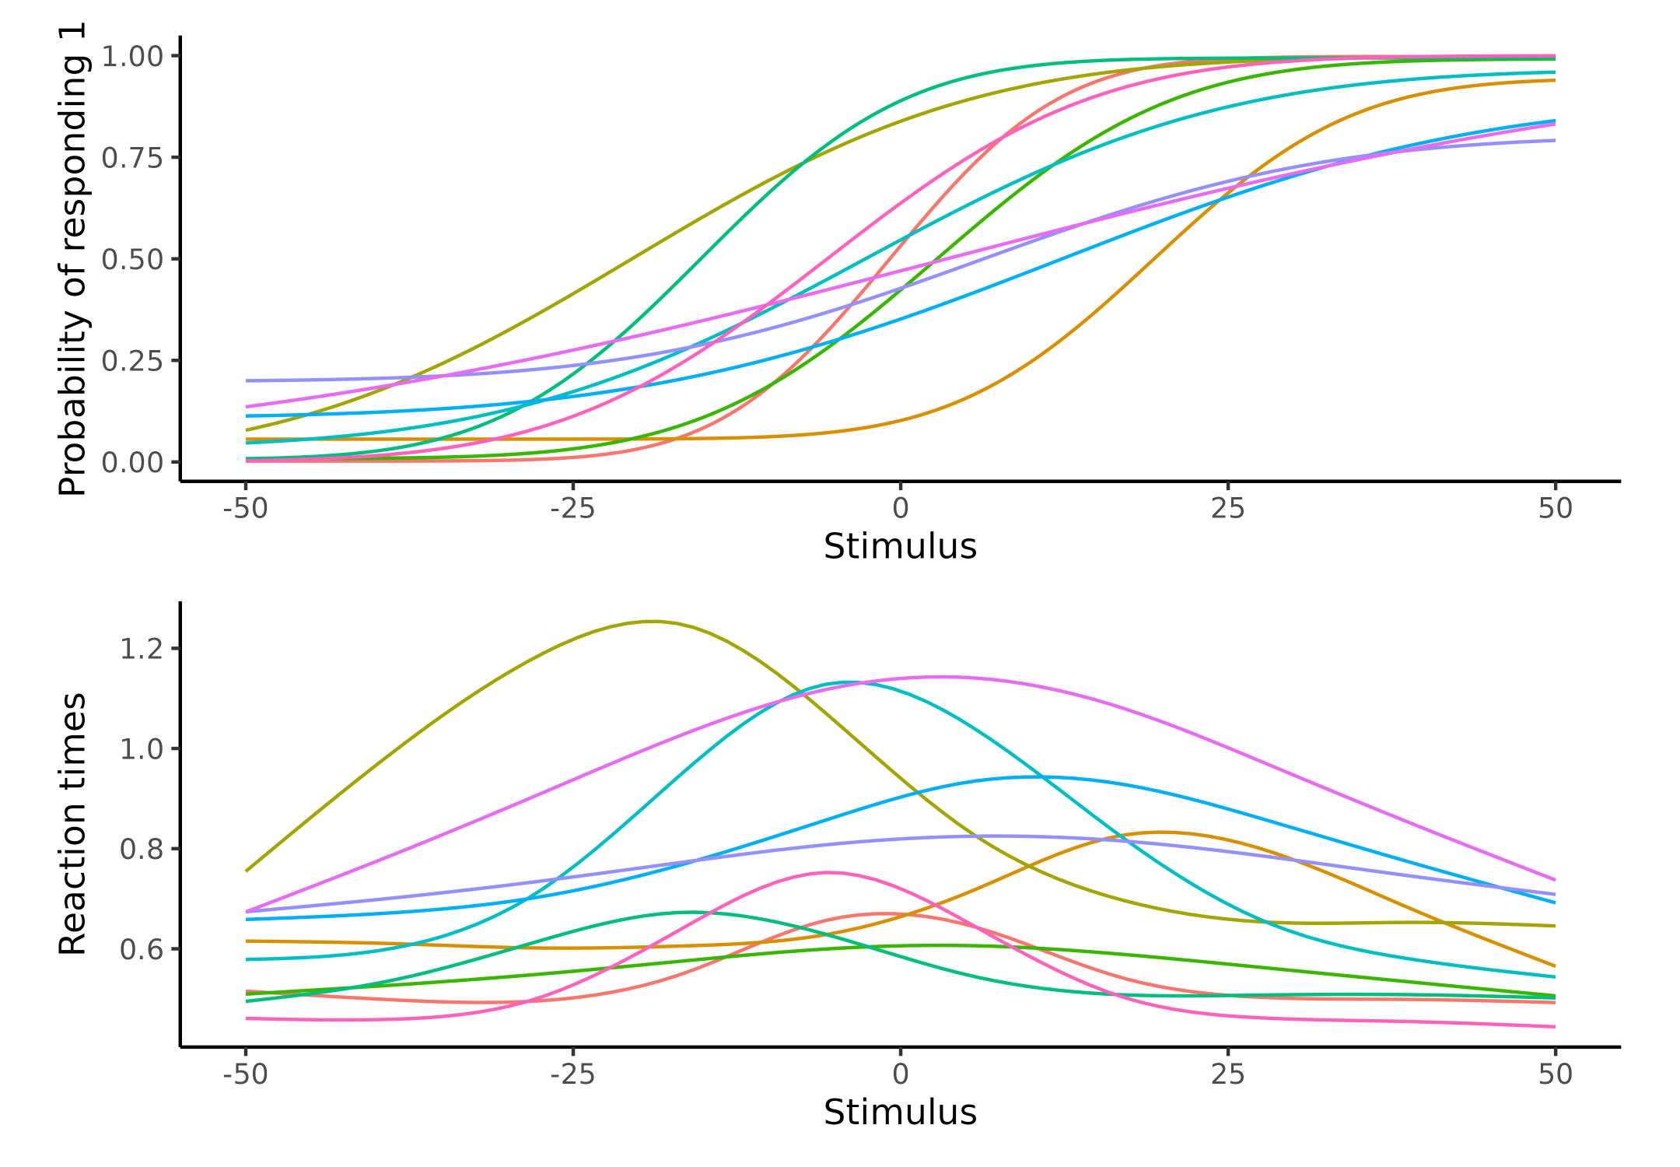

**Figure 14. Visualization of the psychometric function with Reaction times.** Upper panel depicts 10 psychometric functions where parameters were drawn from table2 (Beta = 3 and BetaRT = 1.5). Lower Panel depicts the assumed relationship between the stimulus value (x) and the reaction times (y), which as can be seen is dependent on the shape of the psychometric function in the upper panel. The reaction time functions peak around the psychometric threshold and tapers off when the psychometric function asympotes at 1 or 0.

Next utilizing this generative model a parameter recovery analysis can be conducted that investigates the influence of these reactions times on the recovery of the parameters of the PF. Here only the $ICC_{2}$ are depicted for the 8 combinations of slope, size of the coupling and inclusion of reaction time is depicted. Similar results were obtained by using the correlation coefficient, which can be seen in supplementary figure 7.

Figure 15 displays the difference in parameter recovery between including reaction times in the modeling or not, on the 3 parameters of the psychometric function. The plot firstly highlights increased $ICC_{2}$ values for the two parameters of particular interest i.e. the threshold (Alpha) and the slope (Beta). This difference seems to be present in the slope for both slope conditions (i.e. steep and shallow simulated mean slopes i.e. 1 and 3) but also in the shallow simulated slope (beta = 3) for the threshold where the $ICC_{2}$ metric has not reached its asymptote of 1 as in the steep slope simulation.

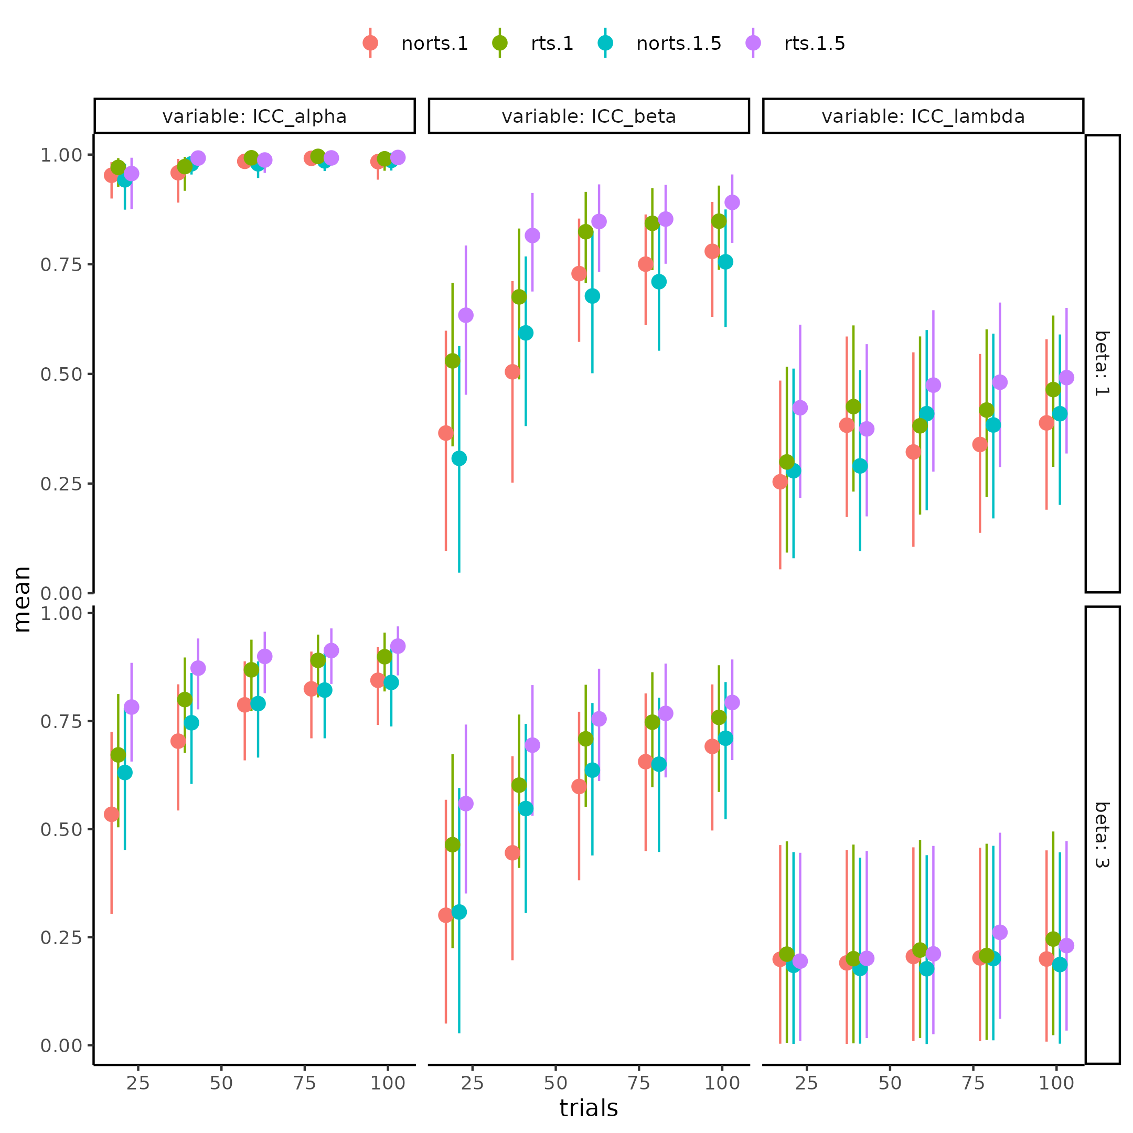

Figure 15 Parameter recovery of the psychometric function for the ICC for each parameter (columns), in each combination of including and not including rts and its size (color), and the simulated mean slope (rows) for differing number of trials x-axis. Stronger coupling is associated with better parameter recovery effects for both threshold slope, and lapse rate, with a strength dependent association i.e. the higher the coupling strength the more improve recovery when comparing to not uterlizing reaction times.

# Experimental data

Having rigorously investigated how the PF, both in terms of the interaction between parameter values, but also in terms of how estimation uncertainty of the parameters are influenced by various factors, the thesis now turns to a re-analysis of data collected on participants. This section introduces the published data-set that will re-analysed utilizing the psychometric functions introduced. The goal with this re-analysis is 2-fold. Firstly, it reiterates the fact that making assumptions about the structure of the data can make big differences in the parameter estimates and their uncertainties. Secondly, it will serve as a starting point to understanding why the internal model validity steps are helpful as a metrics to gauge how trials and subjects interact on the statistical power of a model to reject a hypothesis. This last aspect of testing hypotheses will tie together how the validity steps above can help determine the ability of a particular model to do hypothesis testing. The last point of the thesis is going revolve around conducting a thorough power analysis of the current model, utilizing the published data-set described below. In the regard of conducting a power analyses I will again highlight where uncertainty creeps in and how we can deal with and account for it, as common practices are insufficient.

## *Heart rate discrimination task*

The article introducing the data-set is Legrand et al. (2022) and is an interoceptive task, meaning participants were instructed to attend to their internal bodily states. Here the authors collected 223 participants who came in twice to complete the heart rate discrimination (HRD) task with 6 weeks between visits. The HRD task has participants internalize their own heart rate for 5 seconds, meanwhile the participant’s heart rate is monitored and calculated in real time. Next, based on the observed heart rate participants will hear five auditory tones with a given frequency (not the internal frequency of the tone, but the frequency of how fast the tones is presented) that is either faster or slower than their own objective heart rate. The amount this auditory tone’s frequency is faster or slower is determined by the PSI ADO algorithm introduced in the “Adaptive design optimizing” section. This means that the stimulus value for the PF for this experiment is the difference between the external tone’s frequency and the observed heart rate of the participant. The responses provided by the participants are therefore either faster or slower with faster referring to the belief that the individual heart rate was faster than the tone provided. This means that a participant might have a heart rate of 50 beats per minute (BPM) at a particular trial and then hear tones in a frequency of 40 BPM and are asked to respond whether they think this 40 BPM tone is slower or faster than their own heart rate. The authors of the experiment, ran a single participant level model of each subject, for each session, and then correlated the slope and threshold of the PF. They found a medium correlation between the threshold r = 0.5 p < .001 between sessions and a negligible correlation r = 0.1, p = .15 for the slope. In the next section I will show how this reliability might change given different assumptions of the structure of the data as well as employing different models by incorpurating additional information in terms of reaction times and confidence ratings.

## *The models*

In this section the models fit to the test-retest data-set are described, in order to examine the influence of the type of model fit on the correlation between session one and two of the PF parameters here the threshold and slope. The single fit model is going to be the references and going to be the same as the original authors did. That is estimating each individual for each of the sessions individually without a lapse rate (i.e. a two parameter PF) and then post hoc correlating the estimates between session one and two. adding the propagated uncertainty to these estimates will serve as the next model. Next, the same model as above with a lapse rate with be tested, in order to understand the influence of this parameter in this particular data-set. Two types of hierarchical models are going to be fit, one with a single layer amounting to modeling the two sessions from the same multivariate normal distribution with hierarchical priors for each session. This model directly models the correlation between sessions as its included in the variance - covariance matrix of the multivariate normal distribution. This model would amount to the model displayed in figure 5 if the participant level distributions were removed. The last type of model is the nested hierarchical model identical to the model presented when introducing the ICC, see Figure 5. This model assumes that all subjects have a mean level parameter which is drawn from the same multivariate normal distribution, each parameter for each session is then drawn from a subject level distribution. For this last model the ICC is the statistical metric estimated by the model itself (i.e. what has been described as $ICC_{1}$), and the correlation will afterwards be calculated. In addition to testing the influence of the data structure in the fitted models the reaction times for each trial is also going to be included in the analysis in the same vein as described in the section about increasing information in cognitive models. finally a full model is going to be fit which will also utilize the continous confidence rating readily available in the data-set. This full model will not only incorporate the reaction times on a trial-by-trial basis, but also these confidence ratings for each trial. Confidence ratings were included in the task of the original experiment to examine the participants’ interoceptive metacognitive abilities, but here they will be used to inform the parameters of the underlying psychometric function just as with the reaction times. The confidence ratings are going to be modeled in close resemblance to the reaction times, just inverted. This inversion is because in the middle of the psychometric function (at the threshold) the uncertainty about the stimulus representation is the highest and therefore reaction times should be their highest as well, but confidence should be at the lowest. Another difference between the reaction times and the confidence ratings is their range of possible values and therefore the probability density function used to describe them. The confidence ratings in the task were bounded between 0 and 100 ranging from complete uncertainty and certainty. A natural probability density function for such kind of double bounded variables is the beta distribution as its bounded between 0 and 1 (Geissinger et al., 2022). The problem with using beta distribution in this case is the edge cases of 0 and 1’s which for the confidence ratings are 0 and 100 when deviding each confidence rating with 100. One approach to circumvent this is to model these edge cases separately using a zero-one-inflated beta distribution. This approach, however, models these edge values as separate processes which does not make sense in this case as the confidence ratings are meant to represent a continuous measure of confidence. For reasons of simplicity the thesis therefore subtracts a small number i.e. 0.001 from the 1 ratings and adds 0.001 to the 0 ratings making it possible to use the beta distribution for the full range of confidence ratings. This approach of modeling the bounded ratings between 0 and 100 is tenuous and new methods are slowly being developed for a more holistic approach see Kubinec (2023). Reaction times of the responses were at maximum 8 seconds and can therefore still be modeled by the shifted log normal distribution introduced above.

## *Results*

Table 3 displays the correlation coefficient between the first and second session for the threshold and slope for each model when uncertainty has been propagated using bootstrapping. For a full table of all parameters of all models as well as with and without uncertainty propagation see [Supplementary table 1](https://github.com/JesperFischer/Master-thesis/blob/main/Supplementary%20tables/Supplementary%20table1.xlsx) which is linked to the github of the thesis.

Table 3. Results from reanalysis of legrand (2022). Table showing the correlation between sessions of the threshold and slope parameter of the psychometric function using different model fomulations as well as hierarchical model structures.

| alpha | beta | lapse | model | structure |
| --- | --- | --- | --- | --- |
| 0.51 [0.40 ; 0.63] | -0.00 [-0.07 ; 0.06] | FALSE | Binary | Single |
| 0.50 [0.38 ; 0.61] | 0.03 [-0.06 ; 0.11] | TRUE | Binary | Single |
| 0.52 [0.39 ; 0.63] | 0.09 [-0.03 ; 0.36] | FALSE | RT | Single |
| 0.52 [0.41 ; 0.64] | 0.04 [-0.03 ; 0.14] | TRUE | RT | Single |
| 0.51 [0.38 ; 0.62] | 0.14 [-0.05 ; 0.37] | FALSE | RT+Conf | Single |
| 0.52 [0.39 ; 0.63] | 0.12 [-0.02 ; 0.28] | TRUE | RT+Conf | Single |
| 0.51 [0.41 ; 0.59] | 0.23 [-0.01 ; 0.44] | TRUE | Binary | Hierarchical |
| 0.49 [0.40 ; 0.58] | 0.25 [0.08 ; 0.42] | TRUE | RT | Hierarchical |
| 0.49 [0.40 ; 0.58] | 0.23 [0.08 ; 0.38] | TRUE | RT+Conf | Hierarchical |
| 0.53 [0.49 ; 0.58] | 0.20 [-0.03 ; 0.43] | TRUE | Binary | Nested Hierarchical |
| 0.54 [0.51 ; 0.58] | 0.27 [0.08 ; 0.47] | TRUE | RT | Nested Hierarchical |
| 0.55 [0.53 ; 0.58] | 0.21 [0.06 ; 0.37] | TRUE | RT+Conf | Nested Hierarchical |

Table 3 highlights the fact that the additional assumptions of the hierarchical models both nested and unnested increases the session-by-session correlation of the slope of the psychometric function. Additionally including the reactions times increases the correlation even more, however with overlaying 95% credibility intervals. The models with included confidence ratings perform worse than the models with only the added reaction time in the session by session correlation. This might allude to the fact that another process is present, or that the particular model used for the confidence ratings, might be inappropriate. The main difference in session-by-session correlation between the two hierarchical models can be found in the threshold as the nested hierarchical model outperforms the non-nested hierarchical model in this regard. A concern of this approach of just looking the correlation coefficients is of cause that a model with a high session by session correlation might not fit the data at all. Therefore an examination of the comparison of model fit is crucial to ensure that the nested hierarchical model also fits the data better than the unnested hierarchical model. One approach would therefore be to examine model fit using common metrics such as leave one out cross validation, information criterion etc. The difficulty here is that most of the models are incompatible. This stems from the fact that they have been fit to differing amounts of subjects in the case of hierarchical vs single fit models, and to differing amounts of dependent variables in the case of within model architectures. Another consideration for not conducting model comparison is that the difference between the models that are comparable i.e. the hierarchical and nested hierarchical with the same number of dependent variables is that the difference between these model lie in the assumption of the data and is therefore something that should have been decided before modeling the data. Therefore given that it is known that each subject was accessed twice (and not a new participant was tested), and that the nested Hierarchical model captures this assumption, one should be inclined to choose this model regardless of the session by session correlation. Therefore instead of directly comparing the comparable models, one might look at posterior predictive checks. These checks serves to investigate whether the model predictions align with the data. These posterior predictive checks were performed for the most complicated models to ensure that the models are capturing some of the underlying patterns in the collected data. For these posterior predictive checks on both group level and single subject level see supplementary Figure 8-11 together with Supplementary Note 5.

## *Importance of uncertainty minimization*

Throughout the thesis uncertainties from measurements to estimations to the uncertainty of these estimations over time has been investigated through statistical and cognitive modeling. The focus of the section on measurement uncertainty was brief and highlighted the ways in which computational resources can be used to account for these. Next the section about estimation uncertainty showed how different approaches can be utilized, from smart design of the experiment, to including additional information present in the data to decrease this kind of uncertainty. In the last section reliability of estimates were examined using experimental data and how the approach of adding addition information to the analysis might increase the reliability of the test re-test reliability. In order to fully appreciate how these uncertainties interact and in which regard they matter for hypothesis testing, the thesis will below conduct a power analysis for the experiment that was analysed in the previous section. In conducting this power analysis measurement uncertainty is assumed to be negligible. This amounts to assuming that the heart rate of the participants is estimated with infinite precision, which was also assumed for the previous analysis as the authors of the experiment did not disclose the uncertainty in these estimates. Furthermore only the simplest form of the PF with 3 parameters is going to be analysed, and only a difference in thresholds is analyzed in order to fully capture the potential of this particular way of conducting a power analysis. The reason for the simplicity of the model is for the power analysis to fully explore the effects of combinations of subjects and trials on statistical power with the least amount of computational overhead while still exploring how uncertainties interact, but see discussion and limitations for further elaboration of this. The next sections are therefore an introduction to power analyses and how they are contextualized.

# Power analysis

When researchers are interested in the parameter values of their models, they are many times also interested in how they differ by for instance using pharmacological interventions or between healthy controls and patient populations. The question in such a scenario is how many participants and or trials do you need to reliably detect a particular size of effect, between the two conditions? These estimations of trials and participants can in principle given some assumptions be calculated a priori to conducting the experiment. That is the question of what is the probability that our results are going to be “significant” given that there is some “real” underlying effect can be answered. Here it should be noted that significant is here referred to as the standard frequentist approach of rejecting or failing to reject a null hypothesis based on a significance level. Usually this idea of hypothesis testing is depicted in a 2 by 2 matrix with the real latent effect being in one dimension and the model results in the other dimension see table 4. The probabilities of landing in either of these 4 categories is usually described as functions of our statistical significance threshold (alpha / p-value) and the statistical power of our model and test (1- $β$). The underlying effect might be from the intervention of the study or a difference between a healthy and a patient population group. The framing of power analyses in this way is then to say that results are significant if the p-value is less than a particular value most often 5%, and that the probability that we detect this effect, given that it is present, is another arbitrary value with 80% being the statistical power of the test.

Table 4. 2 by 2 confusion matrix of whether the is an underlying effect (Reality) and whether a model is able to correctly identify this effect or not whether its present or not.

|  | Reality (effect) | Reality (no effect) |
| --- | --- | --- |
| Model result (significant) | 1-β | α |
| Model result (in-significant) | β | 1-α |

Moving to the more practical side of power analysis in cognitive or statistical modeling; our models fit to the data will reject and fail to reject different rates of effects given their magnitude, but also given the amount of data i.e. the number of subjects and number of trials. Here the number of subjects and trials serve to reduce the uncertainty in the estimated magnitude of effect and thereby increasing the probability of detecting said effect. With this understanding the commonly depicted table above (table 4) is quite misleading as the dimension of “reality” is a continuous variable of size of the effect, and our models have a particular probability of rejecting a hypothesis at a particular effect size with a particular set of subjects, trials and alpha level. An example of this could be that a researcher wants to detect whether there is an effect of gender on height in the human population. We assume that there is an underlying effect and observe X females and Y males and run a statistical analysis to determine whether we can reject the null hypothesis (there are no differences in height in the two genders). Compare this to the hypothesis that there is an effect of age (in late adolescents and adults) on height. The former difference might in general be much larger than the former and therefore with all else being equal (trials, subjects, statistical model etc.) this difference will be easier to detect compared to the difference in height based on age. What is therefore done when conducting power analyses is that different observed effect sizes are simulated (effect sizes in the data that is observed) with differing amounts of trials and subjects. The ability of the statistical model to reject these simulated experiments are then accessed through many simulations. Usually, this amounts to then counting the number of times, the model achieves “significant” results compared to non-significant results, which is then the power of the model at that number of trials subjects and observed effect size. This approach accurately captures how we expect the model to behave when we fit the data to the model after obtaining it. It tells us if we observe a particular effect size, we will with a particular probability be able call the results significant. The utility of this analysis is therefore to be able to examine how many subjects and or trials are needed to obtain a statistical power of usually 80% given that a particular effect size in the population is present. The assumed effect size in the population might be informed by previous studies and or meta-analyses in the field. Extra assumptions are then needed to approximate the distribution of effect sizes as these statistical metrics also have uncertainty associated with them.

The power simulations conducted in this thesis will be for a repeated measures design interested in a difference in threshold due to some intervention. Subjects, trials, and effect sizes in a variety of combinations are therefore simulated see figure 16. Here the particular effect size chosen to simulate was cohens’ $d_{r}m$ see formula below. This particular effect size is suitable for repeated measures design as it accounts for the correlation between the two sessions of each participant i.e. the test retest reliability of the measure investigated. The simulation process followed the following procedure: first a set of agents were simulated from a multivariate normal distribution with two sessions from the group level parameters of the binary nested hierarchical model presented in section about experimental data, see supplementary table 2 for the exact values for each parameter. The second session of the agents had their threshold increased by a random variable that was drawn from the difference distribution. This difference distribution was calculated based on the two equations presented below, where the second session variance was defined as 1.5 times the variance of the first session, which made the mean of difference distribution directly related to the simulated effect size. To ensure a particular observed effect size, this process was repeated until an observed effect size of the desired value was obtained ( $±$ 0.01), this step of re-sampling for a particular effect size was mainly for visualization purposes later see Figure 16 and text below. After having simulated the particular parameter values of each agent at each session the agents was put through the pathfinder algorithm to get their trial-by-trial responses and stimulus values. The full trial-by-trial data-set was then fitted using a simple hierarchical model where the threshold was parameterized as a linear combination of an intercept with dummy coding of session as a difference parameter see supplementary note 6 for the full model description.

$$μ_{δ}=d_{rm}*\frac{\sqrt{Var_{1}+Var_{2}−2*σ_{1}*σ_{2}*ρ}}{\sqrt{2*\left(1−ρ\right)}}$$

$$σ_{dif}=\sqrt{Var_{1}+Var_{2}−2*σ_{1}*σ_{2}*ρ}$$

Mean and standard deviation of the difference distribution between the two sessions, where $Var_{1}$ is the variance of session 1 $Var_{2}$ is the variance of session 2. $ρ$ is the correlation between the two sessions. $μ_{δ}$ is the mean of the difference distribution and $d_{rm}$ is the standardized effect size between the two sessions.

## *Power analysis results*

With an understanding of the goal of conducting a power analysis it can be difficult to chose the number of combinations of trials, subjects and observed effect sizes to explore. This is due to the fact that the space of these combinations is in the extreme, infinite, and at even a practical level quite huge. Therefore conducting a complete power analysis for a single model is unfeasible, however the thesis will show that the variation in how well the model rejects the null hypothesis, given subject and trial combinations are stable over observed effect sizes. This makes it possible to give good predictions of power even without having simulated the exact number of participants or trials before. This procedure is therefore about simulating a set of trials, subjects and observed effect sizes and then extrapolate from these simulations.

For the current power analysis, a result is said to be significant if less than 5% of the posterior difference distribution of the threshold (group statistic) cross 0 like setting an alpha value of 5% in a frequentist power analysis. Furthermore 100 simulations are going to be run for each subject, trials observed effect size combination ensuring reasonable estimates of the probability of rejecting the hypothesis. To properly display the raw results of the power analysis where it is possible to compare the effects of trials and subjects visually, the beta distribution is going to be used to aggregate the 100 simulations for each effect size. This is done by utilizing that the beta distribution is a two-parameter distribution that can be parameterized such that one parameter counts how many times an event has happened and the other parameter being how many times this event did not happen. This therefore makes it possible to start with a uniform prior on the probability of rejecting the null hypothesis i.e. Beta(1,1) and then updating this probability density function with the amount of significant or non-significant results. This results in a probability density function that contains all the information in each of the 100 binary points (i.e. significant or not). Figure 16 shows each trial/subject combination with points representing this prior uniform beta distribution updated by the 100 data-points that were either deemed significant or non-significant. A couple of important observations are worth noting when viewing Figure 16. The shape of the points (for each trial,subject combination) very closely resembles a psychometric function where subjects and trials influence both the steepness and the location of the function. This means that increasing the number of subjects (and trials to a lesser extent) has two important features. It shifts the points towards higher power with lower effect sizes, but it also seems to increase the sensitivity to the effect size, i.e. the slope of the curve is getting steeper with higher number of subjects. The extent to which trials matters for the shape is highly dependent on the number of trials, i.e. increasing trials from 10 makes a big difference in the shape of the function, but the difference in going from high to very high i.e. 100 to 150, does not matter much. The tendency of the function to be less affected by ever increasing trials is also present for the number of subjects. This observation makes sense if one takes the function to its extremes in trials and subjects. Increasing subject and trials to infinitely many, we would expect, assuming the model has been shown to become increasingly better with increasing trials (like with the ICC metric presented previously) that the model would be able to pick up on even the tiniest difference in groups. This would essentially mean that the function would consistently be at y = 1 with x approaching 0 from the positive direction and then jump to (0,0) in the (observed effect size, power) curve as no difference would entail no power. In the other extreme were no subjects or trials are present the curve should approach a flat line at y = 0 entailing no power for any amount of effect size. Essentially reaching a step function in the limit when x goes to 0 and subjects and trials goes to infinity. This can mathematically be written as:

$$\lim_{\left(s,t\right)→∞}\left(Ψ\left(x,α,β,s,t\right)=\left\{\begin{matrix}0 & \text{if }x≤0 \\ 1 & \text{if }x>0\end{matrix}\right.\right)$$

where s and t are the number of subjects and trials respectively. x, $α$ and $β$ are the observed effectsize, the threshold of the psychometric function and the slope of the psychometric function respectively. These observations are what is going to be used in the next section in order to extrapolate the results from figure 16. Making it possible to construct a model that will map trials, subjects and effect sizes to power.

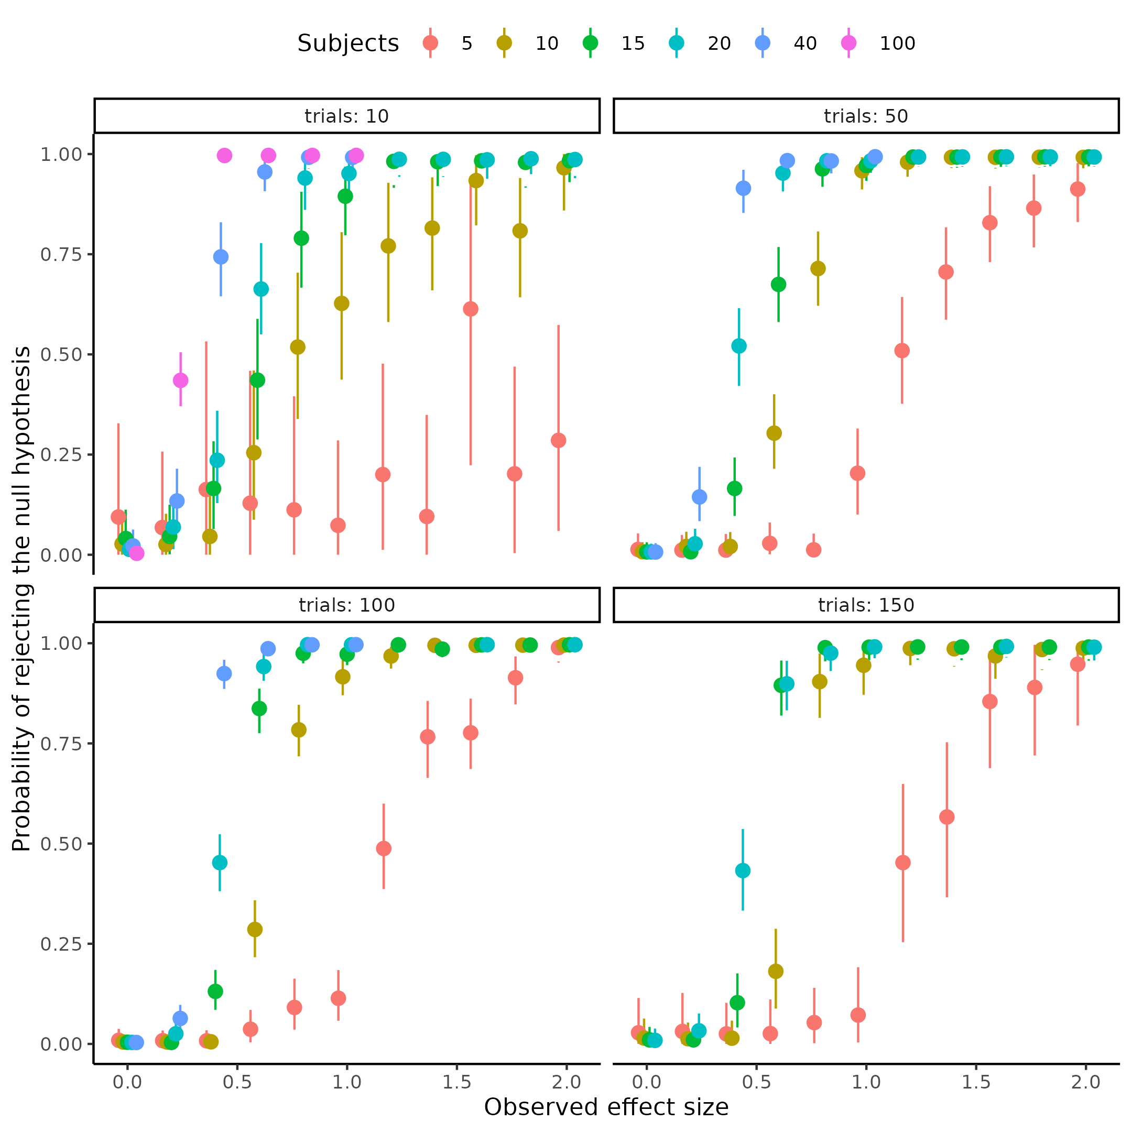

Figure 16, depicts power as a function of observed effectsizes in different combinations of trials and subjects.

## *Modeling of power analysis*

To use the information from above, the latent psychometric function describing the relationship between subjects, trials and effect sizes needs to be investigated. Ideally a psychometric function that enforces the curve going through the origin, as an observed effect size of 0 should always entail no power. Next the parameters of these psychometric functions i.e. the threshold and slope need to be parameterized by the number of trials and subjects such that when trials and subjects move towards infinity the function approaches a step function right as x becomes greater than 0. Before fitting the general case that can be used for extrapolation and also ensuring that a psychometric function is well fitting function to the problem at hand, each set of trials and subject combinations are fit independently to the parameters of the psychometric function. This amounts to estimating a threshold and slope of the psychometric function for each trial and subject combination. This will help ensure that the fitted functions do pass through the points depicted in figure 16 and increase the faith in the next type of modeling. Several types of psychometric functions might be used for this practice, as this problem is defined in terms of finding the function that has the best performance on out of sample predictability. This means that the winning model should be selected based on leave one out cross validation as the ideal model is the model that can best describe new data. This is because the overall goal with this power analysis is to use the quite sparsely simulated space of trials,subjects and effect sizes depicted in figure 16 to inform a model that can predict outside the realms which it has been tested on. Therefore these models were compared using the Pareto smoothed importance sampling leave one out cross validation (Vehtari et al., 2017, 2024; Yao et al., 2018). Three types of psychometric functions were fit in the current thesis, the cumulative normal, the cumulative logistic and the cumulative Weibull function. The main differences between the normal and logistic function is that the logistic function has heavier tails than the normal allowing for more disperse observations. The difference between the Weibull and the two other distributions is that the Weibull function is forced through the origin and its shape therefore quite different from the two other functions. The choice of the cumulative normal or logistic function does not necessarily violate the assumptions laid out above because of the way that the parameters are going to be dependent on the trials and subjects. This is clear if one considers an asymptote at 0 for the slope and threshold (i.e. a step function also for the cummulative normal and logistic function) when trials and subjects move to infinity. This exactly matches the observation from above that the psychometric function moves closer and closer to a step-function (as the slope gets closer to 0) and that the location of this step function approaches x = 0 but never reaches it. The results of this preliminary independent analysis on trials and subjects can be seen in figure 17 where the independently fit logistic psychometric functions are overlaid on the observed data-points from figure 16. The figure clearly highlights a good fit for most of the trials and subject combinations.

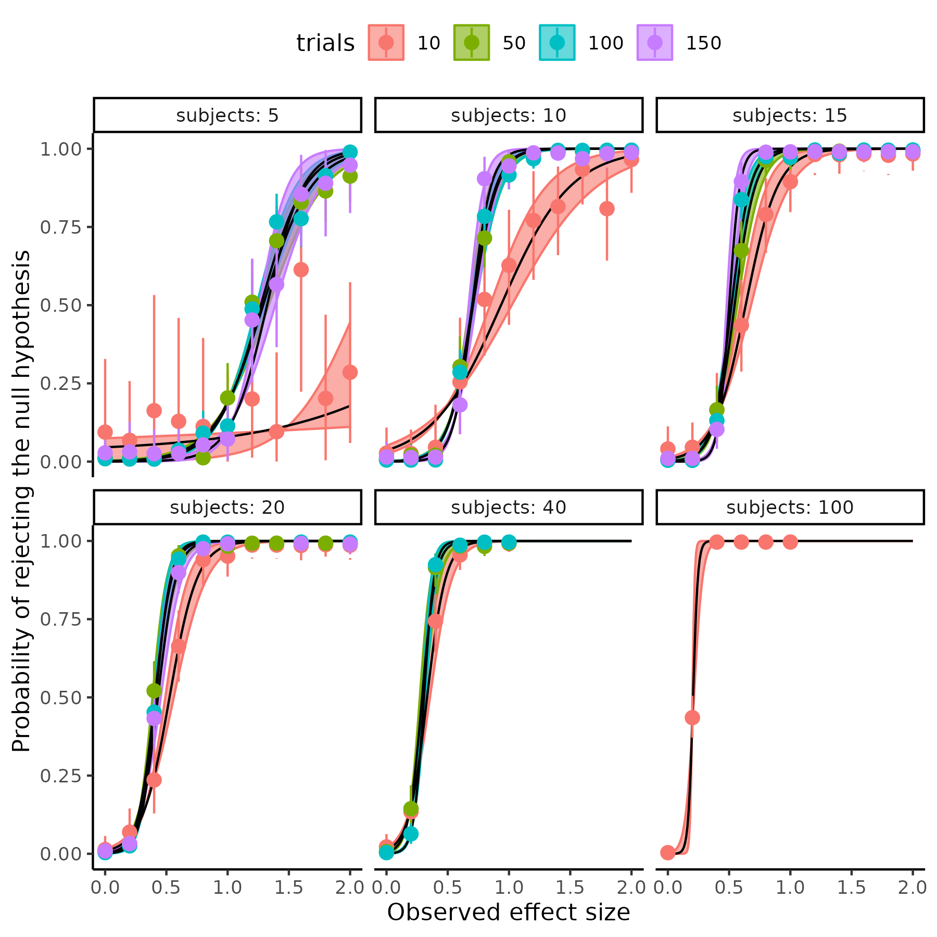

Figure 17; depicts power as a function of observed effectsizes in different combinations of trials and subjects. With lines being independently fit logistic psychometric functions to each trial by subject combination.

## *Continuous mapping of the power analysis*

Moving to the continuous mapping of subjects and trials to the psychometric function’s parameters. This mapping should be defined as a function that relates subjects and trials to the parameters that determine the shape of the psychometric function (i.e. the threshold and slope). Given the observations above, that the steepness of the function increases with increasing trials and subjects and that the threshold moves towards 0, a first choice of this mapping function would be to model the two parameters as exponentially decreasing by trials, subjects, together with their interaction. An exponentially decreasing function in the complete general case would mean the following relationship.

$$Θ=β_{0}*exp\left(−β*X\right)+α_{asym}$$

Where $Θ$ represents the parameters of the psychometric function, $α_{asym}$ is the value of the parameter when the number of trials and subjects approach infinity. $β$ is vector of parameters determining the steepness of the exponential decrease from the covariates in the matrix X, here trials subjects and their interaction. The parameter $β_{0}$ serve, together with $α_{asym}$, as the value of the parameter when trials and subjects are 0. Another formulation of the dependency might be a power law equation as shown below.

$$Θ=β_{0}*X^{β}$$

Both approaches can produce the observed behavior and their difference depends on the underlying relationship between the parameters and the the matrix X i.e. (trials and subjects and perhaps their interaction). The exponential equation assumes that as trials and subjects increase by a fixed amount the parameters will decrease by a percentage, whereas the power law assumes that as trials and subjects increase by a percentage the parameters will decrease by a percentage. There are several ways of investigating which of these two approaches results in the better fit, firstly plotting the parameters of the independent fits (figure 17) vs trials and or subjects, which was conducted in the section above, on two different coordinate systems either in (log(y),x) or (log(y),log(x)). Which of these coordinate systems produces the best-looking linear line would be the best candidate. Figure 18 displays the three function’s parameters fitted independently on each of the two coordinate scales. As can be seen both approach do produce partly linear relationships, making the distinction difficult with this apporach.

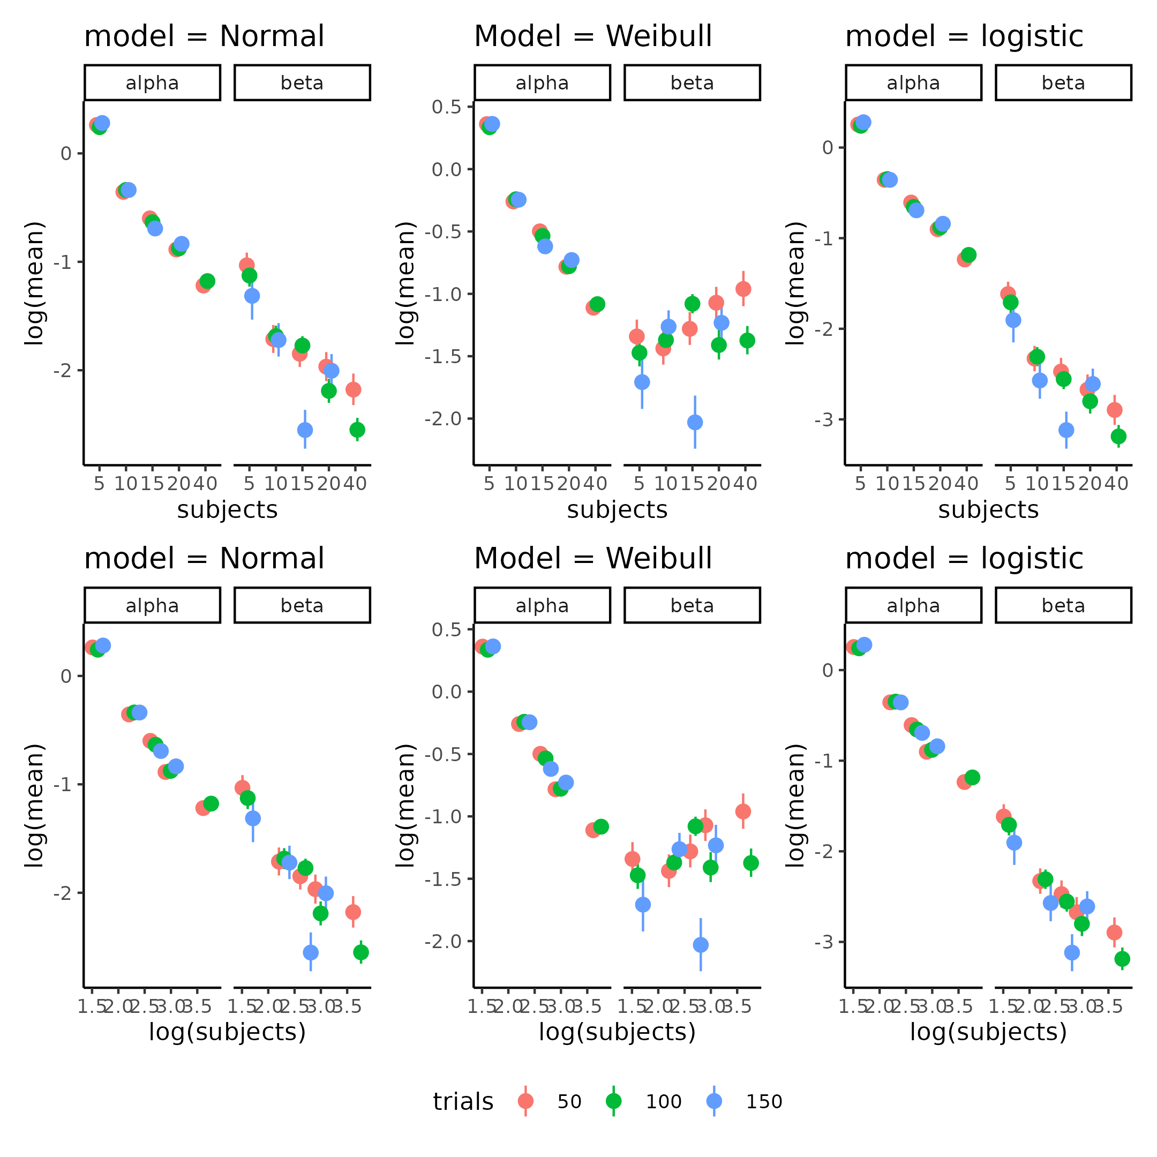

Figure 18. Parameters estimates of the individually fit psychometric functions (columns) on trials and subjects. The top row depcits a (log(y),x) coordinate system whereas the bottom row a (log(y), log(x)) coordinate system. A straight line relationship between subjects (trials) and the log of the parameter value (top row) would indicate exponential relationship whereas a straight line in the log;log coordinate system would imply a power law relationship in the native (x,y) space.

Another approach would be to fit both types of models and then compare them on leave one out cross validation as described above. Implementing this, displayed problems with 15, 25 and 3 % of observations for the normal, Weibull and logistic function respectively as the pareto k diagnostic value was above 1 for these percentages of data-points. This essentially makes it meaningless to compare the functions (Vehtari et al., 2024).

Therefore the thesis moving forward uses the logistic cumulative function as this produced the least amount of problems with pareto k values when fitting trials and subjects as continuous informing the parameters of the latent psychometric function, which is described next. The first model fit used the exponentially decreasing function equation above. Four other models were fit with different ways of parameterizing the power law equation above. These four models displayed different ways of how the trials and subjects interact as there is no straightforward way of combining X and β. The first was an additive model with the following parameterization

$$β_{0}⋅X^{β}=β_{01}+s^{β_{1}}+t^{β_{2}}+{\left(t⋅s\right)}^{β_{3}}$$

The second was with a combination of additive and multiplicative operations:

$$β_{0}⋅X^{β}=β_{01}*\left(s^{β_{1}}+t^{β_{2}}+{\left(t⋅s\right)}^{β_{3}}\right)$$

The third was a multiplicative model without an interaction.

$$β_{0}⋅X^{β}=β_{01}⋅s^{β_{1}}⋅t^{β_{2}}$$

The last was the multiplicative model with an interaction but defined as the sum of subjects and trials as the normal interaction of multiplying trials and subjects would lead to a similar model of the model without an interaction.

$$β_{0}⋅X^{β}=β_{01}⋅s^{β_{1}}⋅t^{β_{2}}⋅{\left(t+s\right)}^{β_{3}}$$

Comparing these five models using leave one out cross validation indicated that the best model was the last model but closely followed by the second model, which can be seen in table 5. Importantly for these reported models the diagnostic values were all below 0.7.

Table 5. Model comparison of the power analyis models, using Pareto smoothed importance sampling leave one out cross validation. Expected log predictive density (elpd) difference and standard error between models is depicted in the second and third column and the absolute ratio between these in the fourth column. The Higher the elpd-ratio the bigger the scaled difference (scaled by the uncertainty) between the models and the more confident one might be that one model outperforms the other.

| models | elpd_diff | se_diff | elpd_ratio |
| --- | --- | --- | --- |
| logs_power | 0.00 | 0.00 |  |
| addititve_multiplicative | -10.06 | 4.65 | 2.16 |
| logs_power_noint | -35.91 | 8.87 | 4.05 |
| logs_expo | -85.86 | 15.74 | 5.45 |
| additive | -820.02 | 37.48 | 21.88 |

This indicates that as the trials and subjects increase by a percentage the parameters of the psychometric decrease by a percentage as the top two models are both variations of the power law. To ensure that the tested models still capture the underlying data, figure 19 displays the winning model superimposed on the data with 95 credibility intervals of the mean of the psychometric function. As can be seen this closely resembles the individual independent fits, with the most drastic deviation in the 5 subjects, 10 trials condition.

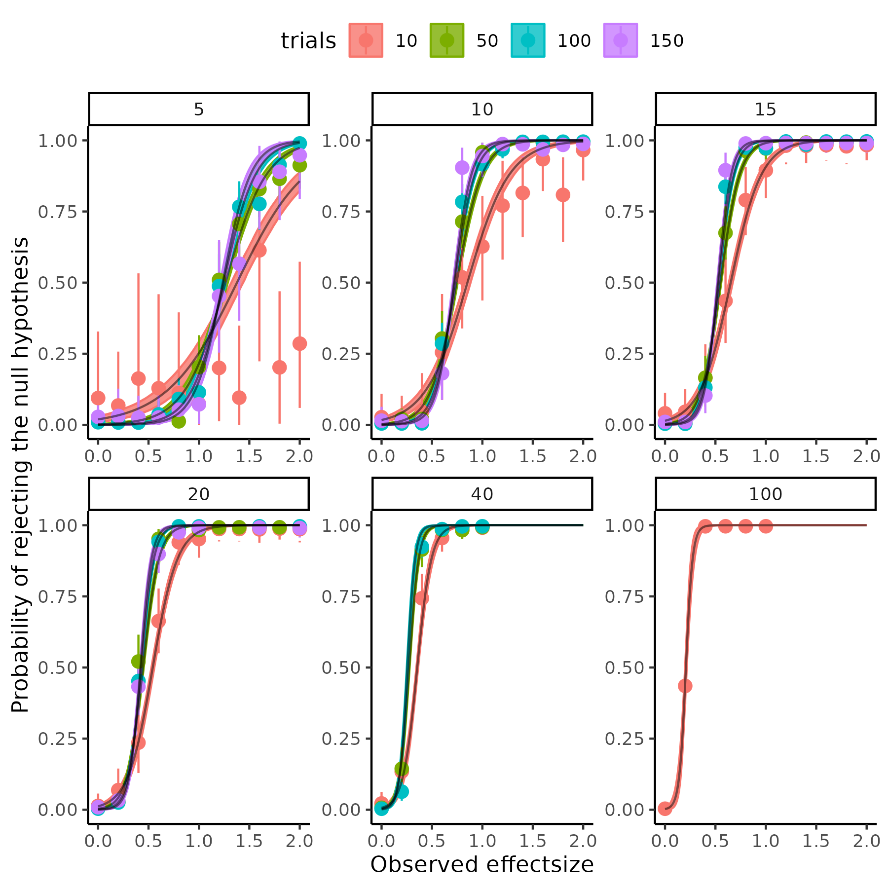

Figure 19; depicts power as a function of observed effectsizes in different combinations of trials and subjects. With lines being the dependently fit logistic psychometric functions to each trial by subject combination.

The marginal posterior distributions of the parameters of the winning model are displayed below in figure 20.

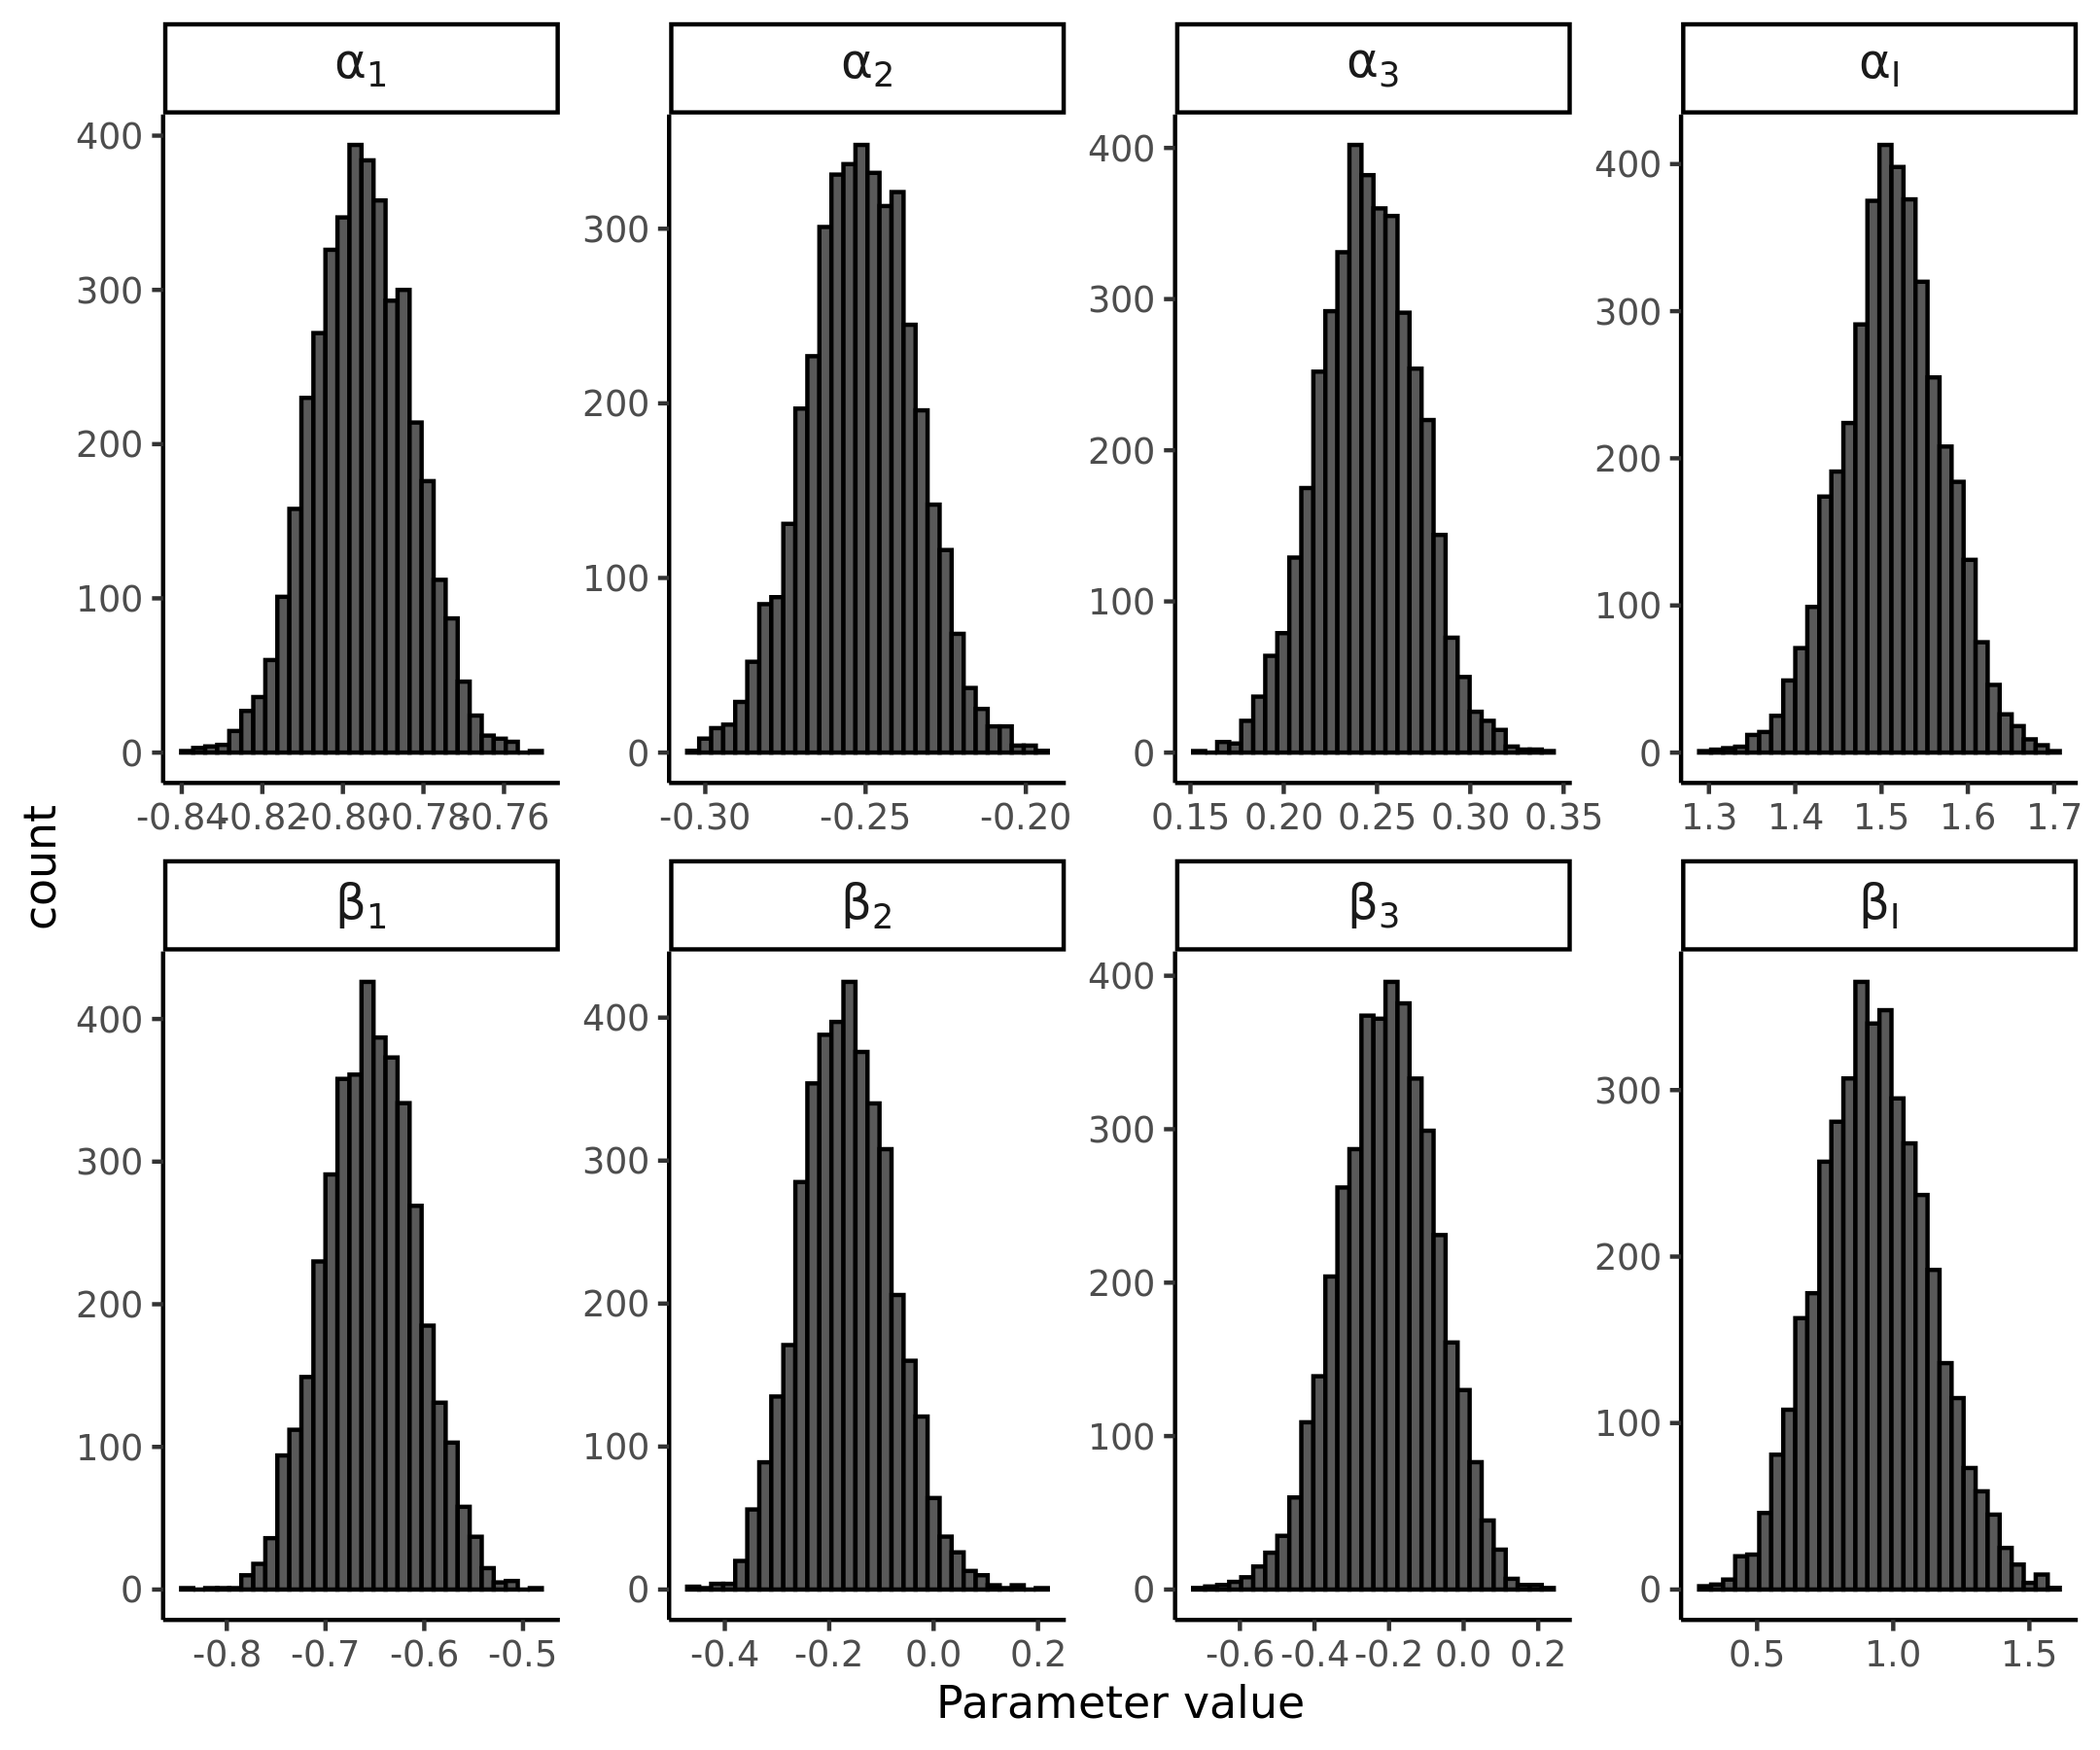

Figure 20. Marginal posterior distributions for the winning model’s parameters

Meaning that the resulting best guess of the underlying function transforming trials, subjects and observed effect sizes into probabilities of rejecting the null hypothesis of no difference in threshold is as follows:

$$Ψ\left(d_{\text{obs}},α,β∣t,s\right)=\frac{1}{1+exp\left(−\frac{1}{β\left(t,s\right)}⋅\left(d_{\text{obs}}−α\left(t,s\right)\right)\right)}$$

Where

$$β\left(t,s\right)=β_{I}⋅s^{β_{1}}⋅t^{β_{2}}⋅{\left(t+s\right)}^{β_{3}}$$

$$α\left(t,s\right)=α_{I}⋅s^{α_{1}}⋅t^{α_{2}}⋅{\left(t+s\right)}^{α_{3}}$$

Where each of these parameters are given by the distributions depicted above in figure 20.

## *Utility of the power analysis*

As alluded to in the beginning section of the power analysis, the work presented here would be able to help an independent researchers determine the probability of rejecting a particular observed effect size using this model, given trials and subjects even outside the realm of simulations presented here. However, if this researcher wants to know the probability of rejecting a null hypothesis given that they assume a particular effect size in the population, further assumptions needs to be made. This is because as the effect size when conducting an experiment is not a fixed quantity. In practice this means that when conducting an experiment, an effect size is drawn from the latent effect size distribution in the population. Mathematically this means that the effect size that is observed in an experiment is given by a probability. The mean and standard deviation of this probability density function is given analytically by Cohen which could also be derived from bootstrapping as was done with the measurement uncertainty (Goulet-Pelletier & Cousineau, 2018; Hedges & Olkin, 2014; Lakens, 2013). Below are the equations for the mean and variance of the effect size measure used in the power analysis.

$$μ_{d_{rm}}=μ_{δ}*\frac{\sqrt{2*\left(1−ρ\right)}}{\sqrt{Var_{1}+Var_{2}−2*σ_{1}*σ_{2}*ρ}}$$

$$σ_{d_{\text{rm}}}=\sqrt{\frac{1}{n}+\frac{μ_{d_{rm}}^{2}}{2⋅n}}$$

As can be seen the equation for the mean effect size $μ_{d_{rm}}$ is mathematically identical to the definition shown in the “Power analysis” section. The standard deviation of this metric $σ_{d_{\text{rm}}}$ is defined as a function of the number of subjects n and the size of the effect itself $μ_{d_{rm}}$. Assuming that the effect size is normally distributed:

$$d_{obs}∼N\left(μ_{d_{rm}},σ_{d_{rm}}\right)$$

The probability of rejecting this sampled effect size is given by the function that was obtained above.

$$P\left(R∣d_{obs}\right)=Ψ\left(d_{\text{obs}},α,β,t,s\right)$$

What one ideally wants to know is the probability of observing a particular effect size AND reject the null hypothesis given this observed effect size. Probability theory and particularly conditional probabilities gives us the relationship between these quantities.

$$P\left(R∣d_{obs}\right)=\frac{P\left(R∩d_{\text{obs}}\right)}{P\left(d_{\text{obs}}\right)}$$

Here $P\left(R∩d_{\text{obs}}\right)$ represents the probability that we are interested in, i.e. rejecting, AND observing a particular effect size.

$$P\left(R∩d_{\text{obs}}\right)=P\left(R∣d_{obs}\right)⋅P\left(d_{\text{obs}}\right)$$

Integrating over all possible values of the effect size is now necessary to essentially integrating out the effect size, also known as marginalizing.

$$P\left(R\right)=\int_{−∞}^{∞}{P}\left(R∣d_{\text{obs}}\right)⋅P\left(d_{\text{obs}}\right) d\left(d_{\text{obs}}\right)$$

Which becomes

$$P\left(R\right)=\int_{−∞}^{∞}{Ψ}\left(d_{\text{obs}},α,β,t,s\right)⋅N\left(μ_{d_{rm}},σ_{d_{rm}}\right) d\left(d_{\text{obs}}\right)$$

Instead of trying to analytically solve this integral, one can use the power of the computational resources to approximate the integral by taking draws of the normal distribution of the observed effect size and then putting them through $Ψ\left(d_{\text{obs}},α,β,t,s\right)$ which will give draws from a probability distribution of rejecting the null hypothesis. As a last step it is then possible to calculate the proportion of rejected null hypotheses to the total number of draws giving us the power of the study assuming the mean difference and variance in the two sessions.

## *Sampling varability of the effect size.*

The above high-level explanation of calculating power for an experiment might be quite difficult to understand and therefore implement for independent researchers. To make this more accessible I will below demonstrate how this can be done using what has been explained up until this point. The next sections will therefore hopefully provide a practical understanding of what different parts should go into a power analysis and how different factors will influence power. Firstly, one needs to investigating how the sampling distribution of the effect sizes changes based on subjects and session by session correlation, $ρ$. I will here assume that the group mean difference of the threshold in the psychometric function is -5 and the variance in the second session is 1.5 times the variance of the first session, i.e. assuming that the intervention increases variation in the threshold, but that there is a clear effect. Firstly, investigating the assumptions for the choice of mean difference and difference in variance can be visualized by repeated sampling from a multivariate normal distribution with the following parameterization:

$$\left(\begin{matrix}x_{i} \\ y_{i}\end{matrix}\right)∼N\left(\left(\begin{matrix}μ_{1} \\ μ_{2}\end{matrix}\right),\left[\begin{matrix}σ_{1}^{2} & σ_{1}⋅σ_{2}⋅ρ_{12} \\ σ_{1}⋅σ_{2}⋅ρ_{21} & σ_{2}^{2}\end{matrix}\right]\right)$$

Here $μ_{1}$ and $σ_{1}$ are given by the test-retest reliability analysis and were -8, 8 respectively. Given our assumptions $μ_{2}$ and $σ_{2}$ are therefore -3, 10. The number of subjects can then be varied i.e. the numbe of draws from this multivariate normal and the correlation coefficient $ρ$ to see the effect on the distribution of effect sizes i.e. $p\left(d_{obs}\right)$ . This highlights the sampling distribution of the effect size, and the factors influencing it. The results can be seen in figure 21, which highlights the fact that both the sample size i.e. subjects, but also the correlation between the sessions is vitally important for the variances of the observed effect size.

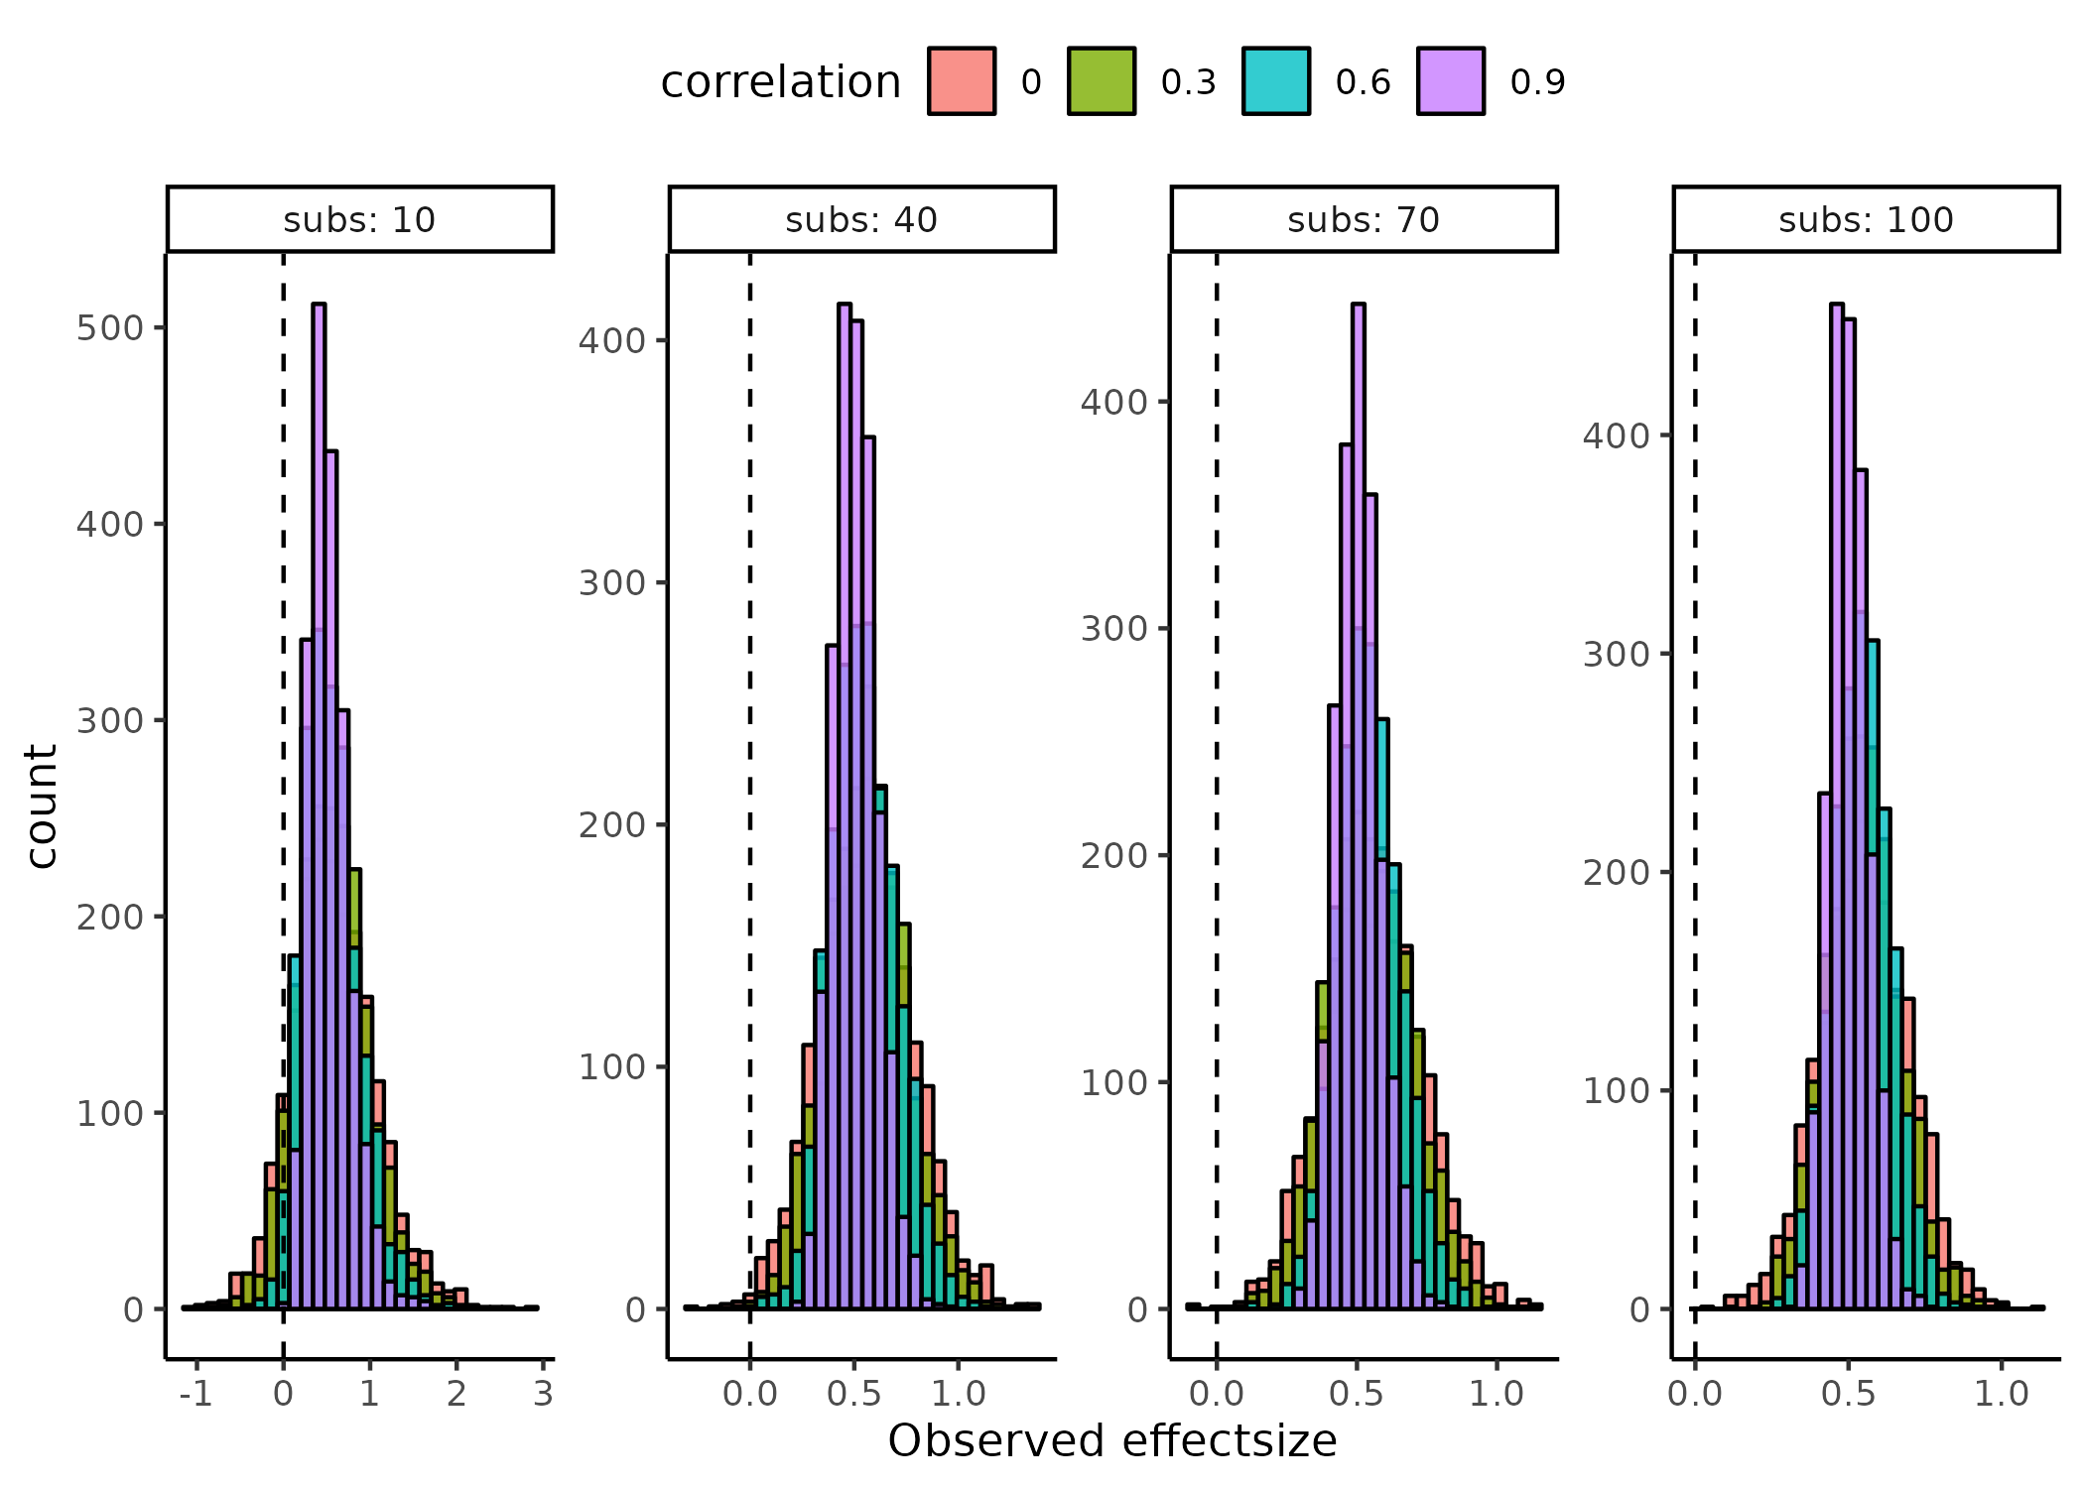

Figure 21. Sampling distributions of effectsizes across subjects (facets) and session by session correlations (colors)

Now we can visualize how these observed effect size distributions fit into the probability of rejecting the null hypothesis i.e. $Ψ\left(d_{\text{obs}},α,β,t,s\right)$  Note that the observed effect sizes above are not dependent on the number of trials in the experiment i.e. assuming that they are observed with perfect precision. What the function derived from the continuous power analysis above does, is that it incorporates this information, together with other factors that might change the precision of the parameters. As shown above the implications of the function $Ψ\left(d_{\text{obs}},α,β,t,s\right)$ can be visualized as psychometric functions in a ( $d_{\text{obs}}$, $Ψ\left(d_{\text{obs}},α,β,t,s\right)$) coordinate system with trials and subjects being fixed at values. Another more informative way for investigating varying trials and subjects is to visualize these implications in a 3-dimensional grid of (Subjects , $d_{\text{obs}}$, $Ψ\left(d_{\text{obs}},α,β,t,s\right)$) with facets being a particular set of trials. This visualization can also serve the purpose of projecting the above distributions in figure 21, of observing a particular effect-size, unto the space of $Ψ\left(d_{\text{obs}},α,β,t,s\right)$. Figure 22 displays the projection of the histograms as ellipse where the vertical width of the ellipse (the major axis) is given by the 95% Highest density interval of the histograms above and the horizontal width (the minor axis) is for visualization purposes, to see the underlying probability of rejection. The correlation is of cause informed by the test-retest reliability study which was found to be 0.54 [0.49; 0.58] for the current model.

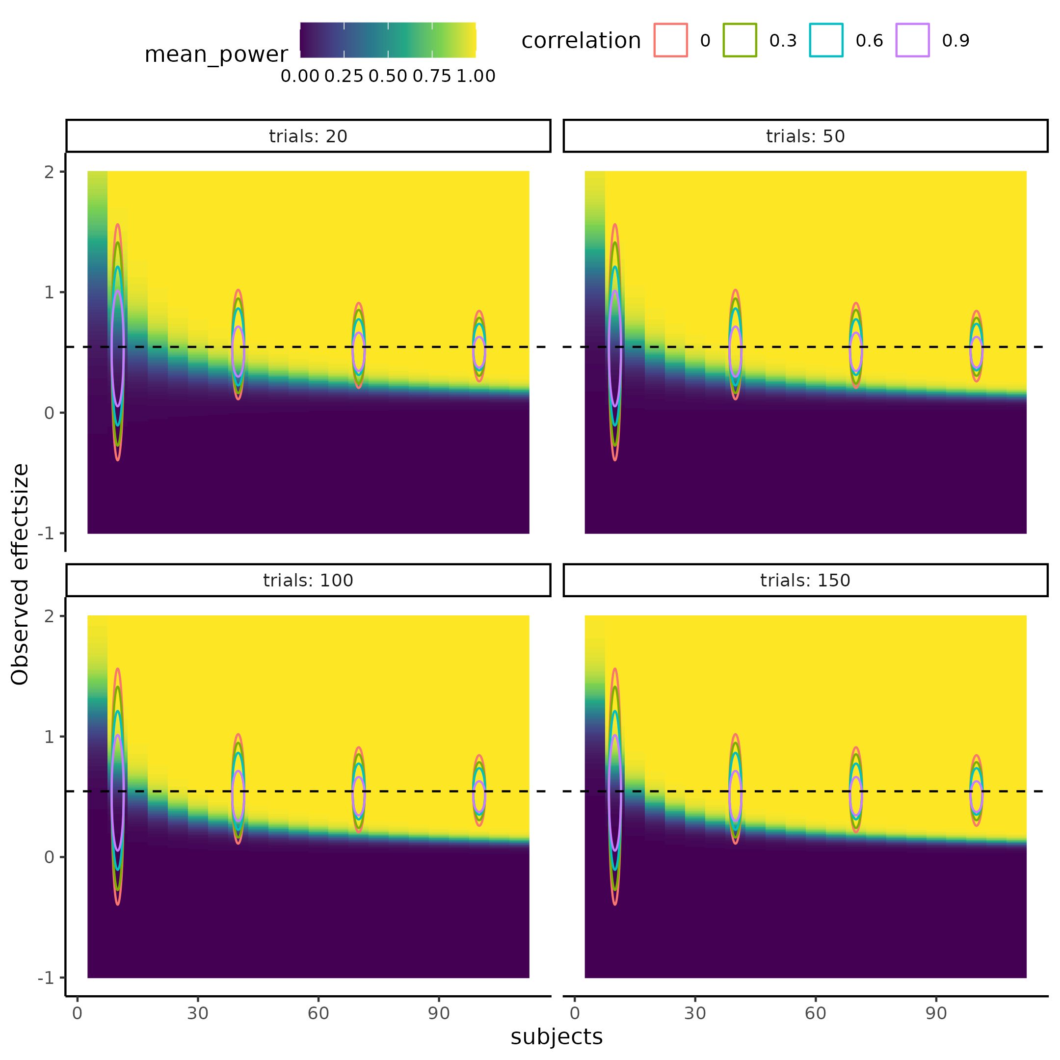

Figure 22. Visualization of how the power of a particular study is informed by the session by session correlation and the number of trials and subjects.

## *Practical implementation of the power analysis*

Now turning to a particular example of a researcher wanting to conduct a power analysis utilizing the information provided. Two assumptions have been made, either a mean effect size or a mean difference of the intervention is assumed, and the variance introduced by the intervention. Here we expect a mean difference of the intervention of 4 and that the intervention does not increase variability meaning that the variance in both groups should be equal. To fully appreciate the power of this approach one could even imagine sampling these values as random variables and not as point estimates. Using the effect size equations above, it is possible to derive the mean difference and therefore simulate observed effect sizes which are then put into $Ψ\left(d_{\text{obs}},α,β,t,s\right)$ and the probability of rejecting that draw is calculated. Repeating this process over the 4000 draws of the posterior distribution distribution of the parameters of $Ψ\left(d_{\text{obs}},α,β,t,s\right)$, and calculating the ratio of rejected to failed rejected null hypotheses gives an estimate of power.

In the case of not including the sampling varability (prior probability) of the effect size the effect size estimate is just repeatedly entered as 0.5. This idea of not including the sampling varability is equivalent of saying that a minimum effect size of 0.5 is deemed to be the minimum effect size of interest. As can now be seen in figure 23 the observed effect size has been “integrated” out and a grid of subjects by trial span the space of power to reject the null hypothesis. The left and right column of figure 23 quite clearly display the difference between accounting for the sampling process of effect sizes with the left not accounting for the sampling process. As a reference frame in figure 23 the red dashed line at subjects = 25 depicts the results from plugging the same assumptions, here $μ_{1}=−8$ $σ_{1}=8$ $μ_{2}=−4$ and $σ_{2}=8$ and $ρ=0.54$, into the widely used and cited statistical software tool G*power (Faul et al., 2007).

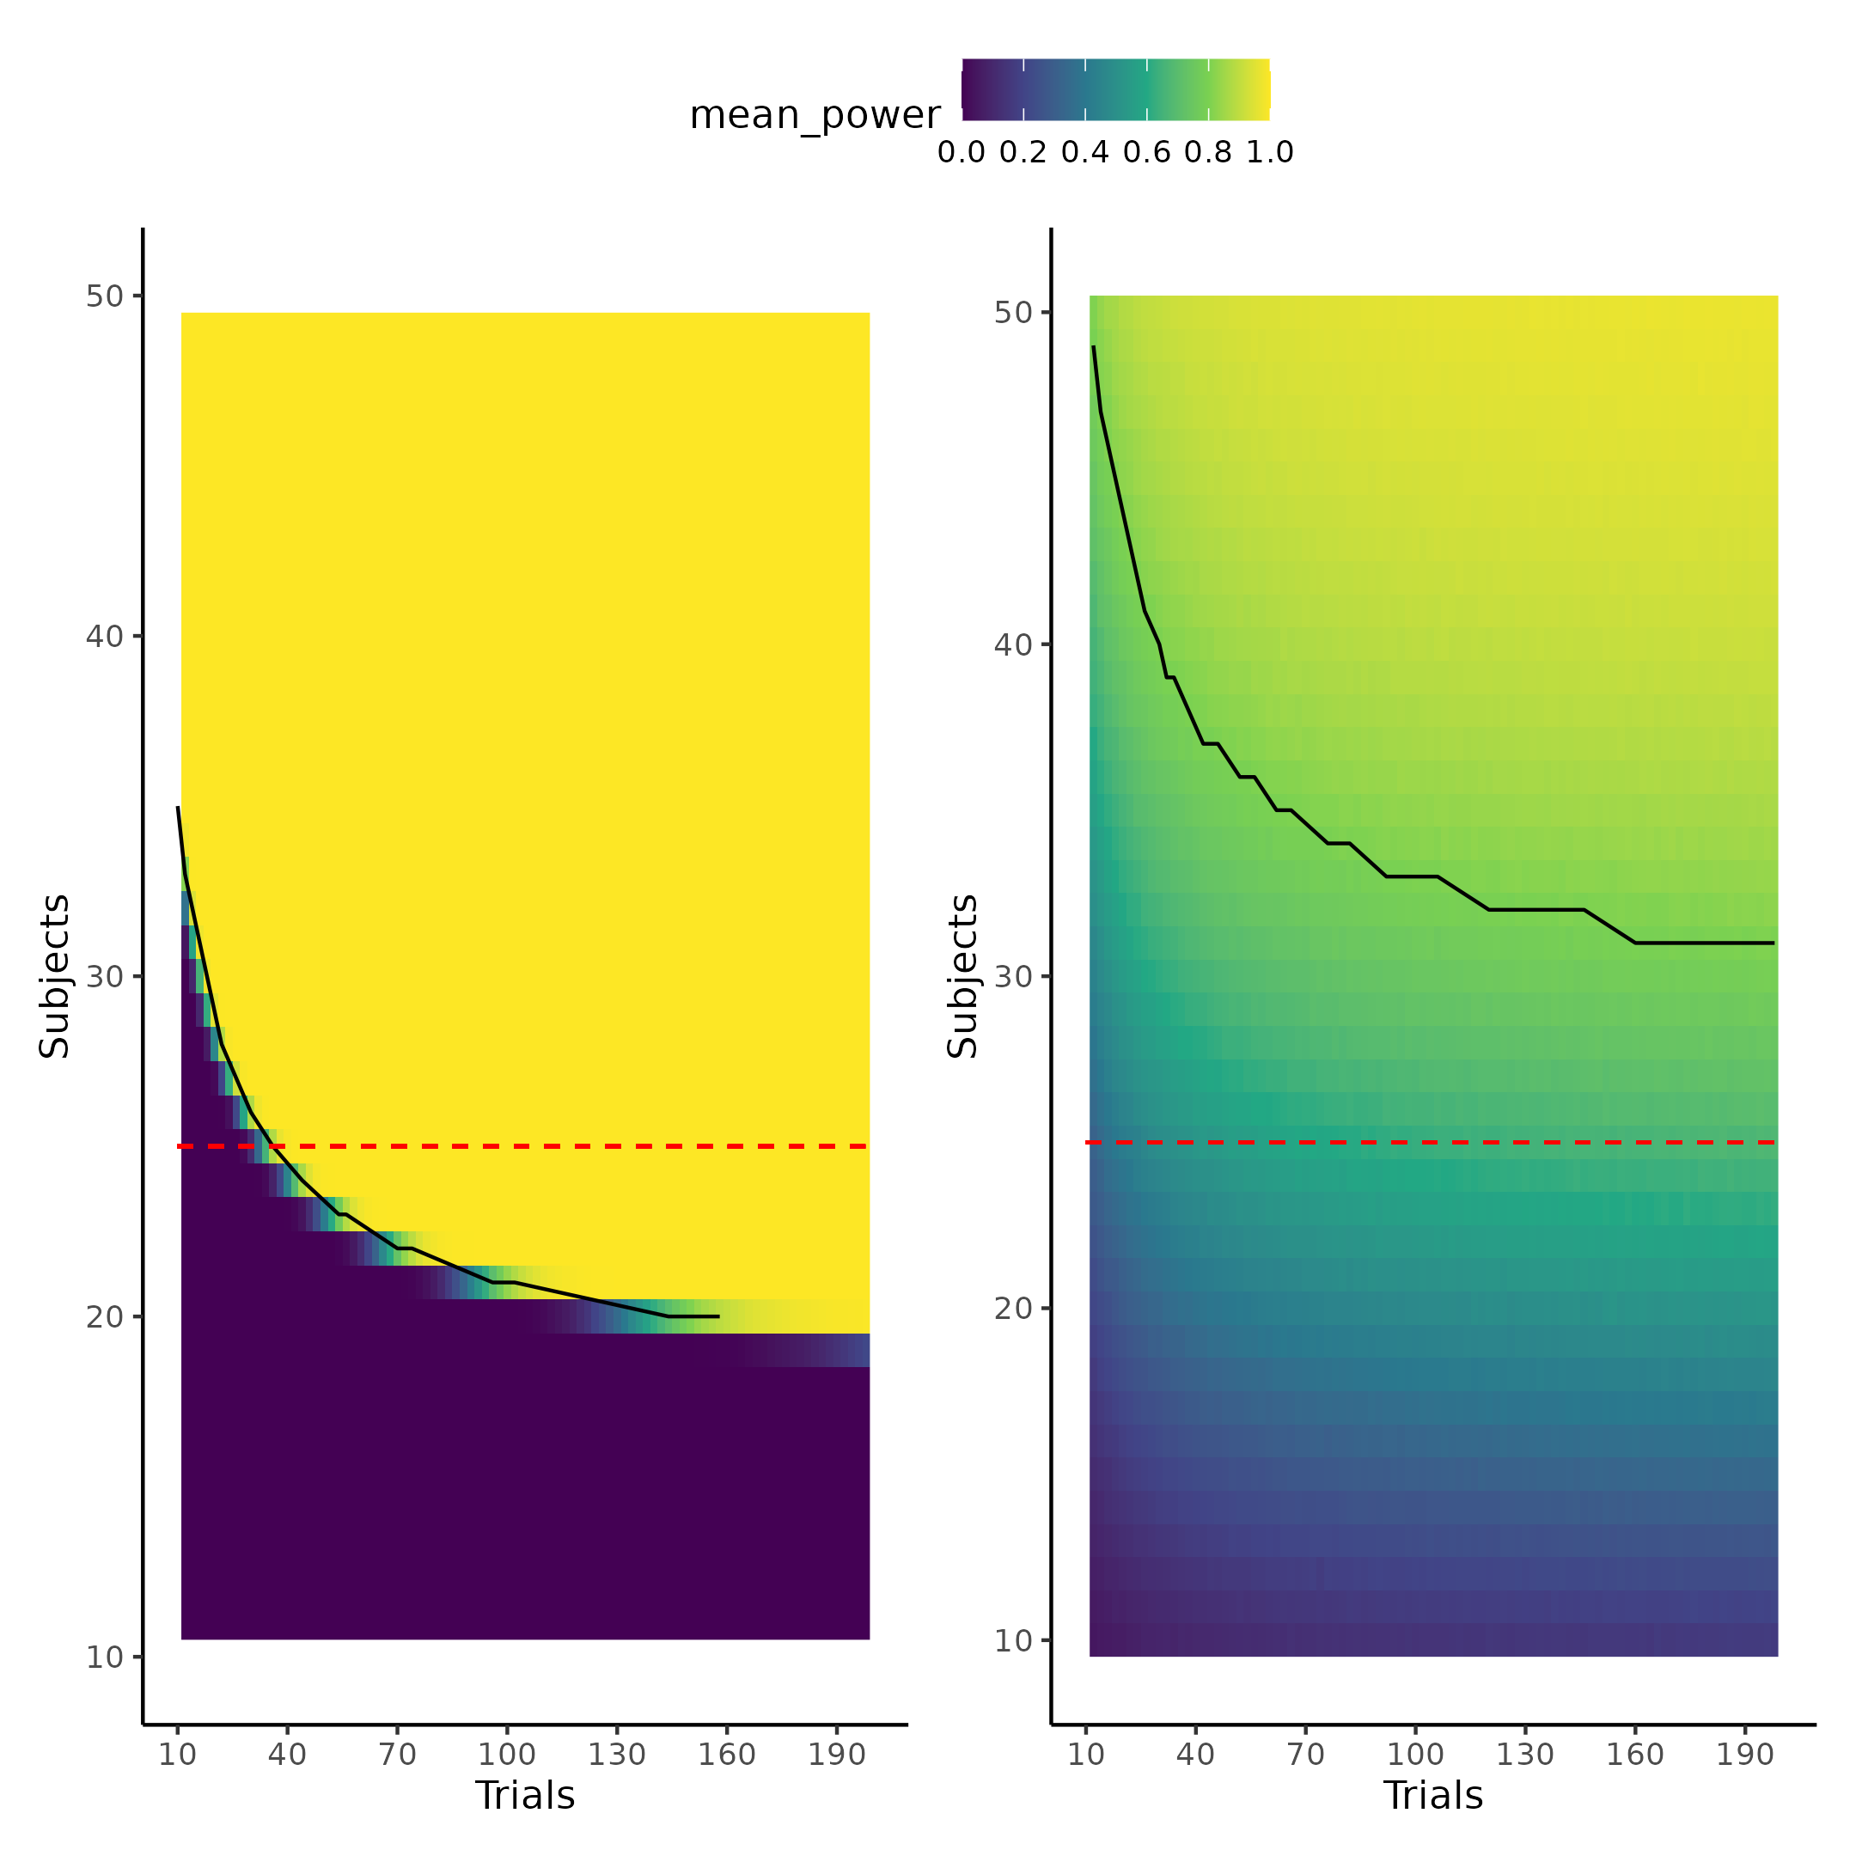

Figure 22.

# Discussion

The thesis has investigated how the handling of uncertainty in the field of cognitive science and especially in the developing field of cognitive modeling can be improved. The thesis has done this by demonstrating that using computational resources in the form of simulations, a deep mathematical understanding with rigorous closed end solutions is not necessary to get an understanding of how uncertainties on each level can and will influence every statistical metric. The thesis outlined three critical types of uncertainty; measurement uncertainty being the lowest level of uncertainty that is often completely neglected in the field, even though it influences the resulting statistical metrics in very unpredictable ways. Researchers should firstly be aware that measurement uncertainty is always present and examining the extent to which it can be safely ignored in their statistical models. Even in measures like reaction times which is commonly used in cognitive science (MacLeod & Dunbar, 1988; Pirolli & Anderson, 1985; Sternberg, 1969), measurement uncertainties are present, which depending on the soft and hard-ware the experiment might be a factor to account for (Crocetta & Andrade, 2015; Holden et al., 2019; Ohyanagi & Sengoku, 2010). Estimation uncertainty was introduced as the uncertainty associated with doing computations and is often displayed as the standard error of statistical metrics. The main focus of the thesis was to investigate this type of uncertainty in the field of cognitive modeling and revise some of the methods and metrics used to validate one of such models. This was done using a psychometric function that maps stimulus values to probabilities by three parameters the threshold ($α$), slope ($β$) and ($λ$). It was argued that using correlations, which has been used in many previous studies (Schurr et al., 2024), between simulated and recovered parameters values was not a particularly sensible metric to determine the extent of internal model validity. Two important things about the correlation coefficient made it insensible for internal model validity, the decision of choosing what size of correlation coefficient to deem model parameters sensible is not straightforward, because the interpretation of the correlation coefficient itself in the regard of model validation is not straightforward. This is particularly true when highlighting that the correlation coefficient is invariant of a linear transformations. The other reason was that in instances where the simulated and recovered parameter values did show good dependency the correlation coefficient rapidly approached the asymptote at 1. This was even the case when more information could be gained by increasing the number of trials, due to its limited inclusion of estimation uncertainty. The thesis therefore suggested that using a variant of the intra class correlation coefficient (ICC) as the statistical metric for examining internal model validity which has recently been suggested in the literature, would be more sensible (Schurr et al., 2024). The thesis found that this metric was much more sensitive to estimation uncertainty in the parameters, with a sensible interpretation of the ratio between desirable to undesirable uncertainty as its interpretation. With this new metric the thesis explored ways to decrease the undesirable variance and thereby increase the ICC metric for the psychometric function’s parameters. Two particular ways was investigated which revolved around, either by incorporating smart experimental designs that are optimized for each individual on a trial-by-trial basis or incorporating reaction times into the cognitive model describing how stimulus intensities are transformed to binary forced choices. These ways are neither mutually exclusive or incompatible and could easily be implemented in experiments to decrease estimation uncertainty in the parameters of the psychometric function without a need for more trials in the experiment itself. The second approach of jointly modeling several dependent variables and their interactions, has been around for quite some time but only now is slowly gaining traction in cognitive science literature (Hess et al., 2024; Pedersen et al., 2017; Stone, 2014). What these two ways to optimizing either experimental design and or analysis have in common is that they do not increase the efficiency of the study by mindlessly increasing trials as this could in principle have troublesome consequences in non-obvious ways. The obvious problems with increasing the number of trials are resource costs, both in terms of money, but also in the time spent for both the participant and the experimenter. From an ethical perspective this is especially true of the time investment from the participants’ side, and perhaps even more so if patient populations are investigated. However, the most problematic aspect becomes more obvious if we take a step back and think carefully about what we are studying. We are studying a complex system that has its own goals, desires and motivations and it is not trivial to know how this participant will behave if the task is double the length. Firstly, will the participant employ a different strategy knowing that the experiment is going to take X time longer, or will they halfway through employ a different strategy because of boredom. Even if the participant keeps the same underlying cognitive strategy that we are trying to model, then one reasonable assumption would be that attentional lapses and engagement in the task will decreasing, making each additional trial after a certain point less informative. The thesis highlights how the above implementations and considerations do not necessarily have to rest on heavy mathematical understandings and proofs as computational resources and especially simulations has made it possible for people with coding experience to gain these insights by the power of (re) sampling; some of the implications of this will be discussed below. The thesis went on to investigate the last type of uncertainty test retest uncertainty by exmaining a data-set from a test-retest reliability study. Here it was showed that a re-analyzis of the original data could achieve better test-retest reliability by incorporating knowledge about the structure of how the data was gathered together with incorporating information already represent in the data i.e. reaction times. This data-set was then used as an example of how power analyses of cognitive models can be conducted. This was done by first simulating and then fitting the cognitive model to many different simulated effect sizes in different trials and subject combinations. This approach allowed for modelling of the latent power curve that relates observed effect size, trials and subjects to the probability of rejecting a null hypothesis in an experiment. Using posterior predictive checks and leave one out cross validation a particular power law related the parameters of the power curve to subjects and trials with good predictive abilities. Using this equation and approach it was shown how the number of trials in an experiment can be added into a power analysis which is not standard practice when using widely used statistical software tools like G*power (AARTS et al., 2015; Faul et al., 2007; Ioannidis, 2005). This comparison showed how G*power’s estimation of sample size for the purposed test was a lot more liberal requiring around 25 subjects whereas the full uncertainty propagated power analysis based on simulations from the fitted model suggested around 30 subjects if the number of trials were larger than at least 150. Lastly this section also highlighted why and where the test re-test reliability of these metric matters as increasing test re-test reliability shrinks the influence of sampling variability in the observed effect sizes. The rest of the discussion of the current thesis will revolve around the implications of improperly accounting for uncertainties in the science and how this might be a contributing factor to the replication crisis.

## **Power analyses, certainty and replication crisis.**

In recent years many scientific fields, and especially psychology, social science and medicine has been under scrutiny due to a lack of and failure of replication of previous studies (Forbes et al., 2023; Wiggins & Christopherson, 2019). Many contributing factors has been laid out such as publication bias, questionable research practices like doing statistical analyses until significant (p-hacking) or hypothesizing after the results are known (HARKING) (Head et al., 2015; Kerr, 1998). A quite paradoxical aspect of this replication crisis and the use of power analyses is that many times it is advised as one of the ways to increase the replicability of studies, as (meta) analyses of power of detecting small to medium effect size in social sciences have been found to be low to very low (Felix Singleton & Fidler, 2023). It is therefore argued that a reason for such low replicability in these fields, might partly be due to very low probability of being able to detect the underlying effect in the first place i.e. low statistical power. The argument is sound as long as the analysis of power is accurate or accurate to a certain degree. What this thesis has highlighted is that the use of very popular tools like G*power for conducting these types of power analyses might underestimate the number of subjects by not including the effect of trials in the estimation process. However if this assumption is not true, then a problem might arise where researchers have more confidence in their experiment due to having conducted a power analysis than is actually justified. This mimics the false sense of certainty about the measurements assumed by these popular softwares or measurements in cognitive science in general. Therefore instead of increasing replicability and certainty in the effects observed, utilizing these tools might paradoxically decrease them, as researchers might be tricked into conducting less powered studies due to the recommendations of the software.

### *Ways of combating the replication crisis.*

Interestingly, quite a large number of scientists have suggested that moving the arbitrary statistical significance threshold to 0.005 instead of the commonly used 0.05, arguing that this could be an approach used to combat the replication crisis (Benjamin et al., 2018). Interestingly, lowing of the statistical threshold for significance would in practice lead to the conclusions drawn from this thesis of including and propagating uncertainty in most cases. This of cause depends on the structure and uncertainty measures of the data, however in most cases including and propagating uncertainties will lower the resulting statistic and therefore increase the resulting p-value of a particular test. These two approaches, i.e. increase the statistical significance threshold or properly propagating uncertainty, however have a very different reason to making these adjustments. Lowering of the significance threshold would be a means to an end, instead of addressing the underlying problems, which the authors also do acknowledge (Benjamin et al., 2018).

Another interesting idea that coincides with the general theme of the thesis to combat the replication crisis is that of preregistration, registered reports, and blind analyses (Chambers & Tzavella, 2022; Evans et al., 2023; Klein & Roodman, 2005; MacCoun & Perlmutter, 2015). What all these types of interventions have in common is that they acknowledge the subjectivity in not only the data collection, but also in the data analysis pipeline of the scientific inquiry. This subjectivity is both what introduces biases, but also what drives novel ideas, and therefore is a tradeoff between exploration and exploitation, that needs to be addressed to partly guard against unwanted subjectivity. What these interventions try to do is to have the analysis pipeline either fixed before data collection or have the data scrambled such that the results of the analyses are not known when producing the analysis pipeline. The rigorous checking, testing and validating of cognitive models the thesis outlined is not at stake with these interventions but facilitates them as they are build on simulations. However, there are still considerations when analyzing the experimental data especially on the model convergence side, where in or excluding covariates or reparameterization of the models might be necessary. This is where the blind analysis intervention might be a valuable insight from physics, where experimental data is scrambled in various ways such that models and analysis pipelines can be done on data that resembles the collected data, but without being able to know the results before the data is unblinded. Decisions are therefore made on scientific justifications instead of on completely subjective citeria that perhaps could make the experimental results fit a research paradigm or perhaps even worse, produce significant results, were none are present. The distinction between decisions based on scientific justification and subjective nonsensical rationale is fuzzy and narrow, however keeping incentives, such as publishing pressure, fitting a hypothesis or research paradigm out of the equation can help with this distinction (Quaia & Vernuccio, 2022). This might even give rise to more rigorous methods and analysis pipelines because it hinders arbitrarily stopping the development of the pipeline when the results fit the preconceived notions of the scientific paradigm. Instead it forces researchers to stop when they are satisfied with the assumptions and implementations made in the analysis pipeline. This process might also help researchers understand the uncertainty that is associated with many of the methods or practices commonly used in the literature, which are taken as either ground truths or good approximations when they are at best noisy estimates. This could for instance be the difference between taking an observed effect size from a previous study instead of relying or even incorporating some further scientifically justified assumptions that the researchers hold in their domain, that might give a much better approximation for the size of the underlying effect.

## *Why and how computational tools are becoming vital in science.*

Perhaps cognitive or even computational modeling is the fresh start that is needed in the sciences that has had trouble with replication. These more sophisticated models, compared to the general linear models employed in statistical modeling, might be the steppingstone to engage in more theoretically driven analyses, hopefully reducing the number of irreproducible studies. However for this movement to succeed, it is essential that rigorous metrics are enforced to access their internal validity, such that models without any even provable, in principle, parameters or behaviors are discarded from the beginning. Examples might arise where mathematical formulation of theories are developed, but that in practice the formulation is not tractable from a computational perspective. It would be a shame to spent years investigating these kinds of models and their implications in a field of research, just to discover that it in fact is intractable in practice (Ho & Griffiths, 2021; McClelland, 2009; Zuidema et al., 2020). One might think that a necessity of these more complicated models is a need for deeper mathematical understanding. What this thesis has argued is that this is not necessarily the case, as simulations allow researchers to observe the implications of their assumptions as well as investigate when they break. Another argument for why more sophisticated models are not necessarily off the shelf due to high level mathematically understanding is the increase in adaption of sophisticated hierarchical models which are mathematically much more complex than single level models in cognitive science, which have widely been adopted in the literature (Dedrick et al., 2009). This is not to say that a better understanding of the machinery and mathematics itself would not be helpful for researchers of various fields, but perhaps not a necessity anymore. This would therefore also imply that the way that statistical methods and tools are taught might need to change. Such that fields were mathematical methods are not common place, students and researchers could be taught statistical methods with the use of coding and simulation examples instead of flowcharts for which statistical analysis to conduct when. This would entail getting the tools to understand and reflect on these statistical models and therefore also the tools to understand when they break. In the same way that a good scientific program does not teach students the right theories or hypotheses, it teaches them to think in a scientific way such that the individual can decide and test these themselves. Here the tools for understanding, reflecting and experimenting with statistical models and concepts would be programming experience in statistics, which would facilitate the types of data simulations presented in the current thesis. This would allow the researcher to understand the assumptions that are being made concretely and examine what happens when they are broken in various ways. This approach also requires to think more generatively about the process of how the data has been generated, because in order to simulate it is necessarily to have a model of how it was generated, which might even help spark new scientific ideas. This approach would have researchers more closely engaged in the statistical process of analyzing the data, instead of just picking an off the shelf model from a flowchart.

## *Standing on the shoulders of giants*

All of the models used in the current paper were fitted using Stan with the cmdstanr interface, which uses full Bayesian statistical inference with Markov chain monte carlo (MCMC) sampling (Gabry et al., 2024). As described in the introduction section about modeling definitions, fitting and building models in this framework is extremely flexible as the sampling algorithm essentially serve as the optimizing process for the parameters of interest. An additional benefit of this framework is that the code for simulating the generative process is close to identical in nature, to the code that specifies the model, making it easy for users with a generative framework to code up these types of models. The additional benefits to using especially Stan and the its Hamiltonian Monte Carlo (HMC) algorithm is that when issues arise the algorithm will complain and let you know, reducing the risk for erroneous inference due to the sampling algorithm or typos in the code (Vehtari et al., 2021).

The thesis used Bayesian inference and Stan, mainly due to its flexibility in model formulation and not because of the inherent differences between Bayesian and frequentist statistics. However Bayesian inference does allow for a more optimistic way to interpret the replication crisis discussion above. This interpretation is that perhaps instead of starting each experimental analysis from the perspective that nothing or very little is known about the parameters of interest, perhaps incorporating information from previous studies would be beneficial. This is in essences what science is about, a hierarchical organization of knowledge, where each step rests on the step below, i.e. on auxiliary assumptions as put by the Duhem–Quine thesis (Ariew, 1984). This view on science also matches that of uncertainties as these are also hierarchically organized and when doing analyses on data with uncertainties these uncertainties has to be accounted for. So in the same way that the results of a scientific theory is only as strong as its auxiliary assumptions; the strength of an analysis is also only as strong as the certainty with which the data is measured with. What the Bayesian framework of inference allows, is that prior information from similar studies can be used in the modelling allowing researchers to not start their scientific studies from scratch, but pick up where others left off. This would essentially mean that instead of having to collect a larger number of subjects to achieve the actual desired power of the study, this could be done by two independent laboratories, the second using the information provided by the first. This essentially is already what is being done when conducting meta-analyses. This approach incentives publications of all types of finding as they serve as the stepping stones for the next researcher, making the problem of publication bias where null findings are unpublished less incentivized (Laitin et al., 2021).

## *Limitations*

One of the main focal points of the thesis was investigating how the correlation coefficient is an inappropriate metric to examine internal model validation of cognitive models. The modified intra class correlation (ICC) was purposed as a more sensible metric. As is the case in Figure 11, the correlation coefficient (otherwise commonly used metric) quickly becomes asymptotic whereas there is more granularity in the ICC. Another reason to favor the ICC compared to the correlation coefficient would be its more straightforward interpretation of a ratio of variances. This interpretation benefit also comes with the ICC’s sensitivity to linear transformation, not found in the correlation coefficient. Lastly future studies should investigate the link between how these metrics behave and compare them to the power analysis conducted, Figure 23 displayed how both trials and subjects effected the power of the study and the link between power and trials might be related to the link between trials and either of these two internal validity metrics. A clear link between these quantities would make the need for conducting a power analysis superfluous as the information would be contained in the ICC or correlation coefficient analysis. A thorough investigation of this link would mean that the somewhat arbitrary choice of trials when designing an experiment would no longer be arbitrary, but informed by how estimation uncertainty in the parameters of interest change based on the number of trials (Miller, 2024).

Another limitation of the current study is the quite limited power analysis conducted. Ideally the thesis would have investigated how other parameters of the psychometric function behaves as a function of trials and subjects. A particular interest would be on the slope of the psychometric function as changes in this parameter changes the estimation uncertainty of all the other parameters. One might suspect that an intervention that increases the steepness of the slope would also make it easier to detect a change in the threshold as both the correlation coefficient and ICC metric showed that with increased steepness of the function less estimation uncertainty was present in the estimation of the threshold and slope itself. This highlights how the parameters of the model interacts which can be accounted for by performing these simulations. Therefore future investigations should expand upon this power analysis for the other parameters and especially the slope of the psychometric function.

The thesis also did not investigate how incorporating the reaction times into the power analysis would change the number of subject and trials needed for observing a particular effect-size. Future studies investigating this would not only help elucidate the question posed above about the relationship between the internal model validation metric, trials and power, but could also give an estimate of the increased efficiency by incorporating information already present in most experiments. The reasoning for only conducting the single power analysis on the threshold in the current thesis highlights one of the main hurdles of the framework purposed, computational resources. Firstly fitting models using HMC and Bayesian inference is both more time and computational resource intensive compared to frequentist inference in packages such as lme4, lmertest or GAMLSS to name a few quite flexible models fitting packages in R (Bates et al., 2015; Kuznetsova et al., 2017; Stasinopoulos & Rigby, 2008). This added time for doing the optimization of posterior distributions of parameters has drawbacks in a need for access to bigger machines to necessitate the need for parallelization of the computational burden especially when several chains are needed to ensure convergence. Fortunately the access to bigger machine both privately but also on an institutional level is something that is growing in accessibility and already available to many universities or centers of research and has been correlated with research competitiveness (Apon et al., 2010). The current thesis was supported by Ucloud (see acknowledgement).

# References

AARTS, A. A., al, et, & LIN, S. C. (2015). Estimating the reproducibility of psychological science. *Science*, *349*(6251), 943–950. <https://doi.org/10.1126/science.aac4716>

Apon, A., Ahalt, S., Dantuluri, V., Gurdgiev, C., Limayem, M., Ngo, L., & Stealey, M. (2010). High Performance Computing Instrumentation and Research Productivity in US Universities. *JITI Journal of Information Technology Impact*, *10*, 87–98.

Ariew, R. (1984). The Duhem Thesis. *The British Journal for the Philosophy of Science*, *35*(4), 313–325. <https://www.jstor.org/stable/687336>

Bahrami, B., Olsen, K., Bang, D., Roepstorff, A., Rees, G., & Frith, C. (2012). What failure in collective decision-making tells us about metacognition. *Philosophical Transactions of the Royal Society of London. Series B, Biological Sciences*, *367*(1594), 1350–1365. <https://doi.org/10.1098/rstb.2011.0420>

Baldi Antognini, A., Frieri, R., & Zagoraiou, M. (2023). New insights into adaptive enrichment designs. *Statistical Papers*, *64*(4), 1305–1328. <https://doi.org/10.1007/s00362-023-01433-0>

Bates, D., Mächler, M., Bolker, B., & Walker, S. (2015). Fitting Linear Mixed-Effects Models Using **lme4**. *Journal of Statistical Software*, *67*(1). <https://doi.org/10.18637/jss.v067.i01>

Benjamin, D. J., Berger, J. O., Johannesson, M., Nosek, B. A., Wagenmakers, E.-J., Berk, R., Bollen, K. A., Brembs, B., Brown, L., Camerer, C., Cesarini, D., Chambers, C. D., Clyde, M., Cook, T. D., De Boeck, P., Dienes, Z., Dreber, A., Easwaran, K., Efferson, C., … Johnson, V. E. (2018). Redefine statistical significance. *Nature Human Behaviour*, *2*(1), 6–10. <https://doi.org/10.1038/s41562-017-0189-z>

Berker, A. O. de, Rutledge, R. B., Mathys, C., Marshall, L., Cross, G. F., Dolan, R. J., & Bestmann, S. (2016). Computations of uncertainty mediate acute stress responses in humans. *Nature Communications*, *7*(1), 10996. <https://doi.org/10.1038/ncomms10996>

Boekel, M. A. J. S. van. (2021). To pool or not to pool: That is the question in microbial kinetics. *International Journal of Food Microbiology*, *354*, 109283. <https://doi.org/10.1016/j.ijfoodmicro.2021.109283>

Chambers, C. D., & Tzavella, L. (2022). The past, present and future of Registered Reports. *Nature Human Behaviour*, *6*(1), 29–42. <https://doi.org/10.1038/s41562-021-01193-7>

Coates, D. R., & Chung, S. T. L. (2014). Changes across the psychometric function following perceptual learning of an RSVP reading task. *Frontiers in Psychology*, *5*, 1434. <https://doi.org/10.3389/fpsyg.2014.01434>

Cohen, S. (1994). *PERCEIVED STRESS SCALE*.

Courtin, A. S., Delvaux, A., Dufour, A., & Mouraux, A. (2023). Spatial summation of cold and warm detection: Evidence for increased precision when brisk stimuli are delivered over larger area. *Neuroscience Letters*, *797*, 137050. <https://doi.org/10.1016/j.neulet.2023.137050>

Crocetta, T., & Andrade, A. (2015). THE PROBLEM OF MEASURING REACTION TIME USING SOFTWARE AND HARDWARE: A SYSTEMATIC REVIEW. *Revista de Psicologia Del Deporte*, *24*, 341–349.

Dedrick, R. F., Ferron, J. M., Hess, M. R., Hogarty, K. Y., Kromrey, J. D., Lang, T. R., Niles, J. D., & Lee, R. S. (2009). Multilevel Modeling: A Review of Methodological Issues and Applications. *Review of Educational Research*, *79*(1), 69–102. <https://doi.org/10.3102/0034654308325581>

Durstewitz, D., Koppe, G., & Toutounji, H. (2016). Computational models as statistical tools. *Current Opinion in Behavioral Sciences*, *11*, 93–99. <https://doi.org/10.1016/j.cobeha.2016.07.004>

Efron, B. (1983). Estimating the Error Rate of a Prediction Rule: Improvement on Cross-Validation. *Journal of the American Statistical Association*, *78*(382), 316–331. <https://doi.org/10.1080/01621459.1983.10477973>

Efron, B., & Tibshirani, R. J. (1994). *An Introduction to the Bootstrap*. Chapman; Hall/CRC. <https://doi.org/10.1201/9780429246593>

Evans, T. R., Branney, P., Clements, A., & Hatton, E. (2023). Improving evidence-based practice through preregistration of applied research: Barriers and recommendations. *Accountability in Research*, *30*(2), 88–108. <https://doi.org/10.1080/08989621.2021.1969233>

Faul, F., Erdfelder, E., Lang, A.-G., & Buchner, A. (2007). G*Power 3: A flexible statistical power analysis program for the social, behavioral, and biomedical sciences. *Behavior Research Methods*, *39*(2), 175–191. <https://doi.org/10.3758/BF03193146>

Felix Singleton, T., & Fidler, F. (2023). *The statistical power of psychology research: A systematic review and meta-analysis*. <https://osf.io/yr8st/download>

Forbes, H. J., Travers, J. C., & Johnson, J. V. (2023). Chapter 11 - Supporting the replication of your research. In D. J. Cox, N. Y. Syed, M. T. Brodhead, & S. P. Quigley (Eds.), *Research Ethics in Behavior Analysis* (pp. 237–262). Academic Press. <https://doi.org/10.1016/B978-0-323-90969-3.00003-7>

Gabry, J., Češnovar, R., & Johnson, A. (2024). *Cmdstanr: R interface to CmdStan*. <https://mc-stan.org/cmdstanr/>

Geissinger, E. A., Khoo, C. L. L., Richmond, I. C., Faulkner, S. J. M., & Schneider, D. C. (2022). A case for beta regression in the natural sciences. *Ecosphere*, *13*(2), e3940. <https://doi.org/10.1002/ecs2.3940>

Gold, J. I., & Ding, L. (2013). How mechanisms of perceptual decision-making affect the psychometric function. *Progress in Neurobiology*, *103*, 98–114. <https://doi.org/10.1016/j.pneurobio.2012.05.008>

Gomes, D. G. E. (2022). Should I use fixed effects or random effects when I have fewer than five levels of a grouping factor in a mixed-effects model? *PeerJ*, *10*, e12794. <https://doi.org/10.7717/peerj.12794>

Goulet-Pelletier, J.-C., & Cousineau, D. (2018). A review of effect sizes and their confidence intervals, Part I: The Cohen’s d family. *The Quantitative Methods for Psychology*, *14*(4), 242–265. <https://doi.org/10.20982/tqmp.14.4.p242>

Harrison, O. K., Köchli, L., Marino, S., Luechinger, R., Hennel, F., Brand, K., Hess, A. J., Frässle, S., Iglesias, S., Vinckier, F., Petzschner, F. H., Harrison, S. J., & Stephan, K. E. (2021). Interoception of breathing and its relationship with anxiety. *Neuron*, *109*(24), 4080–4093.e8. <https://doi.org/10.1016/j.neuron.2021.09.045>

Head, M. L., Holman, L., Lanfear, R., Kahn, A. T., & Jennions, M. D. (2015). The Extent and Consequences of P-Hacking in Science. *PLoS Biology*, *13*(3), e1002106. <https://doi.org/10.1371/journal.pbio.1002106>

Hedges, L. V., & Olkin, I. (2014). *Statistical Methods for Meta-Analysis*. Academic Press.

Hess, A. J., Iglesias, S., Köchli, L., Marino, S., Müller-Schrader, M., Rigoux, L., Mathys, C., Harrison, O. K., Heinzle, J., Frässle, S., & Stephan, K. E. (2024). *Bayesian Workflow for Generative Modeling in Computational Psychiatry*. bioRxiv. <https://doi.org/10.1101/2024.02.19.581001>

Ho, M. K., & Griffiths, T. L. (2021). *Cognitive science as a source of forward and inverse models of human decisions for robotics and control*. arXiv. <https://doi.org/10.48550/arXiv.2109.00127>

Holden, J., Francisco, E., Lensch, R., Tommerdahl, A., Kirsch, B., Zai, L., Dennis, R., & Tommerdahl, M. (2019). *Accuracy of different modalities of reaction time testing: Implications for online cognitive assessment tools*. bioRxiv. <https://doi.org/10.1101/726364>

Hübner, R., & Pelzer, T. (2020). Improving parameter recovery for conflict drift-diffusion models. *Behavior Research Methods*, *52*(5), 1848–1866. <https://doi.org/10.3758/s13428-020-01366-8>

Ioannidis, J. P. A. (2005). Why Most Published Research Findings Are False. *PLoS Medicine*, *2*(8), e124. <https://doi.org/10.1371/journal.pmed.0020124>

Ivanova, A., Schrimpf, M., Anzellotti, S., Zaslavsky, N., Fedorenko, E., & Isik, L. (2022). *Beyond linear regression: Mapping models in cognitive neuroscience should align with research goals*. <https://doi.org/10.48550/arXiv.2208.10668>

Jain, A., Bansal, R., Kumar, A., & Singh, K. (2015). A comparative study of visual and auditory reaction times on the basis of gender and physical activity levels of medical first year students. *International Journal of Applied and Basic Medical Research*, *5*(2), 124–127. <https://doi.org/10.4103/2229-516X.157168>

Jeong, D., Aggarwal, S., Robinson, J., Kumar, N., Spearot, A., & Park, D. S. (2023). Exhaustive or exhausting? Evidence on respondent fatigue in long surveys. *Journal of Development Economics*, *161*, 102992. <https://doi.org/10.1016/j.jdeveco.2022.102992>

Johannes, W. J., & Smilde, P. L. (2009). Fundamentals of Gravity, Elements of Potential Theory. In W. J. Johannes & P. L. Smilde (Eds.), *Gravity Interpretation: Fundamentals and Application of Gravity Inversion and Geological Interpretation* (pp. 23–111). Springer. <https://doi.org/10.1007/978-3-540-85329-9_2>

Johnson, S. U., Ulvenes, P. G., Øktedalen, T., & Hoffart, A. (2019). Psychometric Properties of the General Anxiety Disorder 7-Item (GAD-7) Scale in a Heterogeneous Psychiatric Sample. *Frontiers in Psychology*, *10*, 1713. <https://doi.org/10.3389/fpsyg.2019.01713>

Kerr, N. L. (1998). HARKing: Hypothesizing After the Results are Known. *Personality and Social Psychology Review*, *2*(3), 196–217. <https://doi.org/10.1207/s15327957pspr0203_4>

Klein, J. R., & Roodman, A. (2005). BLIND ANALYSIS IN NUCLEAR AND PARTICLE PHYSICS. *Annual Review of Nuclear and Particle Science*, *55*(1), 141–163. <https://doi.org/10.1146/annurev.nucl.55.090704.151521>

Kontsevich, L. L., & Tyler, C. W. (1999). Bayesian adaptive estimation of psychometric slope and threshold. *Vision Research*, *39*(16), 2729–2737. <https://doi.org/10.1016/s0042-6989(98)00285-5>

Kroenke, K., Spitzer, R. L., & Williams, J. B. W. (2001). The PHQ-9. *Journal of General Internal Medicine*, *16*(9), 606–613. <https://doi.org/10.1046/j.1525-1497.2001.016009606.x>

Kruschke, J. K. (2021). Bayesian Analysis Reporting Guidelines. *Nature Human Behaviour*, *5*(10), 1282–1291. <https://doi.org/10.1038/s41562-021-01177-7>

Kubinec, R. (2023). Ordered Beta Regression: A Parsimonious, Well-Fitting Model for Continuous Data with Lower and Upper Bounds. *Political Analysis*, *31*(4), 519–536. <https://doi.org/10.1017/pan.2022.20>

Kuznetsova, A., Brockhoff, P. B., & Christensen, R. H. B. (2017). **lmerTest** Package: Tests in Linear Mixed Effects Models. *Journal of Statistical Software*, *82*(13). <https://doi.org/10.18637/jss.v082.i13>

Kwon, M., Lee, S. H., & Ahn, W.-Y. (2023). Adaptive Design Optimization as a Promising Tool for Reliable and Efficient Computational Fingerprinting. *Biological Psychiatry: Cognitive Neuroscience and Neuroimaging*, *8*(8), 798–804. <https://doi.org/10.1016/j.bpsc.2022.12.003>

Laitin, D. D., Miguel, E., Alrababa’h, A., Bogdanoski, A., Grant, S., Hoeberling, K., Hyunjung Mo, C., Moore, D. A., Vazire, S., Weinstein, J., & Williamson, S. (2021). Reporting all results efficiently: A RARE proposal to open up the file drawer. *Proceedings of the National Academy of Sciences of the United States of America*, *118*(52), e2106178118. <https://doi.org/10.1073/pnas.2106178118>

Lakens, D. (2013). Calculating and reporting effect sizes to facilitate cumulative science: A practical primer for t-tests and ANOVAs. *Frontiers in Psychology*, *4*. <https://doi.org/10.3389/fpsyg.2013.00863>

Legrand, N., Nikolova, N., Correa, C., Brændholt, M., Stuckert, A., Kildahl, N., Vejlø, M., Fardo, F., & Allen, M. (2022). The heart rate discrimination task: A psychophysical method to estimate the accuracy and precision of interoceptive beliefs. *Biological Psychology*, *168*, 108239. <https://doi.org/10.1016/j.biopsycho.2021.108239>

Lithfous, S., Després, O., Pebayle, T., Casadio, C., & Dufour, A. (2020). Accurate Determination of the Cold Detection Threshold with High-Speed Cooling of the Skin. *Pain Medicine (Malden, Mass.)*, *21*(12), 3428–3436. <https://doi.org/10.1093/pm/pnaa246>

Luijcks, R., Vossen, C. J., Hermens, H. J., Os, J. van, & Lousberg, R. (2015). The Influence of Perceived Stress on Cortical Reactivity: A Proof-Of-Principle Study. *PLoS ONE*, *10*(6), e0129220. <https://doi.org/10.1371/journal.pone.0129220>

Ma, A. C., Cameron, A. D., & Wiener, M. (2024). Memorability shapes perceived time (and vice versa). *Nature Human Behaviour*, 1–13. <https://doi.org/10.1038/s41562-024-01863-2>

MacCoun, R., & Perlmutter, S. (2015). Blind analysis: Hide results to seek the truth. *Nature*, *526*(7572), 187–189. <https://doi.org/10.1038/526187a>

MacLeod, C. M., & Dunbar, K. (1988). Training and Stroop-like interference: Evidence for a continuum of automaticity. *Journal of Experimental Psychology: Learning, Memory, and Cognition*, *14*(1), 126–135. <https://doi.org/10.1037/0278-7393.14.1.126>

Makowski, D., Wiernik, B. M., Patil, I., Lüdecke, D., & Ben-Shachar, M. S. (2022). *correlation: Methods for correlation analysis*. <https://CRAN.R-project.org/package=correlation>

Makowski, D., Wiernik, B. M., Patil, I., Lüdecke, D., & Ben-Shachar, M. S. (2023). *Correlation: Methods for correlation analysis*. <https://easystats.github.io/correlation/>

Mathys, C. D., Lomakina, E. I., Daunizeau, J., Iglesias, S., Brodersen, K. H., Friston, K. J., & Stephan, K. E. (2014). Uncertainty in perception and the Hierarchical Gaussian Filter. *Frontiers in Human Neuroscience*, *8*. <https://doi.org/10.3389/fnhum.2014.00825>

Mathys, C., Daunizeau, J., Friston, K. J., & Stephan, K. E. (2011). A Bayesian Foundation for Individual Learning Under Uncertainty. *Frontiers in Human Neuroscience*, *5*. <https://doi.org/10.3389/fnhum.2011.00039>

McClelland, J. L. (2009). The Place of Modeling in Cognitive Science. *Topics in Cognitive Science*, *1*(1), 11–38. <https://doi.org/10.1111/j.1756-8765.2008.01003.x>

Meier, M., Martarelli, C. S., & Wolff, W. (2024). Is boredom a source of noise and/or a confound in behavioral science research? *Humanities and Social Sciences Communications*, *11*(1), 1–8. <https://doi.org/10.1057/s41599-024-02851-7>

Miller, J. (2024). How Many Participants? How Many Trials? Maximizing the Power of Reaction Time Studies. *Behavior Research Methods*, *56*(3), 2398–2421. <https://doi.org/10.3758/s13428-023-02155-9>

Ohyanagi, T., & Sengoku, Y. (2010). A solution for measuring accurate reaction time to visual stimuli realized with a programmable microcontroller. *Behavior Research Methods*, *42*(1), 242–253. <https://doi.org/10.3758/BRM.42.1.242>

Pedersen, M. L., Frank, M. J., & Biele, G. (2017). The drift diffusion model as the choice rule in reinforcement learning. *Psychonomic Bulletin & Review*, *24*(4), 1234–1251. <https://doi.org/10.3758/s13423-016-1199-y>

Pirolli, P. L., & Anderson, J. R. (1985). The role of practice in fact retrieval. *Journal of Experimental Psychology: Learning, Memory, and Cognition*, *11*(1), 136–153. <https://doi.org/10.1037/0278-7393.11.1.136>

Prins, N. (2013). The psi-marginal adaptive method: How to give nuisance parameters the attention they deserve (no more, no less). *Journal of Vision*, *13*(7), 3. <https://doi.org/10.1167/13.7.3>

Quaia, E., & Vernuccio, F. (2022). Finding a Good Balance between Pressure to Publish and Scientific Integrity and How to Overcome Temptation of Scientific Misconduct. *Tomography*, *8*(4), 1851–1853. <https://doi.org/10.3390/tomography8040155>

R Core Team. (2024). *R: A language and environment for statistical computing*. R Foundation for Statistical Computing. <https://www.R-project.org/>

Ranger, J., Kuhn, J. T., & Ortner, T. M. (2020). Modeling Responses and Response Times in Tests With the Hierarchical Model and the Three-Parameter Lognormal Distribution. *Educational and Psychological Measurement*, *80*(6), 1059–1089. <https://doi.org/10.1177/0013164420908916>

Saccenti, E., Hendriks, M. H. W. B., & Smilde, A. K. (2020). Corruption of the Pearson correlation coefficient by measurement error and its estimation, bias, and correction under different error models. *Scientific Reports*, *10*(1), 438. <https://doi.org/10.1038/s41598-019-57247-4>

Schurr, R., Reznik, D., Hillman, H., Bhui, R., & Gershman, S. J. (2024). Dynamic computational phenotyping of human cognition. *Nature Human Behaviour*, 1–15. <https://doi.org/10.1038/s41562-024-01814-x>

Stasinopoulos, D. M., & Rigby, R. A. (2008). Generalized Additive Models for Location Scale and Shape (GAMLSS) in R. *Journal of Statistical Software*, *23*, 1–46. <https://doi.org/10.18637/jss.v023.i07>

Sternberg, S. (1969). Memory-Scanning: Mental Processes Revealed by Reaction-Time Experiments. *American Scientist*, *57*(4), 421–457. <https://www.jstor.org/stable/27828738>

Stone, J. V. (2014). Using reaction times and binary responses to estimate psychophysical performance: An information theoretic analysis. *Frontiers in Neuroscience*, *8*. <https://doi.org/10.3389/fnins.2014.00035>

Vehtari, A., Gelman, A., & Gabry, J. (2017). Practical Bayesian model evaluation using leave-one-out cross-validation and WAIC. *Statistics and Computing*, *27*(5), 1413–1432. <https://doi.org/10.1007/s11222-016-9696-4>

Vehtari, A., Gelman, A., Simpson, D., Carpenter, B., & Bürkner, P.-C. (2021). Rank-normalization, folding, and localization: An improved $\widehat{R}$ for assessing convergence of MCMC. *Bayesian Analysis*, *16*(2). <https://doi.org/10.1214/20-BA1221>

Vehtari, A., Simpson, D., Gelman, A., Yao, Y., & Gabry, J. (2024). *Pareto Smoothed Importance Sampling*. arXiv. <https://doi.org/10.48550/arXiv.1507.02646>

Watson, A. B. (2017). QUEST+: A general multidimensional Bayesian adaptive psychometric method. *Journal of Vision*, *17*(3), 10. <https://doi.org/10.1167/17.3.10>

White, C. N., Servant, M., & Logan, G. D. (2018). Testing the validity of conflict drift-diffusion models for use in estimating cognitive processes: A parameter-recovery study. *Psychonomic Bulletin & Review*, *25*(1), 286–301. <https://doi.org/10.3758/s13423-017-1271-2>

Wichmann, F. A., & Hill, N. J. (2001). The psychometric function: I. Fitting, sampling, and goodness of fit. *Perception & Psychophysics*, *63*(8), 1293–1313. <https://doi.org/10.3758/BF03194544>

Wiggins, B. J., & Christopherson, C. D. (2019). The replication crisis in psychology: An overview for theoretical and philosophical psychology. *Journal of Theoretical and Philosophical Psychology*, *39*(4), 202–217. <https://doi.org/10.1037/teo0000137>

Wilson, R. C., & Collins, A. G. (2019). Ten simple rules for the computational modeling of behavioral data. *eLife*, *8*, e49547. <https://doi.org/10.7554/eLife.49547>

Wu, C. F. J. (1986). Jackknife, Bootstrap and Other Resampling Methods in Regression Analysis. *The Annals of Statistics*, *14*(4), 1261–1295. <https://doi.org/10.1214/aos/1176350142>

Wu, J., Tong, H., Liu, Z., Tao, J., Chen, L., Chan, C. C. H., & Lee, T. M. C. (2021). Neurobiological effects of perceived stress are different between adolescents and middle-aged adults. *Brain Imaging and Behavior*, *15*(2), 846–854. <https://doi.org/10.1007/s11682-020-00294-7>

Xiao, T., Zhu, F., Wang, D., Liu, X., Xi, S.-J., & Yu, Y. (2023). Psychometric validation of the Perceived Stress Scale (PSS-10) among family caregivers of people with schizophrenia in China. *BMJ Open*, *13*(11), e076372. <https://doi.org/10.1136/bmjopen-2023-076372>

Yang, J., Pitt, M. A., Ahn, W.-Y., & Myung, J. I. (2021). ADOpy: A python package for adaptive design optimization. *Behavior Research Methods*, *53*(2), 874–897. <https://doi.org/10.3758/s13428-020-01386-4>

Yao, Y., Vehtari, A., Simpson, D., & Gelman, A. (2018). Using Stacking to Average Bayesian Predictive Distributions (with Discussion). *Bayesian Analysis*, *13*(3), 917–1007. <https://doi.org/10.1214/17-BA1091>

Zhang, L., Carpenter, B., Gelman, A., & Vehtari, A. (2022). *Pathfinder: Parallel quasi-Newton variational inference*. arXiv. <http://arxiv.org/abs/2108.03782>

Zuidema, W., French, R. M., Alhama, R. G., Ellis, K., O’Donnell, T. J., Sainburg, T., & Gentner, T. Q. (2020). Five Ways in Which Computational Modeling Can Help Advance Cognitive Science: Lessons From Artificial Grammar Learning. *Topics in Cognitive Science*, *12*(3), 925–941. <https://doi.org/10.1111/tops.12474>

# Supplementary material

## **Supplementary Figures**

### Supplementary figure 1

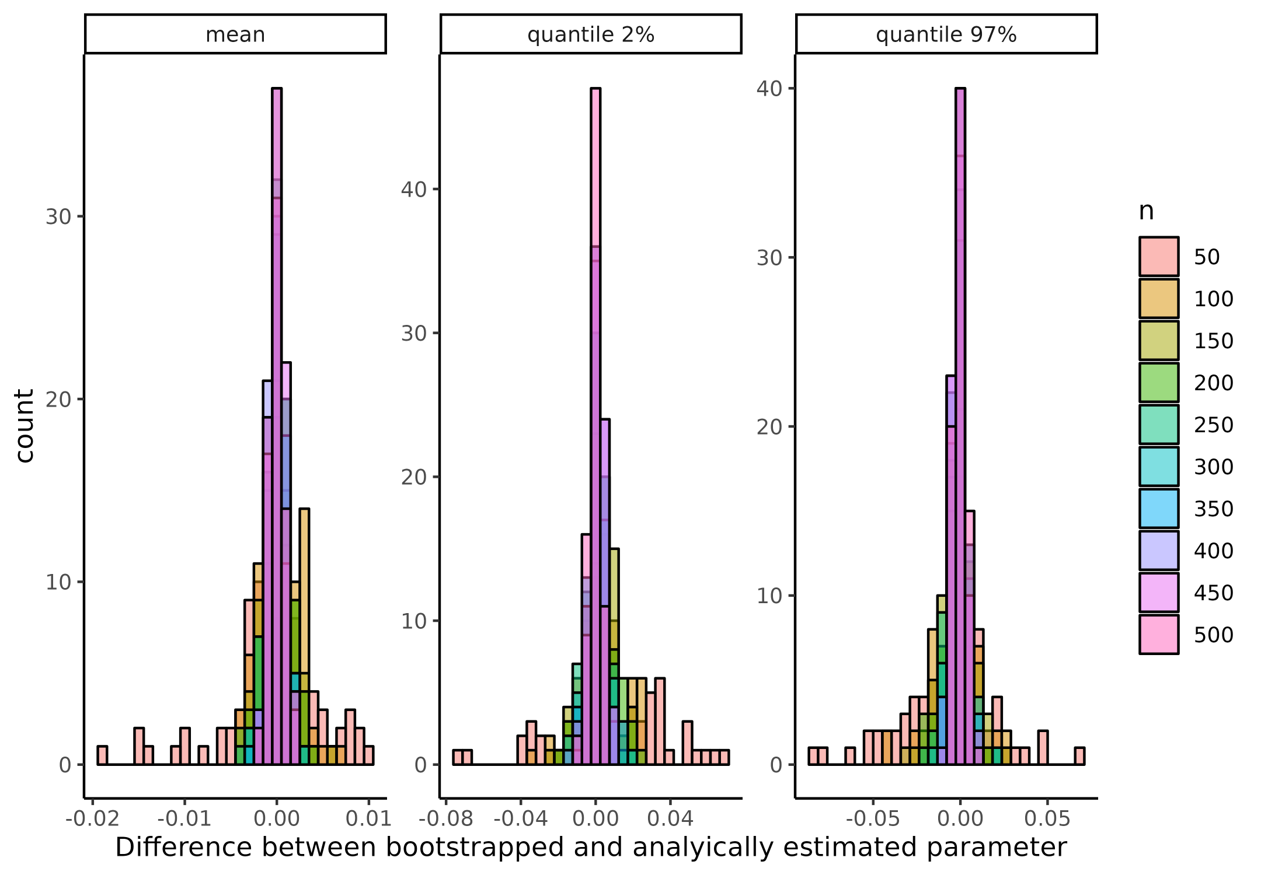

**Supplemenary figure 1 Comparison of analytical and bootstrapping correlation coefficient.** Histograms of the difference between different metrics of the correlation coefficient when bootstrapping and analytically calculating the correlation coefficient. Facets shows the different used metrics when evaluating the correlation coefficient i.e. the mean, the 2% quantile and the 97% quantile. colors represent the sample size, i.e. the number of datapoints the simulated correlation coefficient was based on.

### Supplementary figure 2

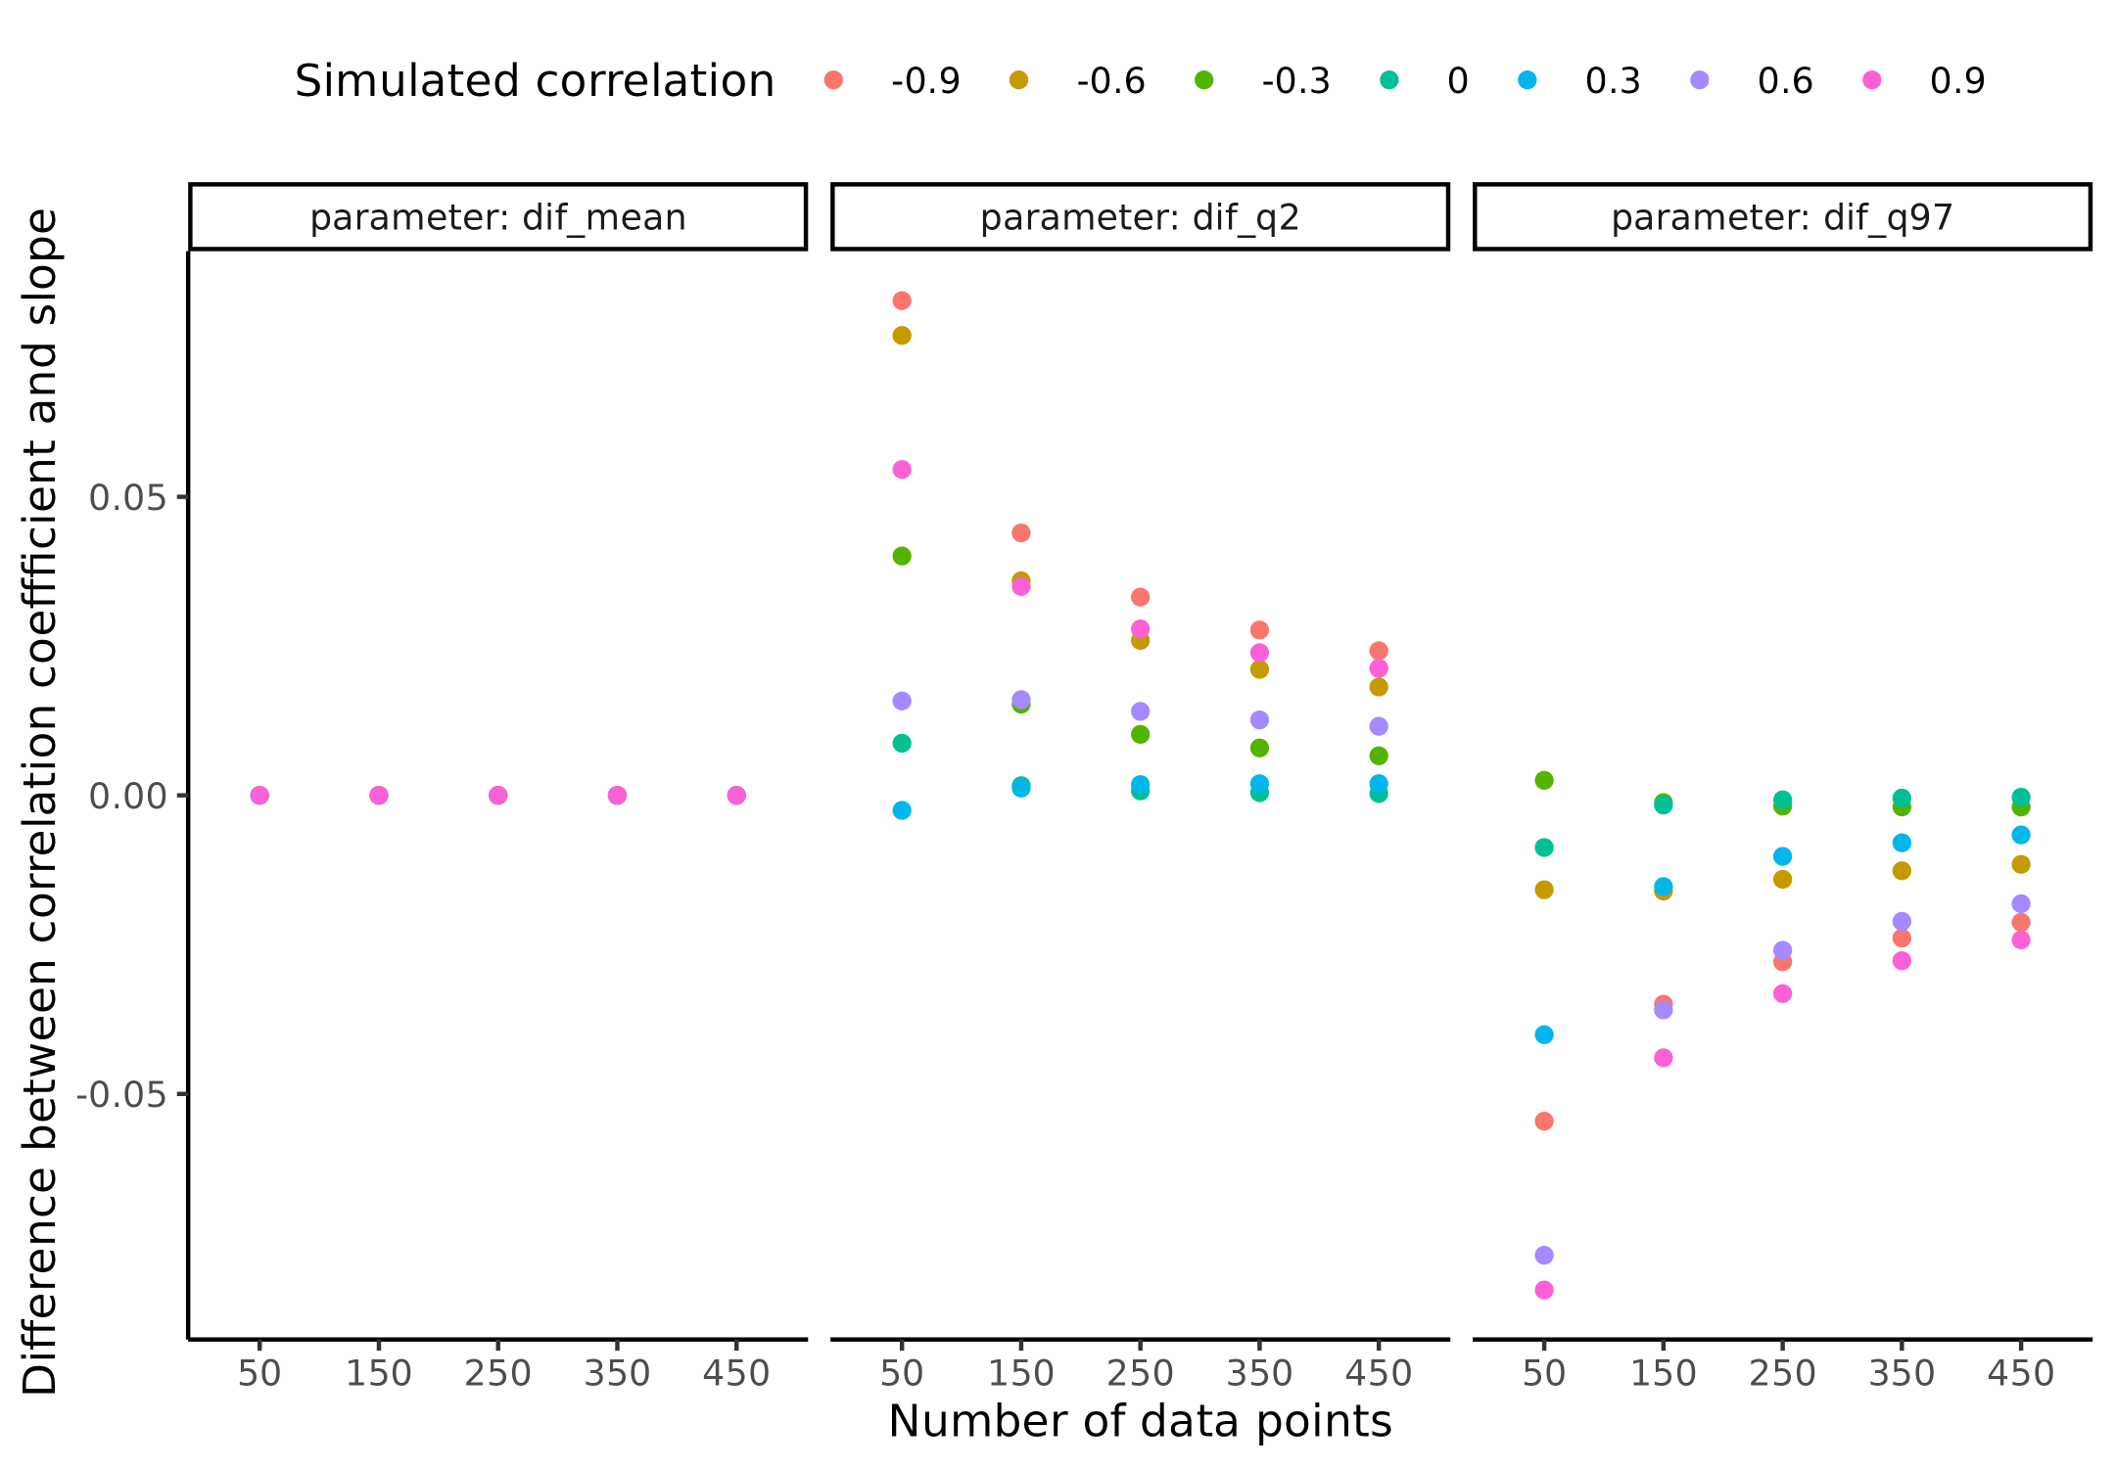 ### Supplementary figure 3

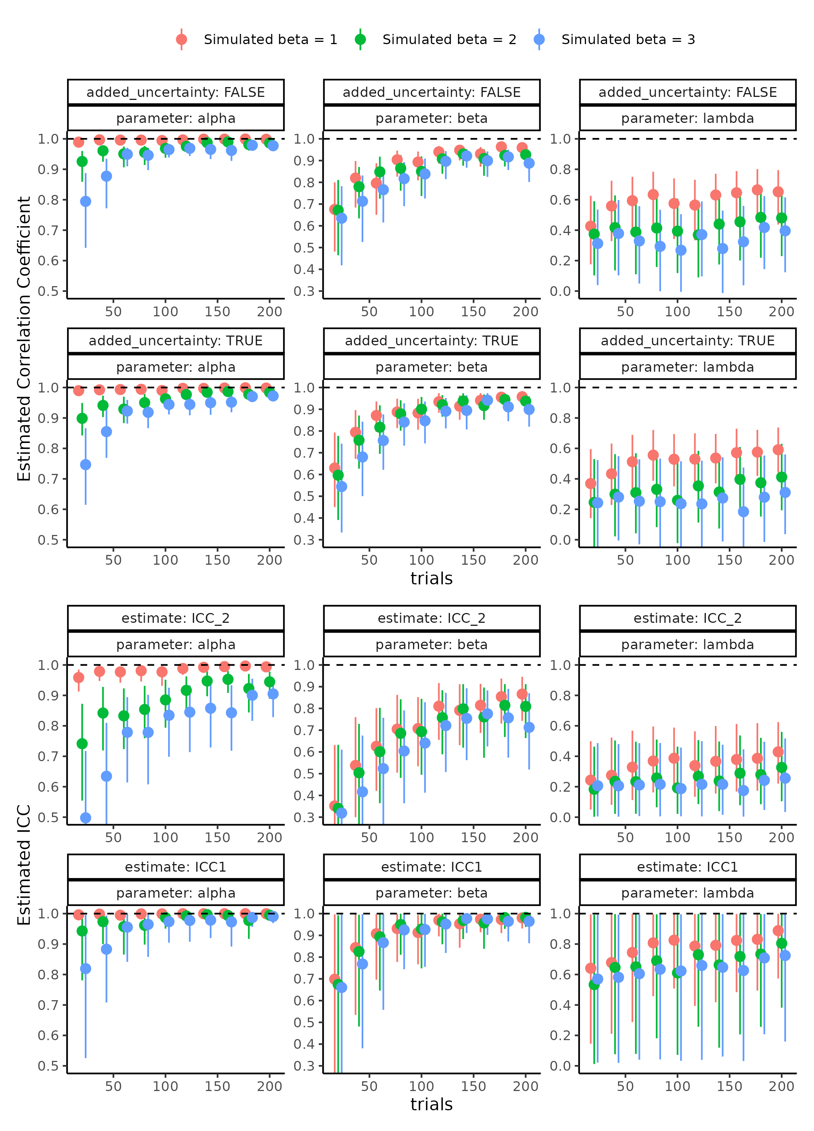

**Supplemenary figure 3 Parameter recovery of the psychometric function for all four parameter recovery metrics investigated.**

### Supplementary figure 4

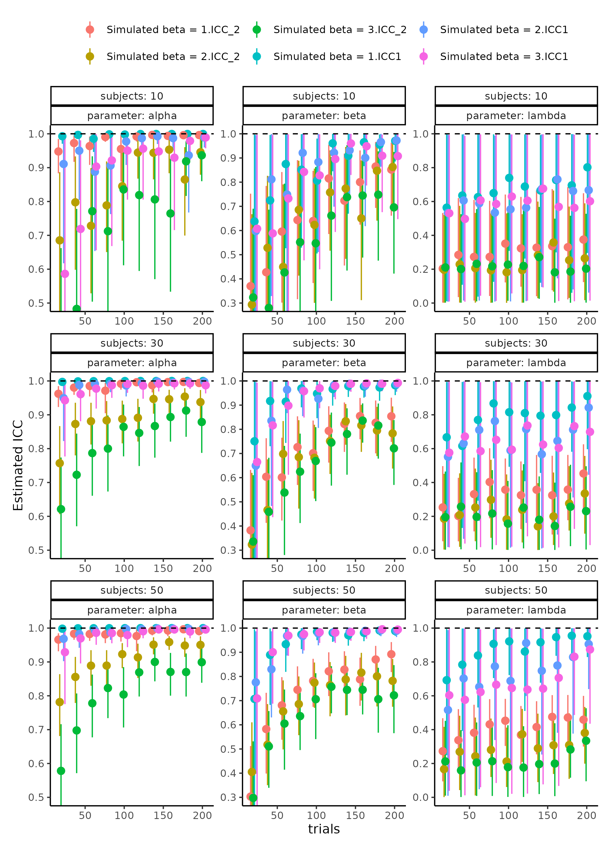

**Supplemenary figure 3 Parameter recovery of the psychometric function for all four parameter recovery metrics investigated.**

### Supplementary figure 5

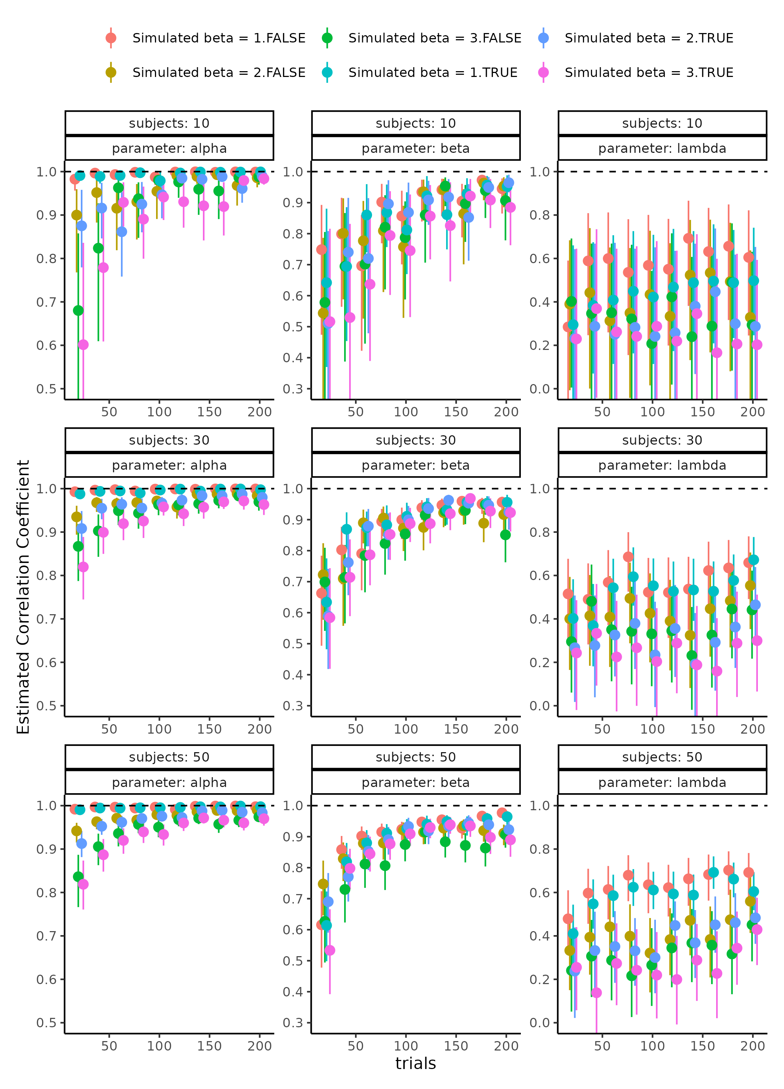

**Supplemenary figure 3 Parameter recovery of the psychometric function for all four parameter recovery metrics investigated.**

### Supplementary figure 6

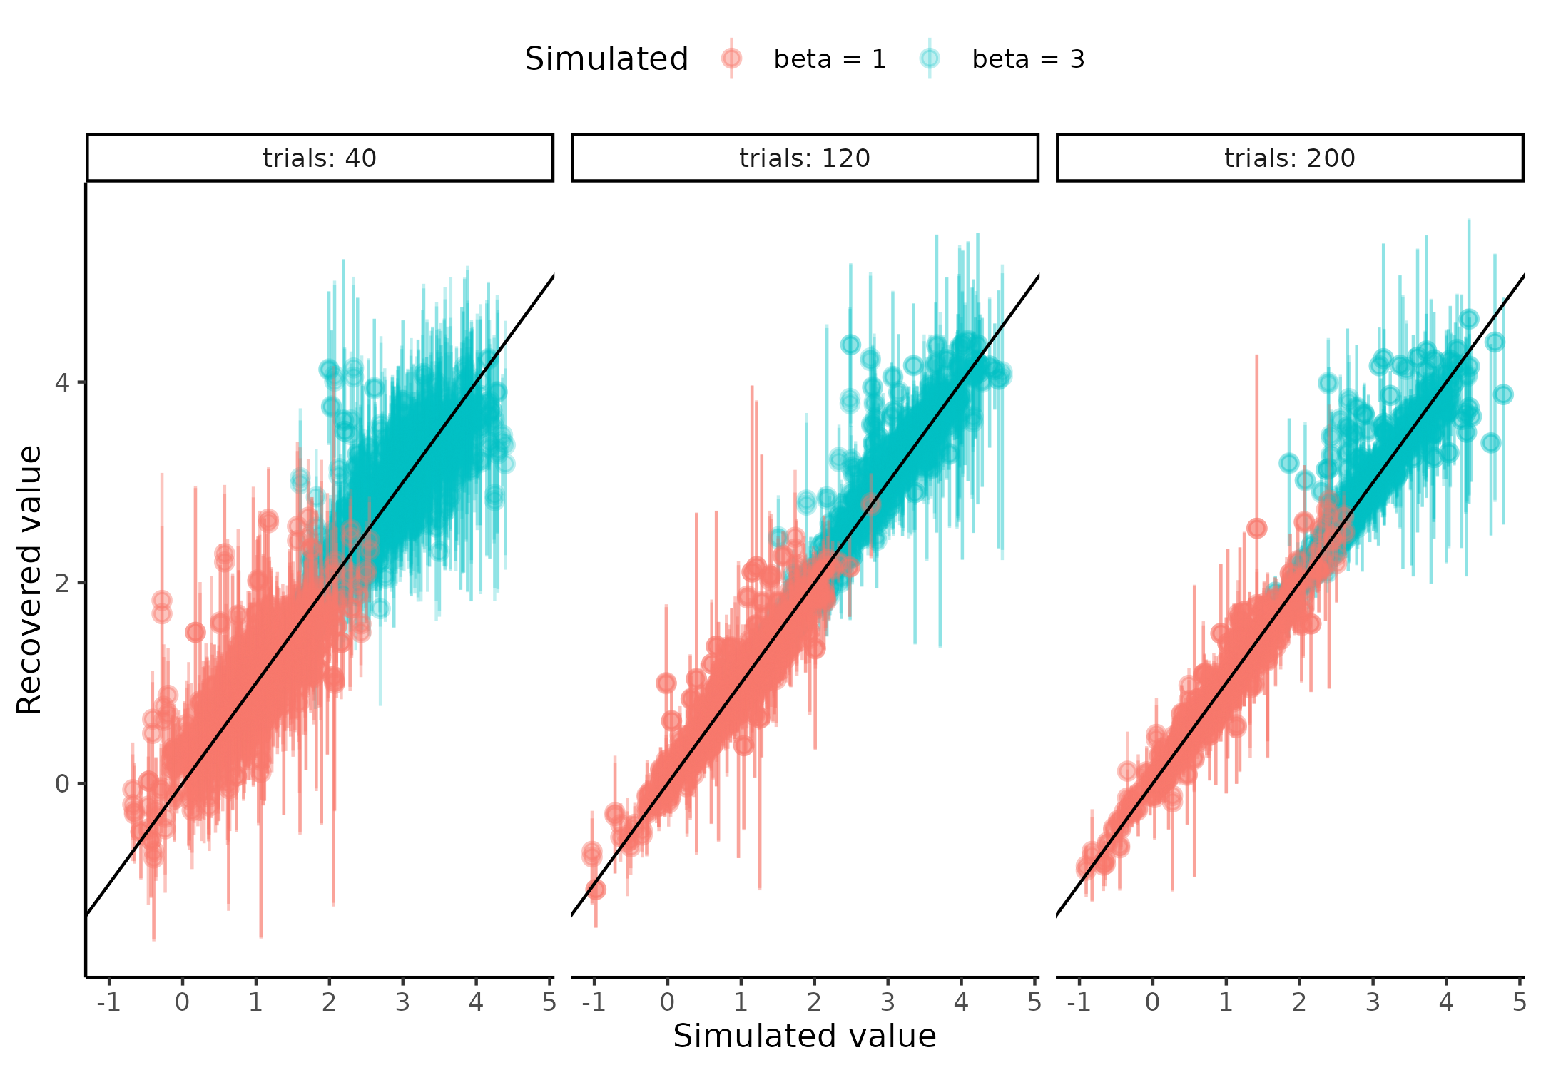

**Supplemenary figure 3 Parameter recovery of the psychometric function for all four parameter recovery metrics investigated.**

### Supplementary figure 7

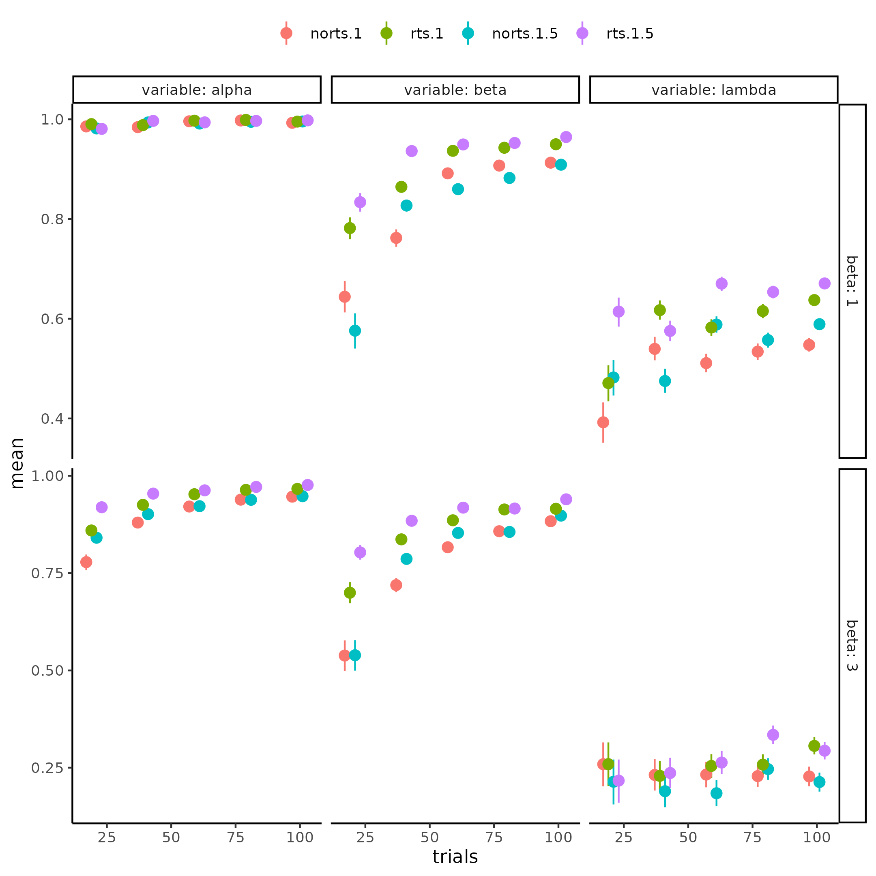

**Supplemenary figure 7. Parameter recovery of the psychometric function for the correlation coefficient for each parameter (columns) in each combination of including and not including rts and its size (color) and the simulated mean slope (rows) for differing number of trials x-axis.**

### Supplementary figure 8

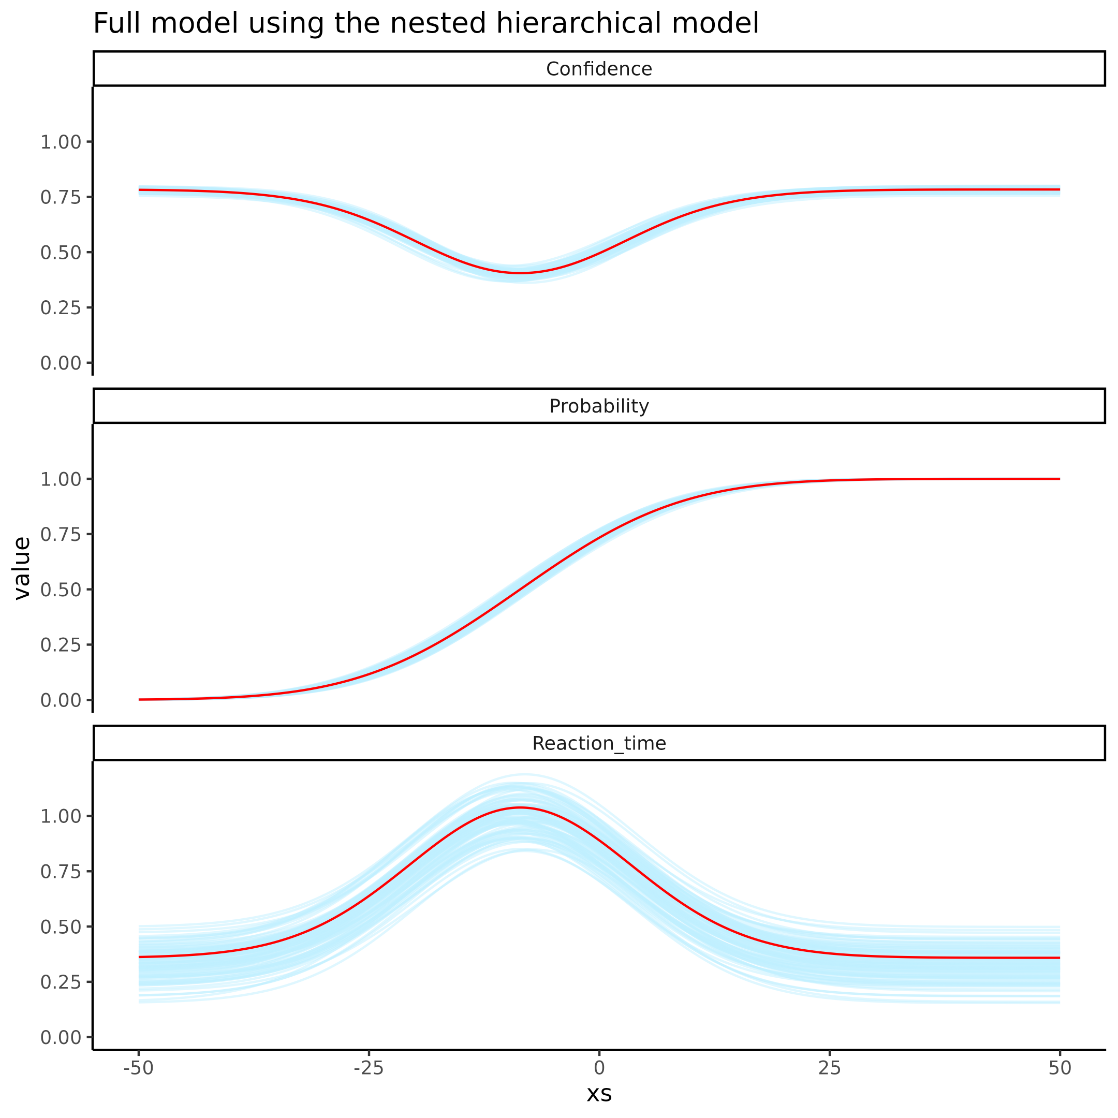 ### Supplementary figure 9

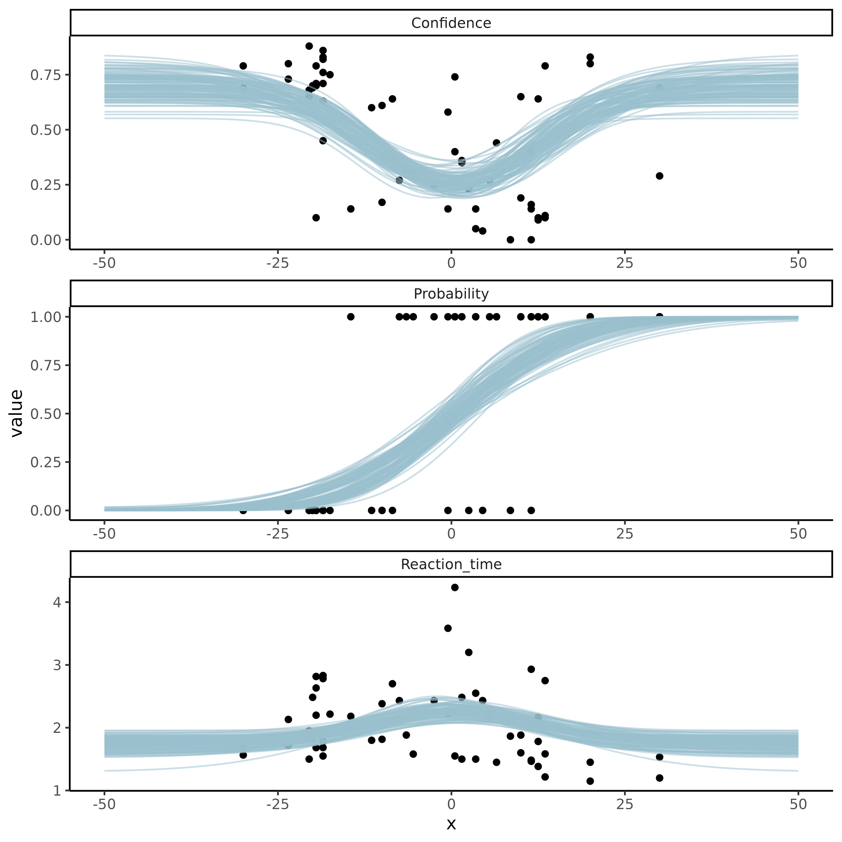

**Supplemenary figure 8. Group level posterior predictive checks of the 3 types of responses, Confidence, binary (faster or slower) and reaction time on the binary response for the Nested Hierarchical model.** Facets represent the 3 types of responses, 0-1 Confidence ratings, 0 or 1 binary responses of (faster or slower) and the reaction time for these binary responses. Red line depicts the mean of the posterior and the blue lines represents 100 posterior draws.

### Supplementary figure 10

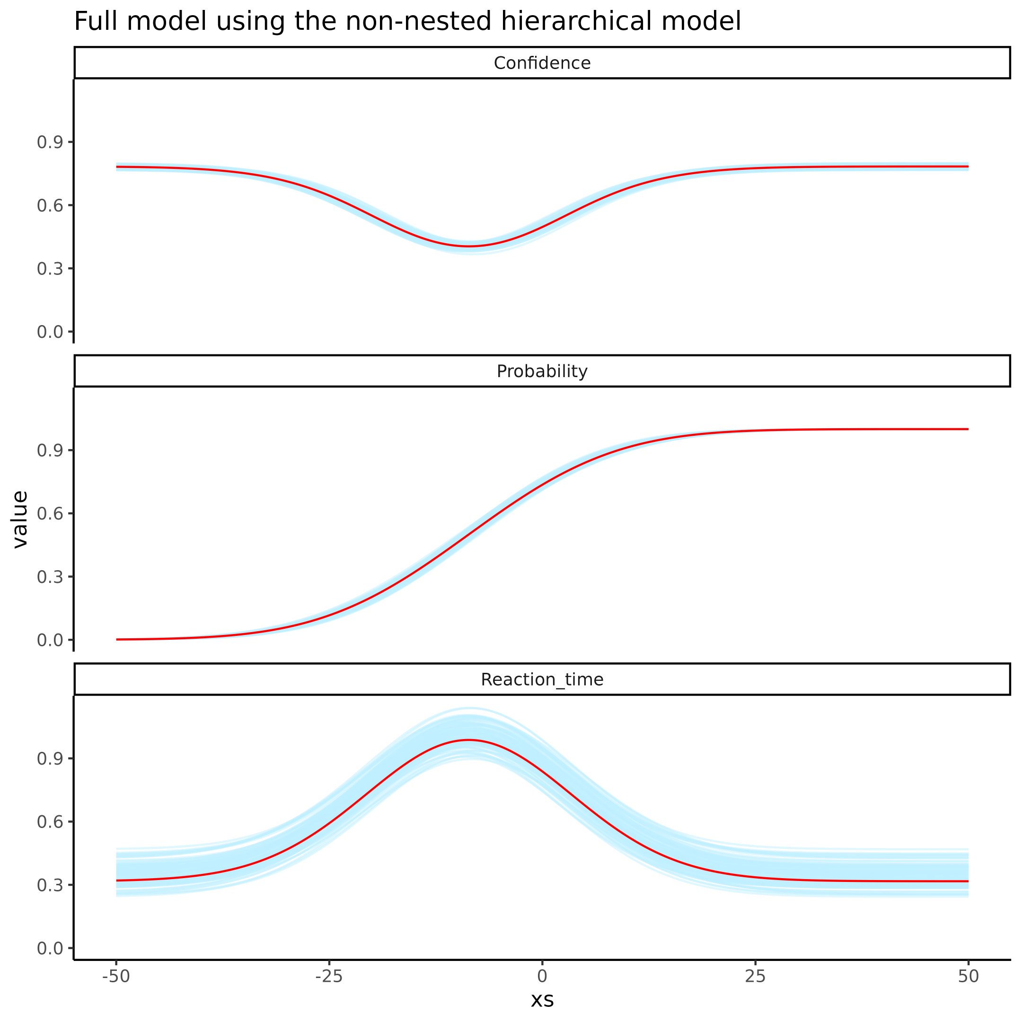

**Supplemenary figure 8. Group level posterior predictive checks of the 3 types of responses, Confidence, binary (faster or slower) and reaction time on the binary response for the non-nested Hierarchical model.** Facets represent the 3 types of responses, 0-1 Confidence ratings, 0 or 1 binary responses of (faster or slower) and the reaction time for these binary responses. Red line depicts the mean of the posterior and the blue lines represents 100 posterior draws.

### Supplementary figure 11

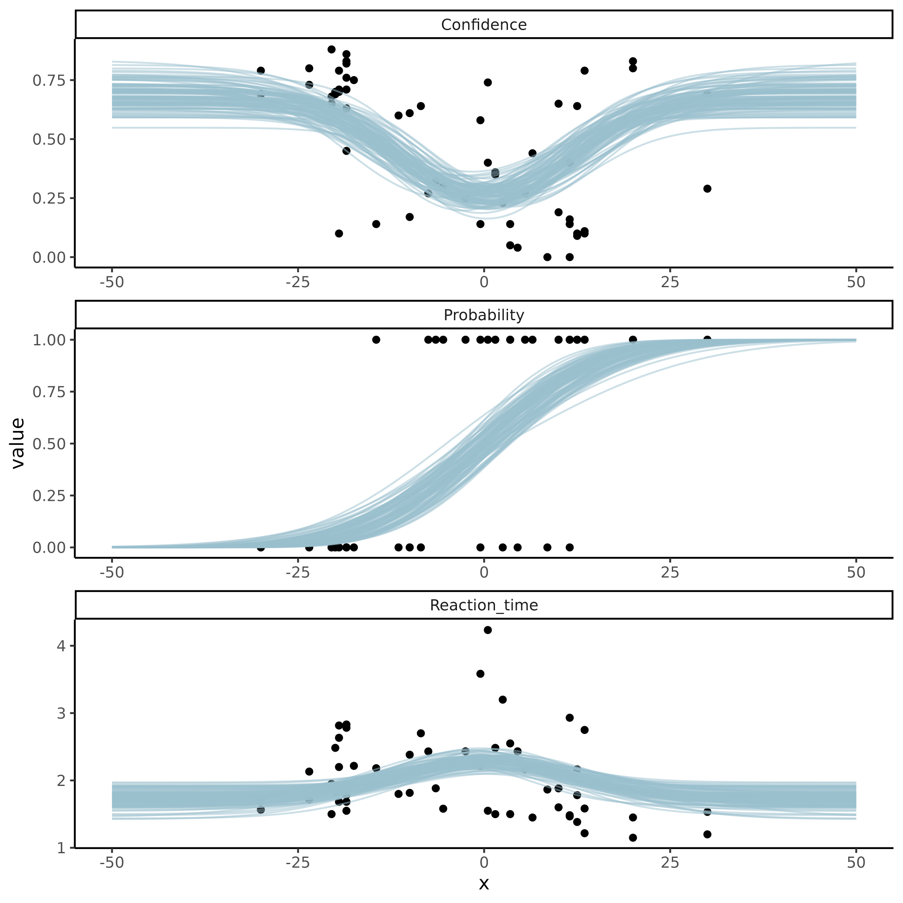

**Supplemenary figure 8. Group level posterior predictive checks of the 3 types of responses, Confidence, binary (faster or slower) and reaction time on the binary response for the non-nested Hierarchical model.** Facets represent the 3 types of responses, 0-1 Confidence ratings, 0 or 1 binary responses of (faster or slower) and the reaction time for these binary responses. Red line depicts the mean of the posterior and the blue lines represents 100 posterior draws.

## Supplementary tables

### Supplementary table 1

see [Supplementary table 1](https://github.com/JesperFischer/Master-thesis/blob/main/Supplementary%20tables/Supplementary%20table2.xlsx) which is linked to the github of the thesis. As the table is to big to show on a single page.

### Supplementary table 2

Table supplementary 2: Group mean parameter distributions of Binary test re-test re-analysis. Summary statistics of the group mean parameters of the Binary hierarchical model, used as the baseline parameters for the power analysis.

| variable | mean | q5 | q95 |
| --- | --- | --- | --- |
| mu_threshold | -8.35 | -9.50 | -7.17 |
| mu_slope | 2.26 | 2.21 | 2.31 |
| mu_lapse | -4.93 | -5.93 | -4.15 |
| std_threshold_between | 7.92 | 6.86 | 8.98 |
| std_slope_between | 0.14 | 0.03 | 0.23 |
| std_lapse_between | 0.48 | 0.04 | 1.19 |
| std_threshold_within | 7.36 | 6.70 | 8.08 |
| std_slope_within | 0.34 | 0.26 | 0.41 |
| std_lapse_within | 1.99 | 1.46 | 2.61 |

## Supplementary Notes:

### Supplementary note 1: Priors

In the section for Standard parameter recovery a single fit psychometric function was used to demonstrate the standard parameter recovery approach to internal validity of the psychometric function. The priors for that model were as follows for the threshold,slope and lapse rate respectively.

$α∼N\left(0,20\right)$ $β∼N\left(0,2\right)$ $λ∼N\left(−4,2\right)$

Next the priors for the nested hierarchical model was as follows:

$μ_{α}∼N\left(0,10\right)$ $σ_{α\left(within\right)}∼N\left(0,10\right)$ $σ_{α\left(between\right)}∼N\left(0,10\right)$

$μ_{β}∼N\left(0,3\right)$ $σ_{β\left(within\right)}∼N\left(0,3\right)$ $σ_{β\left(between\right)}∼N\left(0,3\right)$

$μ_{λ}∼N\left(−4,2\right)$ $σ_{λ\left(within\right)}∼N\left(0,3\right)$ $σ_{λ\left(between\right)}∼N\left(0,3\right)$

$ρ_{between}∼LKJ\left(2\right)$ $ρ_{within}∼LKJ\left(2\right)$

### Supplementary note 2: Lapse rate explanation

As mentioned in the main text, the lapse rate can be quite difficult to estimate if the proportion of lapses are low. In the main text it is argued that lapse rate of approximately 1% is difficult to estimate as this would on average in the particular simulation with 100 trials per subject amount to 1 trial where the subject would have a lapse. However from the models perspective, these lapses are not created equally, which makes it even more dificult to estimate this parameter. This is because of the difference between having a lapse when the stimulus value is extreme in either end (high or low) or having a lapse when the stimulus value is close to the simulated threshold. A lapse close to the simulated threshold would from the models perspective not interfere with the estimation of the parameters as this response could just be due to the stochastic nature of the task (i.e. the y-axis of the Psychometric function is the probability of responding 1). Therefore only lapses at the extreme ends would inform the model about the underlying probability of having a lapse.

### Supplementary note 3: Pathfinder explanation

The pathfinder algorithm was used for optimization of the trial by trial simulations. The implementation was as follows. Firstly a randomly drawn stimulus value in the domamin of [-50 ; 50] was drawn. After the representation of this stimulus value a response is collected based on the simulated parameters. The stimulus value together with the responses is then fit to pathfinder which uses the priors of the model with this observation to update the parameters. The next stimulus is then selected by taking the posterior mean of the threshold. This was done for the first 5 trials to get resonable estimates of the parameters of the model. In order to properly explore the width and size of the psychometric function the stimulus values were after the first 5 trials selected based on a single draw from the posterior threshold and slope. This meant extracting a draw of the threshold and then randomly either adding the draw of the slope or subtracting it. For the [full code see](https://github.com/JesperFischer/Master-thesis/blob/main/Analyses/ICC%20analysis/Visualizing%20pathfinder%20scripts.R). The priors for this model are identical to those found in the single subject psychometric function (see supplementary note 1)

### Supplementary note 4: Comparison of ADO algorithms

Comparison between the 3 tested model rested on having each algorithm simulate stimulus values based on simulated parameter values. These simulated stimulus values were then used to obtain responses of the agents (again using the simulated parameter values). Each set of stimuli and responses for each algorithm were then fit using the same Bayesian model (see supplementary note 3 and 1) and the posterior distributions were computed for each of the three parameters values (i.e. threshold $α$, slope $β$ and lapse rate $λ$).

### Supplementary note 5: Posterior preditive checks

Supplementary figure 8 and 10 displays the posterior predictive check for the two hierarchical models with the three types of responses i.e. binary, reaction time and confidence ratings. In these plots the group means of the parameters are depicted giving an indicating of the overall structure of the behavioral responses of the participants.

Supplementary figure 9 and 11 depicts instead of the group level estimates a particular participant at a particular session with overlaid data. Interrested readers are refered to [the github](https://github.com/JesperFischer/Master-thesis/blob/main/manuscript/Supplementary%20material/supplementary%20analyses.Rmd) to explore other participants than depicted here.

Note that for the non-nested hierarchical model the group level estimates are the mean of the two sessions whereas this is directly estimated in the nested hierarchical model.

### Supplementary note 6: Power analysis model description

The full stancode for the model used in the power analysis, see [the github](https://github.com/JesperFischer/Master-thesis/blob/main/Analyses/Power%20analysis/Make%20datasets/Parameterized%20cummulative%20normal.stan). The model assumes that all three parameters of the psychometric function is drawn from a multivariate normal distribution with group means and between subjects variances, furthermore two group differences are also drawn from this multivariate normal distribution that calculates the the difference between slopes and thresholds between sessions. The variance co-variance matrix was decomposed using the Cholesky-decomposition and the LKJ-prior was used for the correlation coefficients between parameters which was set to $η=2$ i.e. a quite wide prior on the correlation but with less mass for more extreme correlations.